SENIOR SIX TERM 1 PHYSICS LESSON NOTES 2026

TOPIC 1/6: CIRCULAR MOTION
Competency: The learner examines the motion of bodies on curved paths and ensures safety precautions for people using automobiles on such paths.

Circular motion
This is the motion of an object moving in a circular path with a uniform speed around a fixed point O. consider a body moving from A to B in a small time ∆t such that the radius r, sweeps through a small angle ∆θ in radians

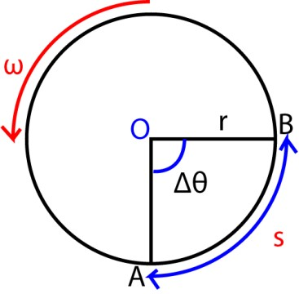

Distance, AB = s = r∆θ But speed, v = 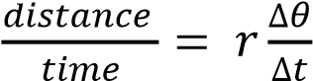
As ∆t → 0, 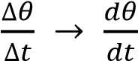 v = 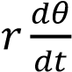
Since, 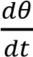 = ω v = rω

Terminology in circular motion

Angular velocity, ω
This is the rate of the angle for an object moving in a circular path about in a circular path about the center. S.I units are rads⁻¹.

Period, T
Time taken to make one complete revolution

Time = 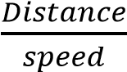
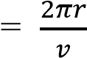
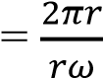
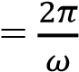

Frequency, f
This is the number of revolutions made in one second. The S.I units are hertz (Hz)
F =
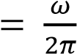

Centripetal acceleration (a)
This is the rate of change of velocity for a body moving in a circular path and it is directed towards the center of that circular path. a = 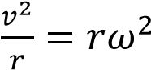

Derivation of a = 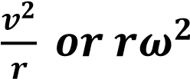
Consider an object moving with a constant speed, v, round a circle of radius, r.

In figure (i) below; at A, its velocity v_{A} is in direction of the tangent AC, a short time dt later at
B, its velocity v_{B} is in the direction of tangent BD

Since their directions are different, the velocity v_{B} is different from the velocity v_{A} although their magnitude are both equal to v.

Thus a velocity change or acceleration has occurred from A to B
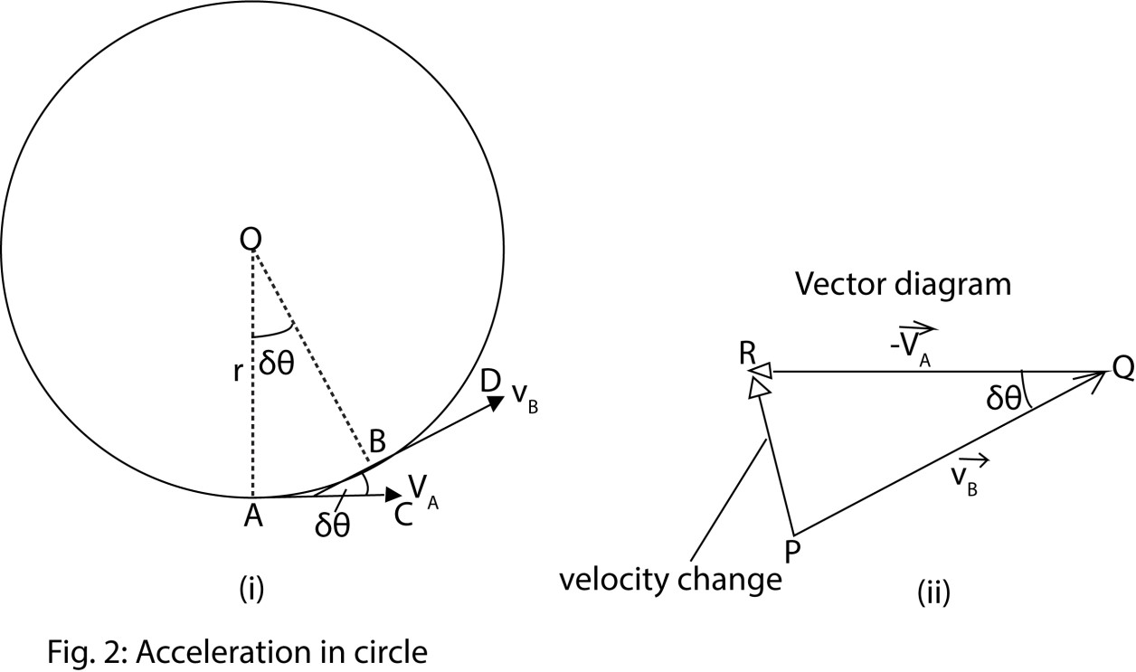

The velocity change from A to B = v_{B} – v_{A} or v_{B} + (-v_{A}).

In figure 2(ii) above, PQ represents v_{B} in magnitude (v) and direction BD; QR represents -v_{A} in magnitude (v) and direction (CA).

Velocity change = v_{B} + (-v_{A}) = PR

When δt is small, the angle AOB or δθ is small;
Also angle PQR equal to δθ is small

PR or acceleration then points toward O, the center of the circle.

a = 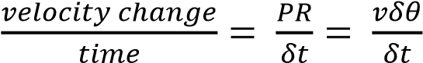
but 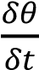 =ω and v = rω

a = rω x ω = rω²

thus an object moving in a circle of radius r with a constant speed v has a constant acceleration towards the center equal to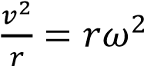

Centripetal force
This is the force which keeps the body moving in a circular path and it is directed towards the center of the circular path.

F = ma = m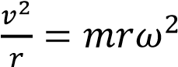

Centrifugal force
This is the force acting on a body moving in a circular path.

Examples of circular motion
1. A conical circular pendulum
Consider a mass , m, attached to a string of length L moving around a horizontal circle of radius, R, at a constant speed, v, and the string make an angle θ with the vertical and have a tension, P.
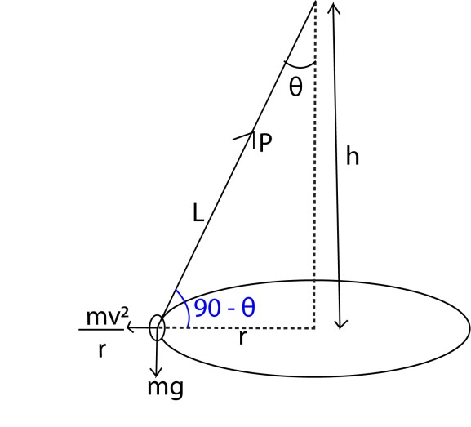
Resolving vertically
Pcosθ = mg …………………………………………….. (i)
Resolving horizontally
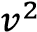
Psinθ = m ……………………………………………… (ii)

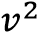
Eqn (i) and Eqn (ii) tan θ =
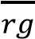

From the diagram sin θ = , r = Lsinθ cos θ = , r = Lcos θ Pcos θ = mg

⇨ P . = mg
P = 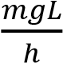 …………………………….. (iii)

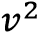
Psinθ = m
P . 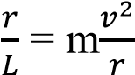
P = 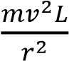
But v = rω
P = 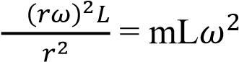 …………………….. (iv)
Eqn (iii) and (iv)
mLω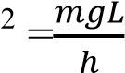
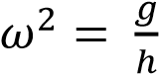
From T = 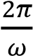 ω =
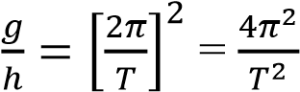

T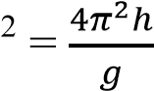
T =
√

=
2π

√

Example 1
A mass of 0.2kg is whirled in a horizontal circle of radius 0.5m by a string inclined at 300 to the vertical. Find
- The tension in the string
- The speed of the mass in the horizontal plane
- The length of the string
- The angular speed
Solution
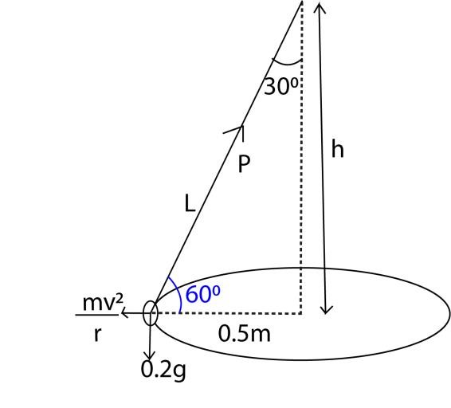
(i) Resolving vertically
Pcos θ = mg
P = 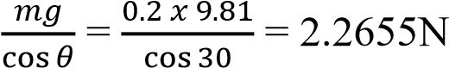
Tension P = 2.2655N (ii) Resolving vertically
Psinθ = m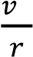
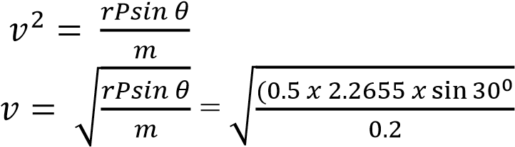= 1.6828ms⁻¹
- From sinθ =
L = 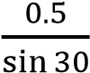 = 1m
- From ω =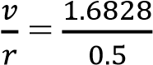 = 3.265rads⁻¹

Example 2
A 30kg body is swirled in a horizontal circle as a conical pendulu by means of inelastic string that has a breaking strength of 392N. when the speed of the body is 8ms⁻¹, the string broke.
Calculate
(i) The angle the string made at that instant. (ii) The length of the string.
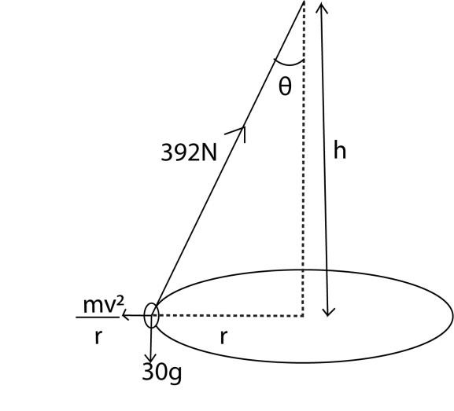
- From Pcos θ = mg cos θ = 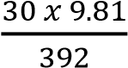 θ 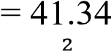
- From Psinθ = m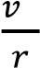 r = 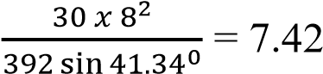
But sin θ =
L = 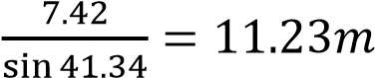

Example 3
A steel ball of mass 0.5kg is suspeneded from a light inelastic string of length 1m, the ball is whirled in horizontal cirle of radis 0.5m. find
- Centripetal force and tension in the string
- The angular speed of the ball
- The angle between the string and the radius of the circle is thetension in string is 10N Solution
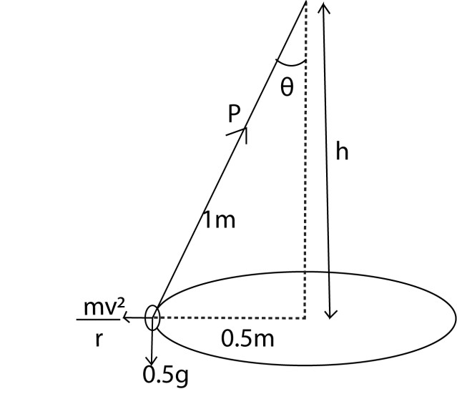

- From sinθ = θ = sin⁻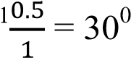
From Pcos θ = mg

Tension, P = 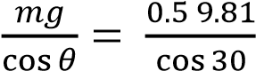 = 5.664N

But, Psinθ = F
F = 5.664 sin 30= 2.832N

- tanθ =
v =

But, ω =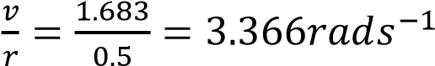
- From Pcos θ = mg cos θ = 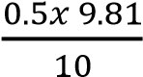
θ = 60.60
the required angle = 90 – 60.6 = 29.4⁰

Motion in verticle circle
Consider a body of mass, m, attached to a string of length, r, and whirled in a vertical circle at constant velecity, v.
At A, m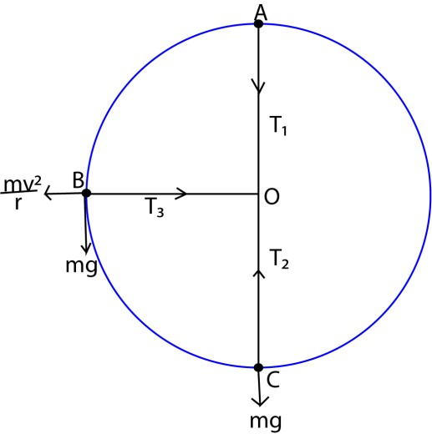 + mg

=
T
1

T
1

=
m

–

mg

At B, T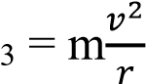

At C, T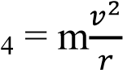 + mg

From the above expressions, tension in the string is minimum aat the top of the circle and maximum at the bottom of the circle. So the string is most likely to break when the body is at the bottom of the circle.

Example 4

A mass of 0.4kg is rotated by a string at a constant speed, v, in a vertical circle of radius 1m. If the minimum tension in a string is 3N. calculate
- The velocity
- The maximum tension
- Tension when the string is just horizontal

Solution

Minimum tension, T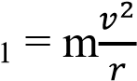 – mg
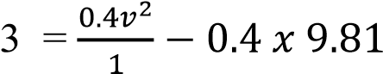
v = 4.16ms⁻¹

Maximum tension T 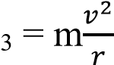+ mg
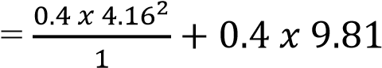
= 10.85N
Tension when the string is horizontal T = m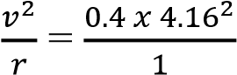 = 6.92N

Example 5
A particle of mass 5kg describes a complete vertical circle at the end of a light inextensible string of length 2m. given that the speed of the particle is 5ms⁻¹ at the highest point. Find
- Speed at the lowest point
- Tension in the string when it is horizontal
- Magnitude of centripetal acceleration when the string is horizontal Solution

(i) Mechanical energy at A = m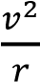 + mg
r = 2m, m = 5kg, v = 5ms⁻¹

Mechanical energy at A = 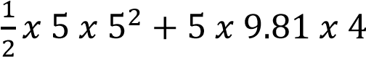 = 258.7J
Mechanical energy at C = m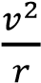 + mg = 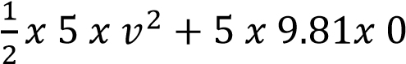 = 2.5v² J
But from the principle of conservation of energy mechanical energy

Mechanism energy at A = mechanical energy a t C
258.7 = 2.5v² v = 10.2ms⁻¹.

- Mechanical advantage at B, = m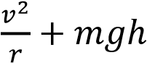 = 5 x 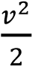 + 5 x 9.81 x 2 = 258.7
v = 8ms
tension at B = m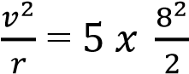 =160N
- From a = 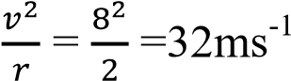

Example 6
A particle of mass m describes a complete vertical inextensible string of length, r, given that the speed at the lowest point is twice the speed at highest point. Show

- The speed of the particle at the lowest point is = v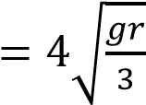.
- The tension in the string when the particle is at the highest point, T = 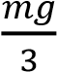

- Mechanical energy at A = mechanical energy at B = m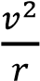 + mg Let the speed at A = u
The speed at C = 2u
⇨ m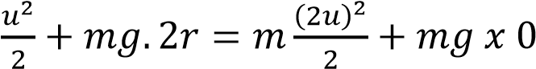 u² + 4gr = 4vu²
3u² = 4gr
u = 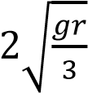.
At the lowest point velocity = 2u = 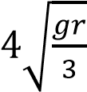.
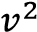
- Tension at the highest point = m – mg = 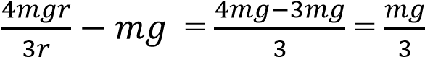

Revision Exercise 1
- An object of mass 0.kg on the end of a string is whirled around in a horizontal circle of radius 2m, with a constant speed of 10ms⁻¹. Find its angular velocity and the tension in the string [Ans. ω = 5rads⁻¹, T = 25.5N)
- A small ball of mass 0.1kg is suspended by an inextensible string of length 0.5m and is caused to rotate in a horizontal circle of radius 0.4m. find
  - The tension in the string [Ans. 1.3N]
  - The period of rotation [ans. 1.2s]
- A pendulum bob of mass 0.2kg is attached to one end of an inelastic string of length 1.2m. the bob moves in a horizontal circle with the string inclined at 30⁰ to the vertical.
Calculate
  - Tension in the string [Ans. 2.27N]
  - The period of motion [Ans. 2.02s]
- The period of oscillation of a conical pendulum is 2.0s. if the string makes an angle 60⁰ to the vertical at the point of suspension, calculate the
  - vertical height of the point of suspension above the circle [ h = 0.994m]
  - length of the string [ L= 1.99m]
  - velocity of mass attached to the string. [v = 5.41ms⁻¹]

Motion of Bicycle Rider Round Circular Track
When a person on a bicycle rides round a circular racing track, the frictional force F at the ground provides the inward force· towards the centre or centripetal force, Fig. 1below
This produces a moment about his centre of gravity G which is counterbalanced, when he leans inwards, by the moment of the normal reaction R.
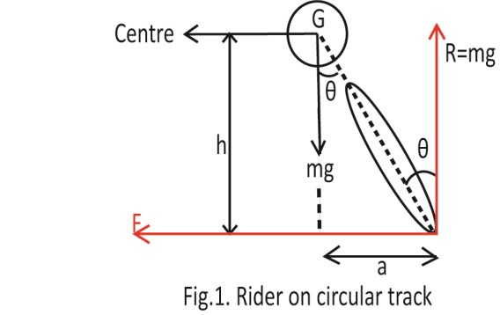
Thus provided no skidding occurs,
F . h = R . a= mg . a, since R = mg for no vertical motion .
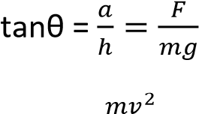
But F =
 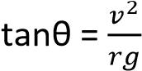
When F is greater than the limiting friction, skidding occurs. In this case F > µmg, or mg tan θ > µmg. Thus tan θ > µ is the condition for skidding.

Motion of Car (or Train) Round Circular Track
Suppose a car (or train) is moving with a velocity v round a horizontal circular track of radius r, and let R₁, R₂ be the respective normal reactions at the wheels A, B, and F 1, F 2 the corresponding frictional forces, Fig. 2.

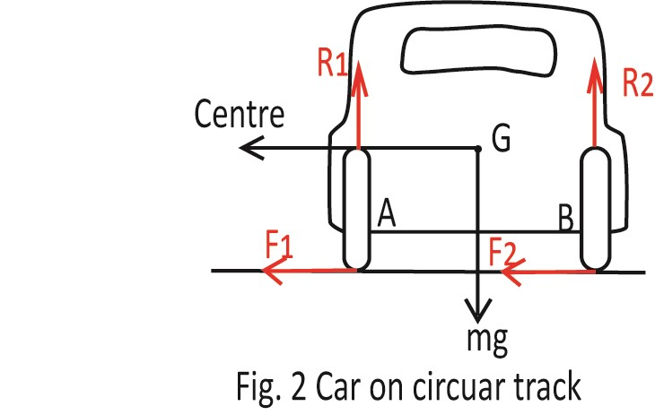
Then, for circular motion we have
Horizontally, 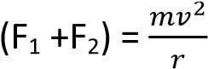 …………………………..(i)
and vertically, (R₁ + R₂) = mg ………………………. (ii)
Taking moments about G
(F₁ +F₂)h + a(R₁ - R₂)……………………………………….(iii)
where 2a is the distance between the wheels, assuming G is mid-way between the wheels, and h is the height of G above the ground.
From these three equations (i), (ii), (iii)
R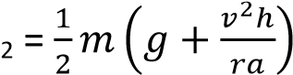
and vertically R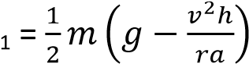
R2 never vanishes since it always has a positive value. But if 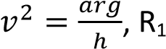 = 0, and the car is about to overturn outwards. R₁ will be positive if 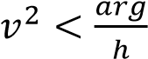

Motion of Car (or Train) Round Banked Track
Suppose a car (or train) is moving round a banked track in a circular path of horizontal radius r, Fig. 3. the only forces at the wheels
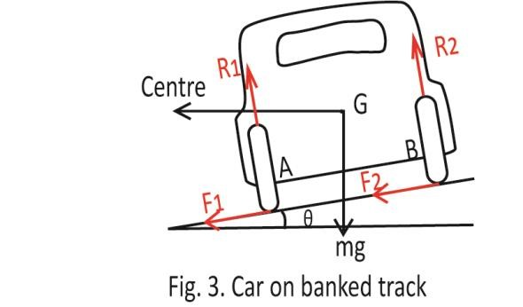
If A, B are the normal reactions R₁, R₂ respectively, that is, there is no side-slip or strain at the wheels, the force towards the centre of the track is (R₁ + R₂) sin θ, where θ is the angle of inclination of the plane to the horizontal.
 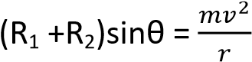 ……………………………………………………(i)
For vertical equilibrium, (R₁ + R₂) cos θ= mg ………………………………………………….(ii)
Dividing (i) by (ii), 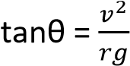 ……………………………………………………………….. (iii)
Thus for a given velocity v and radius r, the angle of inclination of the track for no side-slip must be 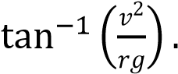As the speed v increases, the angle θ increases, from (iii). A racing-track is made saucer-shaped because at higher speeds the cars can move towards a part of the track which is steeper and sufficient to prevent side-slip. The outer rail of a curved railway track is· raised about the inner rail so that the force towards the centre is largely provided by the component of the reaction at the wheels. It is desirable to bank a road at comers for the same reason as a racing track is banked.

Thrust at Ground
Suppose now that the car (or train) is moving at such a speed that-the frictional forces at A, B are F₁, F₂ respectively, each acting towards the centre of the track.
Resolving horizontally, 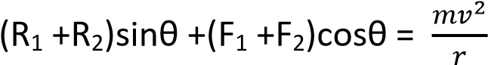 ……………………………………………………(i)
Resolving vertically, 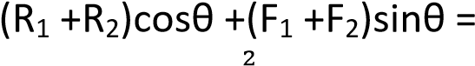 mg ……………………………………………………..(ii)
Simplifying. We find 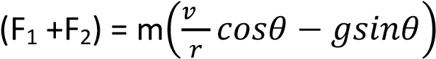 ……………………………………………………… (iii)
I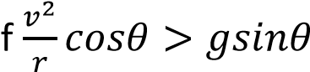, then (F ₁ + F ₂) is positive; and in this case both the thrusts on the wheels at the ground are towards the centre of the track.
If 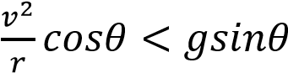 , then (F ₁ + F ₂) is negative. In this case the forces F ₁ and F ₂ act outwards away from the centre of the track. For stability, we have, by moments about G,
(F₁ + F₂)h + R₁a – R₂a = 0
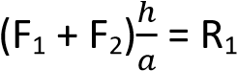 – R₂
From (iii)

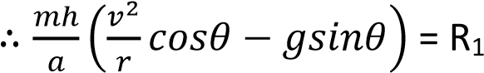 – R₂………………………………………………..(iv)

The reactions R₁, R₂ can be calculated by finding (R₁ + R₂) from equations (i), (ii), and combining the result with equation (iv). This is left as an exercise to the student.

Topical revision questions
- (i) Explain the significance of the banked tracks. (02 marks)
It enables vehicles to navigate turns at higher speeds without skidding because, on banked track, a component of normal reaction supplements friction to provide the centripetal force.
(ii) Explain why a cyclist bends inward while going round a curved path. (03marks)
A cyclist bends inwards while going round a curved path to counterbalance centripetal force provided by friction between the tyres and the road such that skidding does not occurs.
(iii) Derive an expression for the speed of a bicycle rider around a circular path. (03 marks)
Assumption
v = speed of the bicycle r = radius of the circular path m= mass of the bicycle and the rider g = acceleration due to gravity θ = banking angle of the track (if applicable)
F_{c} = centripetal force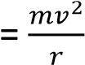
F_{r} = friction = μR=μmg
For a circular motion centripetal force = friction
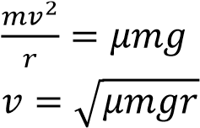
⇨

For banked track
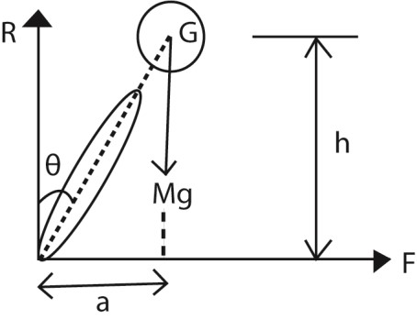θ
Ncosθ = mg (vertical component)
N = 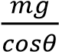 ……………………………………………………………..(i)
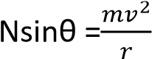(horizontal component) ……………………(ii)
Substituting (i) into (ii)
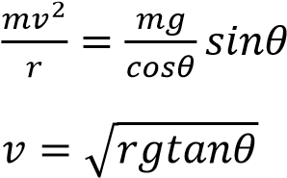
(iv) A body of mass 1.5kg moves once round a circular path to cover 44.0cm in 5s. Calculate the centripetal force acting on the body. (04marks)
Radius of circular path, r Circumference = 2πr = 44cm
r = 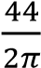 =7cm
Linear velocity, v = 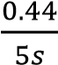 = 0.088ms⁻¹
Centripetal force, 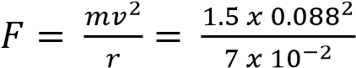 = 0.166N
- A stone tied to a string is whirled in a horizontal circle. Explain the motion of the stone when the string breaks. (05marks)
- Before the String Breaks:
        - The stone is kept in a circular path by the tension in the string, which provides the necessary centripetal force directed towards the center of the circle.
        - The stone continuously changes direction as it moves along the circular path, but the tension in the string ensures it stays in the circle.
- At the Moment the String Breaks
        - The string likely to break at the lowest point in the circle because tha tis where tension in the string is highest.
        - The centripetal force disappears immediately because the tension in the string is no longer present.
        - Without this force, there is nothing to keep the stone moving in a circular path.
- After the String Breaks:
        - According to Newton's First Law of Motion (inertia), an object in motion will continue in motion with the same speed and in the same direction unless acted upon by an external force.
        - Therefore, the stone will move in a straight line tangent to the circle at the point where the string breaks. This path is called a tangential path.
        - The stone's velocity at the moment the string breaks determines the direction of this straight-line motion.
- (a) (i) Define angular velocity. (01mark)
Angular velocity is the rate of change of angular displacement.
      - Explain why a body moving with constant speed along a circular path has an acceleration. (03 marks)
Acceleration is a rate of change of velocity with respect to time. In the circular motion, the speed of the body is constant but velocity changes continuously due to changes of its direction. Hence it is an accelerated motion
      - Derive an expression for the acceleration of a body moving in a circular path of radius r
with a constant speed V. (04marks)
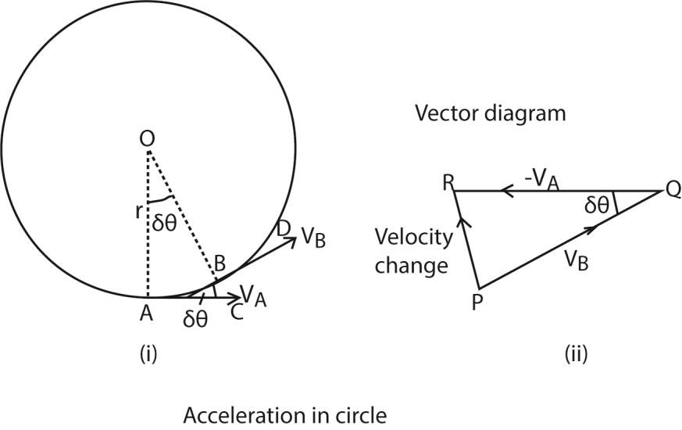

The velocity change from A to B = V_{B} – V_{A} or V_{B} + (-V_{A}).

In figure 2(ii) above, PQ represents V_{B} in magnitude (V) and direction BD; QR represents -V_{A} in magnitude (V) and direction (CA).

Velocity change = v_{B} + (-v_{A}) = PR

When δt is small, the angle AOB or δθ is small;
Also angle PQR equal to δθ is small

PR or acceleration then points toward O, the centres of the circle.
PR = -V_{A}sin δθ - V_{A}δθ = Vδθ

a = 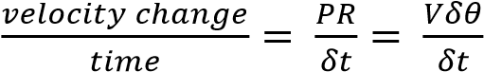
but 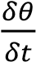 =ω and V = rω

a = rω x ω = rω² but ω =
a = 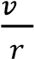
      - Derive the condition for a car to move round a banked circular track without slipping. (04 marks)
Consider car negotiating a bend inclined at an angle θ to the horizontal. It is assumed that there is no tendency to slip at the wheels, therefore no frictional forces.
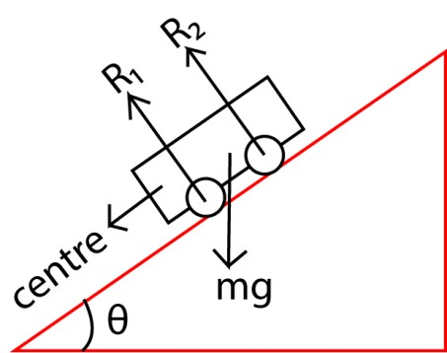

Resolving horizontally
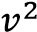
R₁sinθ + R₂sinθ = 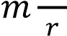 …………………………… (i)
Resolving vertically
R₁cosθ + R₂cosθ = 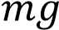 …………………………… (ii)

Eqn. (i) Eqn. (ii)
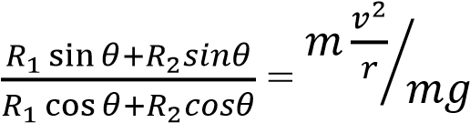
tan θ =

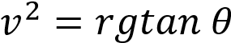

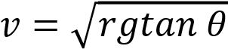
Hence car will not skip when 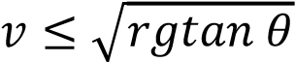

      - A car of mass 1000kg moves round a banked track at constant speed of 108kmh⁻¹. Assuming the total reaction at the wheels is normal to the track, and the radius of curvature of the truck is 100m, calculate the:
(i) angle of inclination of the track to the horizontal (04marks)
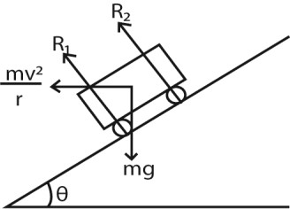
Frθm tan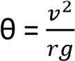
v = 108kmh⁻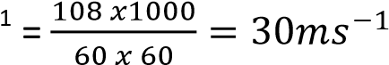
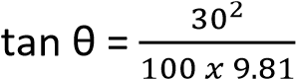
θ = 42.5⁰
(ii) reaction at the wheels (02marks)
From (R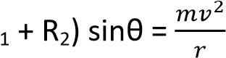
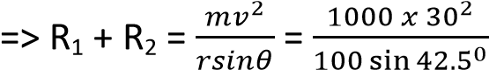= 1.33 x 10⁴N

- (a) Explain the energy changes which occur when a pendulum is set into motion. (03marks)
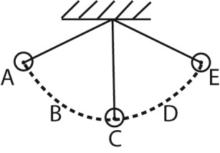
Potential energy at A → Kinetic + potential energy at B → kinetic at C → Kinetic + potential energy at D→ potential energy at E
(b) A simple pendulum of length 1m has a bob of mass 100g. It is displaced from mean position A to position B so that the string makes an angle of 45⁰ with the vertical. Calculate the
(i) maximum potential energy of the bob. (03marks)
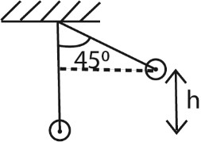
h = 1 – cos 45 = 0.293
P.E = mgh = 0.1 x 9.81 x 0.293 = 0.287J
(ii) velocity of the bob when the string makes an angle of 30⁰ 2ith the vertical. [Neglect air resistance]
Height of the ball when the string makes 300 = 1 – cos 30 = 0.134
Potential energy at this point = mgh = 0.1 x 9.81 x 0.134 = 0.122J
Kinetic energy = change in potential energy = 0.287 – 0.122 = 0.165J
Let the velocity be v
⇨ 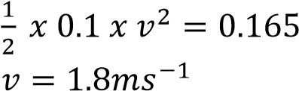
(c) A body moving in a circular path of radius 0.5m makes 40 revolutions per second. Find the centripetal force if the mass is 1kg (03marks)
F = mr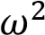but ω = 2πf
= 1 x 0.5 x (2π x 40)² = 1.36 x 10⁴N

(d) Explain why a mass attached to a string rotating at constant speed in a horizontal circle will fly off at a tangent of the string breaks. (02marks)
If the spring breaks, the mass will not have any centripetal force and will continue in a straight line along the tangent according Newton’s first law of motion.

- (a) (i) What is meant by banking a track? (01mark)
Banking of roads is defined as the phenomenon in which the outer edges are raised for the curved roads above the inner edge to provide the necessary centripetal force to the vehicles so that they take a safe turn.
(ii) Derive an expression for the angle of banking θ for a car of mass, m, moving at speed, v, round a banked tract of radius, r. (04marks)
Resolving horizontally: (R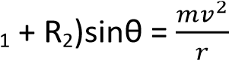 ………………….. (i)
Resolving vertically: (R₁ + R₂)cosθ = mg ………………………..(ii) Eqn. (i) and Eqn. (ii);
tan θ = 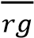 θ = tan⁻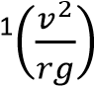
(c) A bob of mass, m is tied to an inelastic thread of length, L, and whirled with constant speed in a vertical circle
        - With the aid of a sketch diagram, explain the variation of tension in the string along the circle. (05 marks)
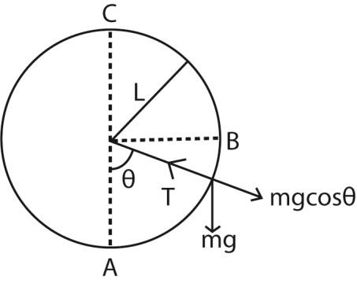
At A, θ = 0
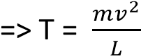+ mg
At B, θ = 90⁰
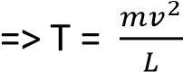
At C, θ = 1800
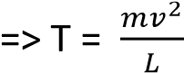- mg

        - If the string breaks at one point along the circle, state the most likely position and explain the subsequent motion of the bob.
The string breaks at the lowest point, A of the circle because tension the string is highest. Motion is tangential to the circle and when the string breaks, the bob follows a parabolic path.
(d) Explain why maximum speed of a car on a banked road is higher than on an unbanked road. (04marks)

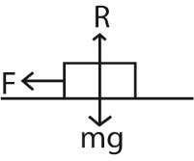
Along a circular path on a horizontal road, the frictional force provides the centripetal force
i.e. centripetal force = 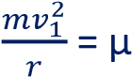R
On a banked road, the centripetal force is provided by the component of normal reaction, R, and the component of friction
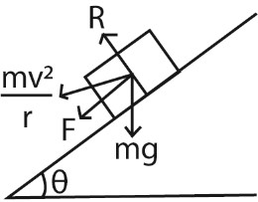

Centripetal force = 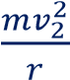 = Fcosθ + Rsinθ
But F = μR
Centripetal force =  + Rsinθ
For 0⁰ < θ < 90⁰, μcosθ+ sinθ > μ
Therefore, v₂> v₁

(e) A small bob of mass 0.2kg is suspended by an inextensible string of length 0.8m. The bob is then rotated in a horizontal circle of radius 0.4m. Find
(i) linear speed of the bob (03marks)
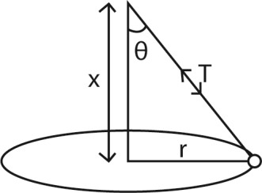
x² = 0.8² – 0.4² x = 0.692m
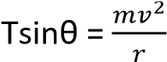 ………………………….. (i)
Tcosθ = mg
Eqn. (i) and Eqn (ii)
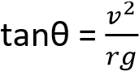
v² = rgtanθ
v = 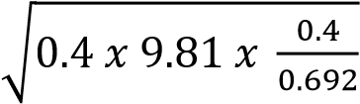 = 1.51ms⁻¹
(ii) tension in the string. (02marks)
T = 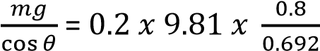 = 2.29N

- (a) (i) Define angular velocity. (01marks)
Angular velocity is the rate of change of angle of rotation of an object moving in a circular path about the centre.
(ii) Derive an expression for the force, F, on a particle of mass, m, moving with angular velocity, ω, in a circle of radius, r. (03marks)
F = ma = 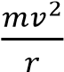 since a = 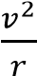 But v = ωr
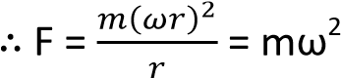r
(b) A stone of mass 0.5kg is attached to a string of length 0.5m which will break if the tension in it exceeds 20N. The stone is whirled in a vertical circle, the axis of rotation being at a vertical height of 1.0m above ground. The angular speed is gradually increased until the string breaks.
- In what position is the string most likely to break? (02marks)
At A, θ = 0
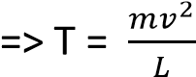+ mg
At B, θ = 90⁰
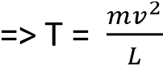
At C, θ = 1800
- mg
The string breaks at the lowest point, A of the circle because tension the string is highest.

- At what angular speed will the string break? (03marks)
String breaks T = mω²r + mg
20 = 0.5 x 0.5 x ω2 + 0.5 x 9.81 Ω = 7.77rads⁻¹
v = ωr=7.77 x 0.5 = 3.9ms⁻¹

(i) Find the position where the stone hits the ground when the string breaks. (03marks) Vertical distance to be covered = 0.5m s = ut + 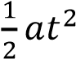
but initial component of vertical velocity = 0
=> 0.5 = 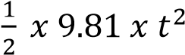
t = 0.3s
Horizontal distance = 3.9 x 0.3 = 1.17m
(c) Explain briefly the action of a centrifuge. (03marks)
Consider a body falling through a viscous fluid. For small speed, the liquid opposes motion with a resisting force, f, proportional to the velocity, v. f = kv where k is a constant of proportionality.
At terminal velocity, 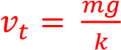
If a container is whirled at high speed, the particles will move approximately in circles with speed, v, and acceleration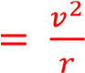.
When they reach their terminal velocity, v_{t}, relative to the fluid, the resisting force of the fluid on the particle, f = kv_{t} must be equal to the mass of the particle multiplied by its acceleration such that the terminal velocity, vt of the particles relative to the fluid is given by
v_{t} 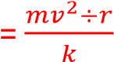
The terminal speed or sedimentation rate is increased by a factor of  which may be in thousands.
Centrifuges are used to separate cream from milk, silt from river water, blood cells from plasma, etc.

- A pendulum bob of mass 0.2kg is attached to one end of an inelastic string of length 1.2m. The bob moves in a horizontal circle with the string inclined at 30⁰ to the vertical. Calculate
(i) the tension in the string(02marks)
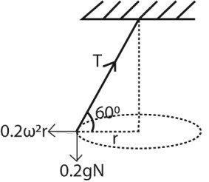
Resolving vertically
Tsin60⁰ = 0.2g = 0.2 x 9.81
T = 2.27V
(ii) the period of motion (04marks)
Tcos 60 = 0.2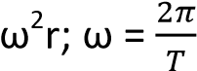; r = 1.2cos 60 = 0.6m
2.27cos 60 = 0.2 x 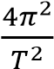 x 0.6
Period, T = 2.04s
- (a) Define the following terms:
  - Angular velocity (01mark)
Angular velocity is the rate of change of the angle swept out by the radius joining a body to the centre of circular path.
  - Centripetal acceleration (01mark)
Centripetal acceleration is the rate of change of velocity for a body describing a circular path and is always directed towards the centre of the path.

(b) (i) Explain why a racing car can travel faster on a banked road than on flat track of the same curvature. (04marks)
(ii) Derive an expression for the speed with which a car can negotiate a bend on a banked track without skidding. (03marks)
- On a flat track
For Suppose the car is moving with velocity, v, around a horizontal circular track of radius, r. if m is the mass of the car and R₁ and R₂ are normal reactions at the inner and outer wheels respectively and F₁ and F₂ are the corresponding frictional forces, then for circular motion:
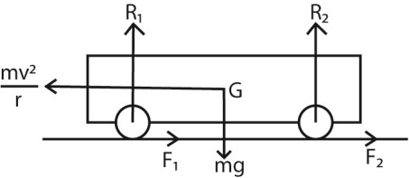
F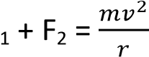 …………………………………………. (i)
For vertical equilibrium
R₁ + R₂ = mg …………………………………………(ii)
Taking moments about G
Clockwise moments = anticlockwise moments
(F₁ + F₂)h + R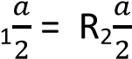(a = distance between the wheels, h = the height of the centre of gravity from the ground)
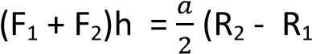) = ……………………… (iii)
Substituting Eqn. (i) into Eqn. (iii)
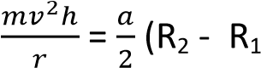) …………………………………….(iv)
From (ii)
R₁ = mg – R₂
From equation (iv)
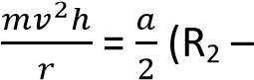(mg – R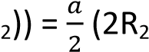 – mg )
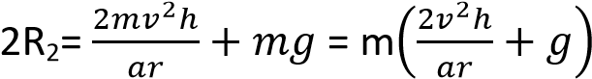
R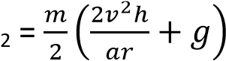
Also R₂ = mg- R₁
From equation (iv)
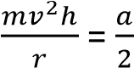((mg – R₁) 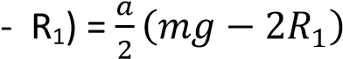
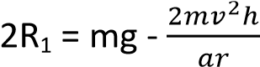
R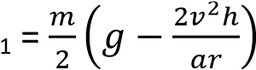
When the car is about to overturn, 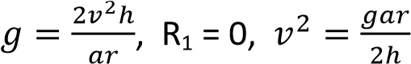
The maximum velocity of a car to negotiate a bend of radius r on a flat track, v =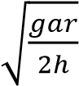
- On banked ground
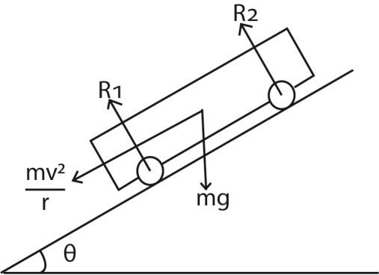
Resolving horizontally
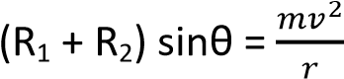 …………………… (i)
Resolving vertically;
(R₁ + R₂) cos θ = mg ………………….. (ii) Divide equation (i) by Eqn. (ii)
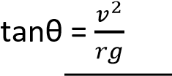
v =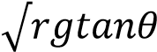

TOPIC 2/6: SIMPLE HARMONIC MOTION
Competency: The learner investigates the behaviour of oscillating systems in order to optimize the performance of devices that employ simple harmonic motion.

Simple harmonic motion
It a special type of periodic motion in which the acceleration of the body along the path of the body is directed towards a fixed point in the line of motion and is proportional to the displacement of the body from a fixed point

Characteristic of a body describing simple harmonic motion
- Motion is periodic
- Acceleration of the body is towards a fixed point
- Acceleration of the body is directly proportional to the distance from the fixed point
- Mechanical energy is conserved

Equation of simple harmonic motion

Acceleration, a = - ω²x
Where ω is angular velocity, x, is displacement from fixed point

Or a = 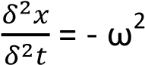x

The solution of above differential equation is x = Acos ωt or x = Asin ωt

where A is the maximum displacement of the body from the restposition the called Amplitude x is the displacement of the body at any time t.

For x = Asin ωt, the curve is given below

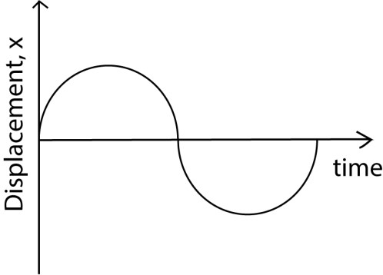

In general x = Asin(ωt + Ф) where Ф is the phase angle

Examples of simple harmonic motion

(i) Vertical spiral spring or Elastic thread
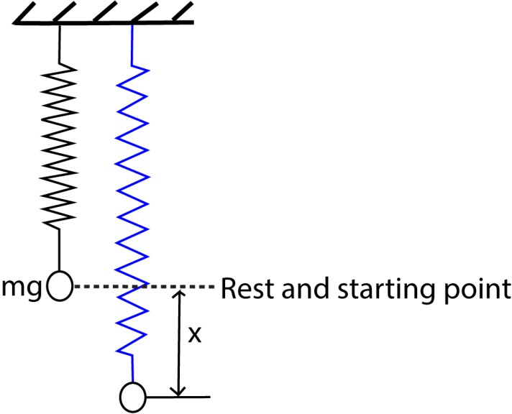

Consider a body of mass, m suspended from a spiral spring of force constant, k, as shown in the diagram above.

In that case the body will be in equilibrium

At equilibrium, T = mg

But T = ke (From Hooke’s law)

Where e is the extension in the spring at equilibrium and k is the force constant of the spring.

Hence ke = mg ……………………………………….. (i)

When the mass is pulled through a distance x, then released, the resultant upward force on the mass is

F = T’ –mg

But T’ = k(e + x)

F = k (e + x) – mg

From (i) ke = mg
F = k(e + x) – ke
F = kx
From Newton’s 2nd law, ma = F ma = -kx
a = -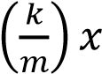

The above equation is in the form a = - ω²x where ω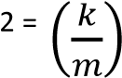
ω = 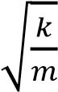 T =
T = 2π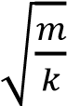
Frequency, f = 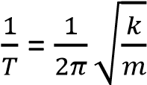

(ii) Horizontal spring
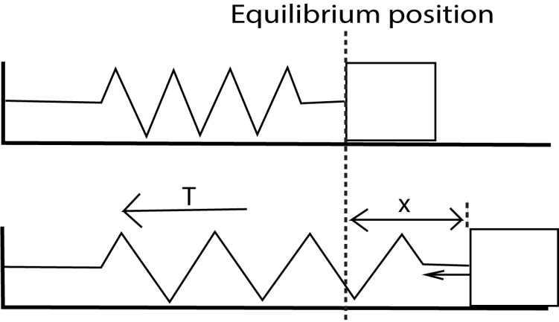

When a spring is stretched by a distance, x.

The resultant force = 0 –T
Since at equilibrium there is no force.
ma = 0 -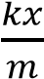 a = -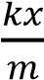 from a = - ω²x then, ω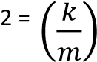

ω = 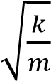 T = 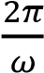
T = 2π
Frequency, f = 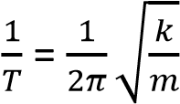

(iii) Simple pendulum
Suppose a body of mass, m, attached to a string is displaced through a small angle θ and then released. The resultant force on the body towards O is mgsinθ.

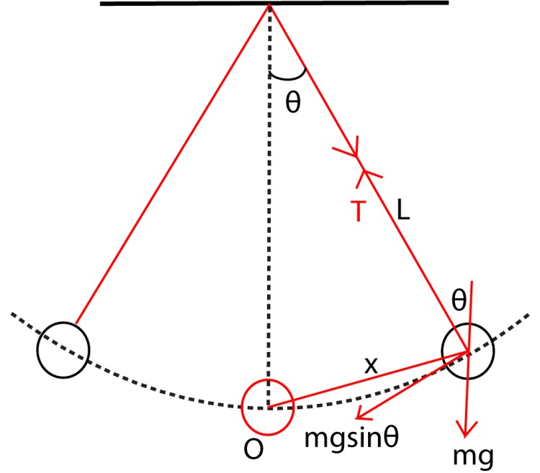

By Newton’s 2nd law
ma = - mgsinθ
a = -
a = g

But a = - ω²x
ω = T =
√

T = 2π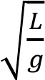
Frequency, f =

=

√

(iv) U-shaped tubes
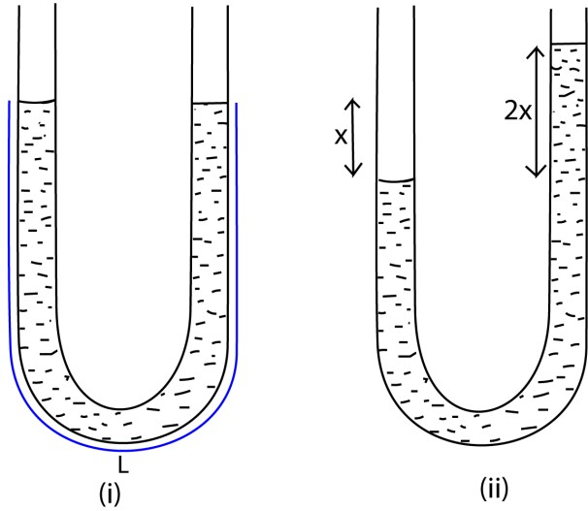
A liquid of density ρ contained in a U-tube of cross section area A and column L, if the liquid is displaced slightly through a distance x from equilibrium position

The restoring force of the liquid = 2xAρg

Using Newton’s 2nd law, ma = - 2xAρg
a = -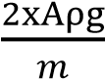 but, m = ALρ
a = -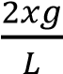 But a = - ω²x
ω =
√

T =
T = 2π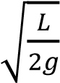
Frequency, f = 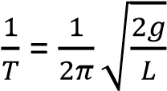

(v) A floating cylinder
Consider a cylinder of mass, m, floating vertically in a liquid of density, ρ, to a depth, h
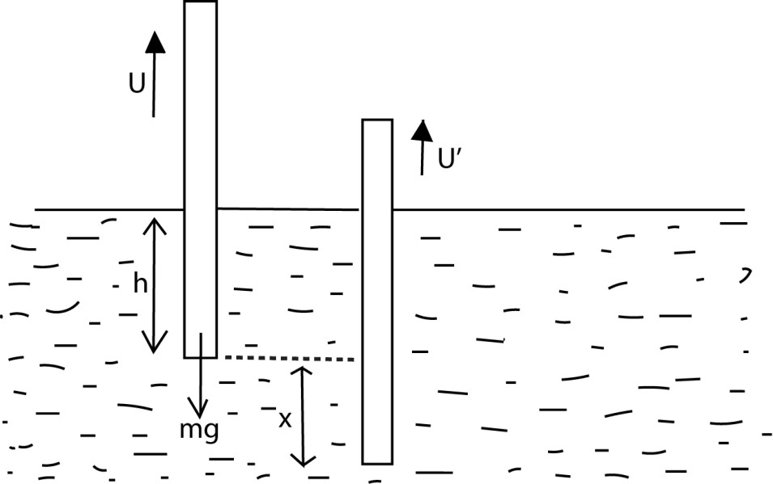

At equilibrium position, the body sinks to a height, h, below the liquid surface
Up thrust = weight of the body
But U = Ahρg
mg = Ahρg ……………………………………..(i)
A is the cross section area of a cylinder
When a body is displaced through a distance, x, and released,
Up throust = (h + x) Aρg

Resultant force = mg - (h + x) Aρg

But, m = Ahρ
ALρa = Ahρg – Ahρg – Aρgx a = 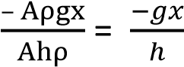
But a = - ω²x
ω = 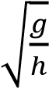 T =
T = 2π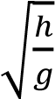
Frequency, f = 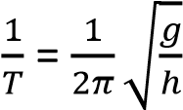

Velocity of a body executing simple harmonic motion
The displacement of the body executing simple harmonic motion is given by x = Asin(ωt + Ф)
Velocity, v= 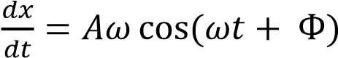

sin(ωt + Ф) =

cos (ωt + Ф) = 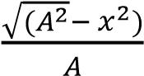

v = Aω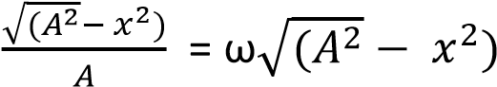
When x = 0, v is maximum
V_{max} = ωA
When x = A, v = 0

Kinetic energy and potential energy of vibrating object

K.E = 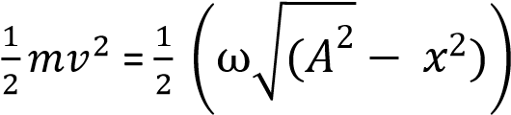
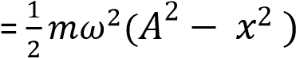
For a spring force constant, k; ω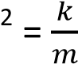
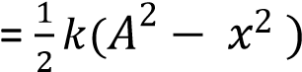

Potential energy, P.E
Work done against restoringforce is potential energy
F = mω²r

Potential energy = 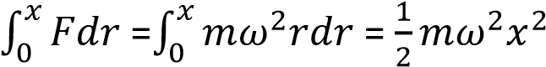

For vinrating spring, potential energy = 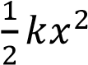

Total mechanical energy = kinetic energy + Potential energy
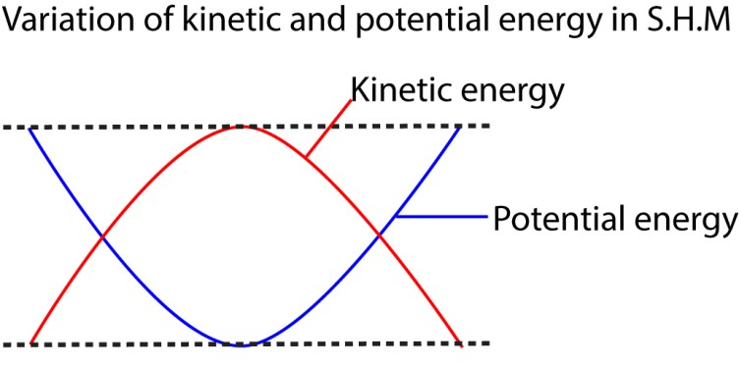

=

+

=

Example 1
A light spiral spring is loaded with a mass of 50g and it extends by 10cm. Calculate the period of small vertical oscillations.

Using T = 2π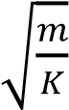 , but mg = ke
k = 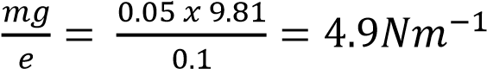

T = 2π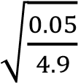 = 0.635s

Example 2
A body of mass 0.1kghangs from a long spiral spring. When pulled down 10cm below its equilibrium point, A and released, it performs simple harmonic motion with a period 2s

- What is the velocity as it passes through A?
- What is its acceleration when it is 5cm above A.
Solution
- v = ωA, where A = 0.1m, 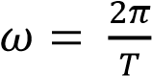, but T = 2s ω = 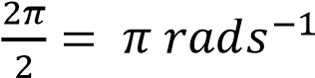
v = π x 0.1 = 0.314s
- a = -ω²x = π² x 0.05 = 0.5ms⁻²

Types of oscillations

(i) Free oscillations
Free oscillations occur in absence of any dissipasive force like air resistande, friction and viscous drag. The Amplitude and total mechanical energy remain constant and the sysstem oscillates indefinitely with a period T (the natural period of vibration of the system

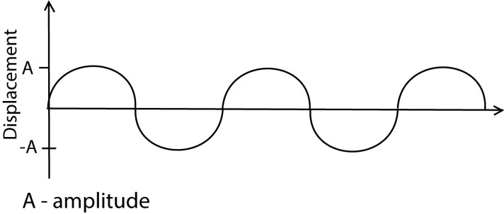

e.g. a simple pendulum will undergo free oscillation in a vacuum

(ii) Damped oscillations
These are oscillation where the system loses energy to the surrounding due to the dissipative forces. The amplitude reduces with time an be grouped into under damped, critically damped and over damped oscillation.

- Under-damped oscillation

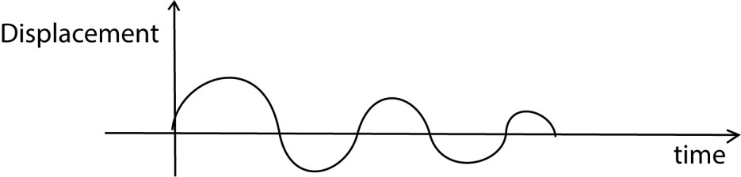

The system oscillates but gradually dies out due to the dissipative forces. The amplitude of oscillation decreases with time. Examples are a simple pendulum in air, horizontal spring moving over a surface of little roughness.

- Critically damped oscillation
The system does not oscillate when displaced, but returns to equilibrium position in the minimum possible time.

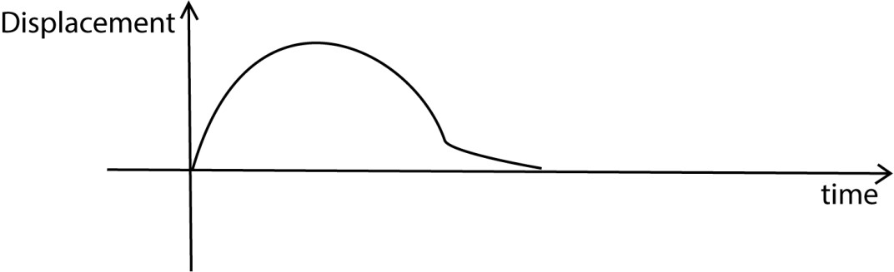
Example: a horizontal spring moving over a very rough surface, a metal cylinder attached to a vertical spring and mad to move in a very viscous liquid.

Example 3
(a) (i) What is meant by simple harmonic motion
- state two practical examples of simple harmonic motion
- using two graphical illustrations, distinguish between under damped oscillation (b) (i) Describe an experiment to measure acceleration due to gravity using a spiral spring. (ii) State two limitation to accuracy of the value in (b)(i).
(c) A horizontal spring of force constant 200Nm⁻² fixed at one end has a mass of 2kg attached to the free end and resting on a smooth horizontal surface. The mass is pulled through a distance of 4.0cm and released. Calculate
- Angular speed
- Maximum velocity attained by the vibrating body
- Acceleration when the body is half way towards the center of initial position.

Solution
(a) (i) It a special type of periodic motion in which the acceleration of the body along the path of the body is directed towards a fixed point in the line of motion and is proportional to the displacement of the body from a fixed point

(ii) – motor vehicle inspection spring
- Atom vibrating in a crystal
(iii) under damped
Critically damples
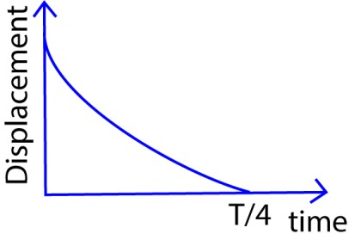
If a system is under damped, the amplitude of oscillation decrease with time due to energy loss in doing work against the dissipative forces; whereas for critically damped oscillation the time taken for the displacement to be zero is minimum and it is equal to ¼ of the periodic time, T.

- (i) Known mass, mass hanger, meter rule, pointer, retort stand and stop clock.
The set up is shown below
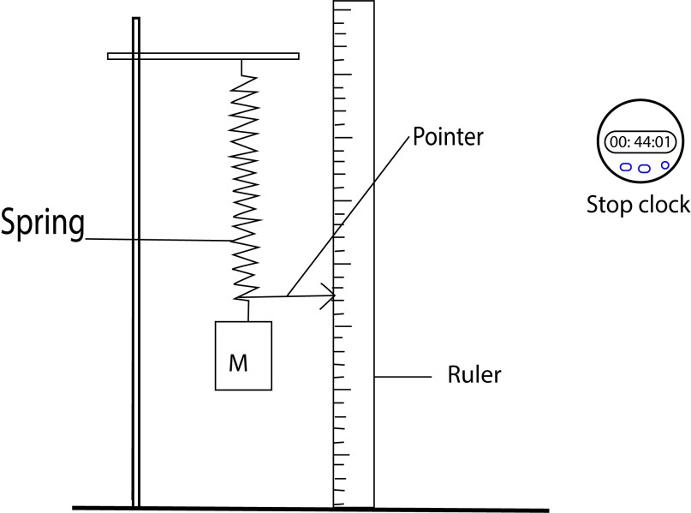
  - A mass M is loaded the spring and extension x is recorded.
  - The mass is given a slight displacement, time for twenty oscillations, t, is noted.
  - Period of the oscillation, T, and T² are calculated.
  - The procedures a. to d. for several masses are repeated.
  - A graph of T² against x is plotted as a slope of the graph, s, is calculated.
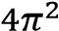
  - The slope, s = , g =
- (i) ω = 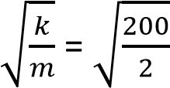 = 10rads⁻¹

- v_{max} = ωr but r =4.0cm = 4 x 10⁻² m
v_{max} = 10 x4 x 10⁻² = -1
0.4ms
- Since a = - ω²x x = 2cm = 2 x 10⁻²m
a = - 10² x 2 x 10⁻² -2
a = 2ms

Example 4
(a)(i) What is meant by a simple harmonic motion?
(ii) Distinguish between damped and forced oscillation.
- A cylinder of length, l, cross section area A and density, ς, floats in a liquid of density, .
The cylinder is pushed down slightly and released.
  - Show that it performs simple harmonic motion
  - Derive the expression for the period of oscillation
- A spring of force constant 40Nm⁻² is suspended vertically, A mass 0.1kg suspended from from the spring is pulled downward a distance of 5mm and released. Find the
  - Period of oscillation
  - Maximum acceleration of the mass
  - Net force acting on the mass when it is 2mm below the center of oscillation.
Solution
(a)(i) It a special type of periodic motion in which the acceleration of the body along the path of the body is directed towards a fixed point in the line of motion and is proportional to the displacement of the body from a fixed point.
(ii) Damped oscillation are oscillation in which the amplitude of oscillation decreases due to the presence of dissipative forces like friction.

Forced oscillation is those where external force only is required to keep the system in perpetual oscillation.

(c) (i)
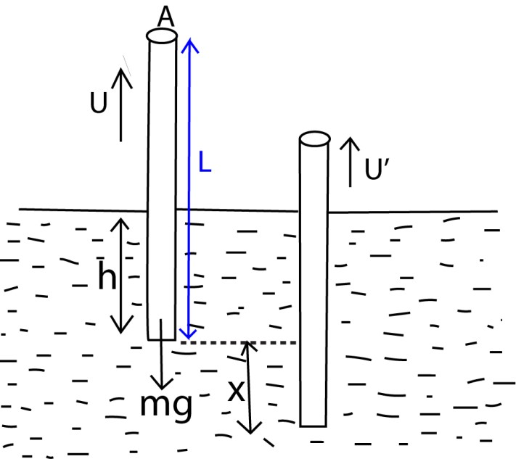 At equilibrium position, the body sinks to a
height, h, below the liquid surface
Up thrust = weight of the body
But U = Ahρg
mg = Ahρg ……………………………………..(i)
A is the cross section area of a cylinder
When a body is displaced through a distance, x, and released,
Up thrust = (h + x) Aρg

Resultant force = mg - (h + x) Aρg

But, m = Ahς
ALςa = ALρg – Ahρg – Aρgx a = 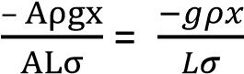
But a = - ω²x
ω = thus S.H.M is executed
√

(ii) T = 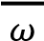
T = 2π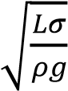

(c) (i) the acceleration of the spring –mass system is given by a = -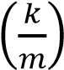x From a = - ω²x ω = 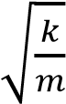
But T = 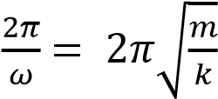
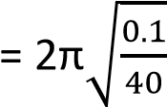= 0.314s
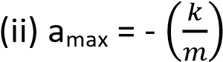r where, r= is the amplitude of oscillation
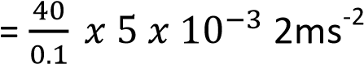
(iii) F = ma but a = - ω²x F = mω²x
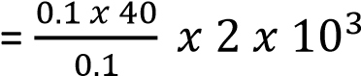
= 0.08N

Example 5
- What is meant by simple harmonic motion?
- A cylindrical vessel of cross section, a, contains air of volume, V, at pressure P, trapped by frictionless air tight position of mass, M, the position is pushed down and released.
  - If the position oscillates with simple harmonic motion, show that the frequency is given by
F =

√

  - Show that the expression in (b)(i) is dimensionally correct.
- A particle executing simple harmonic motion vibrated in a straight line. Given that the speed of the particle is 4ms⁻¹ and 2ms⁻¹ when the particle is at 3cm and 6cm respectively from equilibrium, calculate
  - Amplitude of oscillation (ii) Frequency of the particle.
- Give two examples of oscillating motion which approximate to simple harmonic motion and state the assumptions made in each case.

Solution
(a) It a special type of periodic motion in which the acceleration of the body along the path of the body is directed towards a fixed point in the line of motion and is proportional to the displacement of the body from a fixed point. (b)
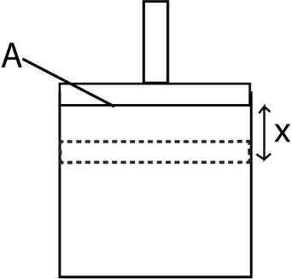

At equilibrium, force = PA
PA = Mg …………………………….. (i)
Suppose it is pushed through a small distance x and pressure changes to P’

Restoring force, F= P’A – Mg ……………………… (ii)

Using Eqn. (i) and Eqn. (ii)

Hence Ma = (P’A –PA) …………………………… (iii)
From Boyles’ Law, P₁V₁ = P₂V₂
P’(V –Ax) =PV
P’ = 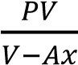
Putting Eqn. (ii) into (i)
Ma = -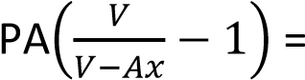-PA x 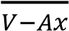
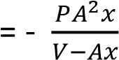
But for very small displacement, Ax = 0
- Ma = -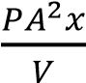
- a = -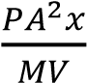 but a = - ω²x
ω =
√

=
A
√

Frequency, F = 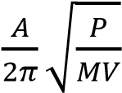 (ii) LHS = T⁻
1

=

T
=
-
1
RHS =
Since LHS = RHS, the expression is dimensionally consistent.
(c)(i) from v² = ω²(r²-x²)
4² = ω² (r² – 0.03²)
16 = ω² (r² – 0.0009) …………………………….. (i)
Also 4 = ω² (r² – 0.06²)
= ω² (r² – 0.0036) ……………………………... (ii) Eqn. (i) Eqn. (ii)
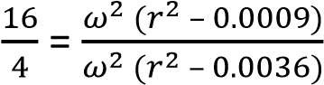
r = 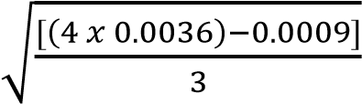 = 6.7 x 10⁻²m
Amplitude of oscillation = 6.7 x 10⁻²m (ii) Putting r = 6.7 x 10-2m into (ii)
ω = 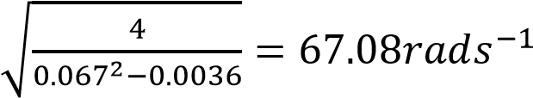
But ω = 2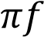 f = 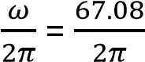 =10.676Hz
(d) (i) The oscillation of a simple pendulum when the angle of displacement is very small and air resistance is negligible.
(ii) The mass oscillating at the end of spiral spring when the displacement from equilibrium solution is very small and dissipative force is negligible.

Example 6
(a)(i) Define simple harmonic motion.
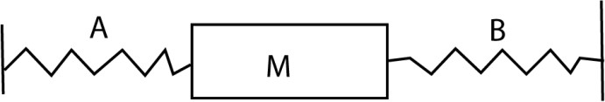
(ii) A particle of mass m executes simple harmonic between two points A and B about equilibrium position O. Sketch a graph of the restoring force acting on a particle as a function of distance, r, moved by the particle. (b)

Two springs A and B of spring constant K_{a} and K_{b} respectively are connected to a mass as shown in the figure above. The surface of which the masses slide is frictionless.
- Show that the mass is displaced slightly. It oscillates with simple harmonic motion of frequency, f, given by f =

√

- If the two springs are identical such that that Ka = Kb = 5.0Nm⁻¹ and mass, m = 5.0g. Calculate the period of the oscillation.

Solution
(a) (i) It a special type of periodic motion in which the acceleration of the body along the path of the body is directed towards a fixed point in the line of motion and is proportional to the displacement of the body from a fixed point.
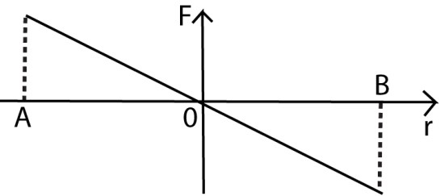
(ii)

(b)(i) Suppose the body is displaced through a small distance x towards B
Resultant force, F = K_{a}x + K_{b}x ma = K_{a}x + K_{b}x a = -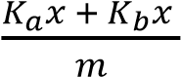 From a = - ω²x
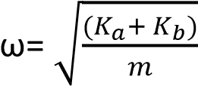
since ω = 2

, f =

=

√

(ii) T = 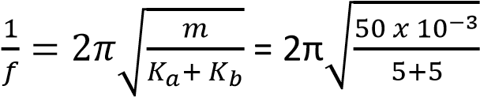 = 0.444s

Example 7
- Define simple harmonic motion.
- Sketch a graph of
  - Velocity against displacement
  - Acceleration against displacement for a body executing S. H.M.
- A glass U- tube containing a liquid is titled slightly and then released (i) Show that the liquid oscillated with S.H.M.
(ii) Explain why oscillations ultimately come to rest.

Solution
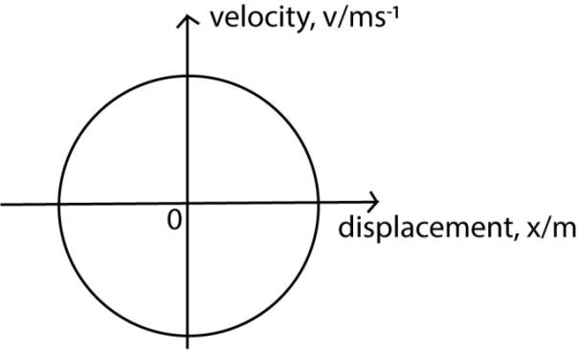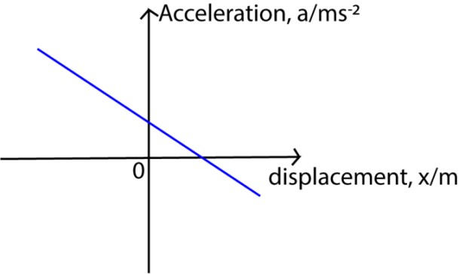
(
b)(i) From v = ±
√

(
ii)

(c)

A liquid of density ρ contained in a U-tube of cross section area A and column L, if the liquid is displaced slightly through a distance x from equilibrium position

The restoring force of the liquid = 2xAρg

Using Newton’s 2nd law, ma = - 2xAρg
a = -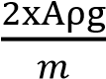 but, m = ALρ
a = -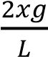
Comparing a = - ω²x ω = , thus it executes S.H.M
√

(ii) the oscillation eventually come to rest because energy is lost due to dissipative forces.

Example 8
(a)(i) What is meant by simple harmonic motion?
(ii) Show with a suitable sketch graph how the kinetic energy of a mass attached to end of oscillating mass changes with distance from the equilibrium position.
(b) A mass of 1kg hangs from two springs S1 and S2 are connected in series as shown below. The force constant of the springs are 100N/m and 200N/m respectively.
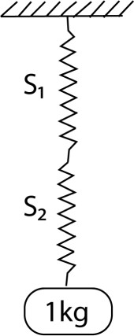

Find (i) the extension produced in the combination
(ii) the frequency of oscillation of the ass if it is pulled down a small distance and released.
(c) Explain with the aid of a sketch graph what would happen to the oscillations in (b)(ii) as the mass was immersed in a liquid such as water.

Solution
(a) (i) It a special type of periodic motion in which the acceleration of the body along the path of the body is directed towards a fixed point in the line of motion and is proportional
to the displacement of the body from a fixed point.
(ii) K.E = 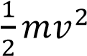
But v² = ω²(r²-x²)
K.E = 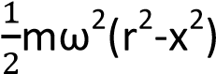

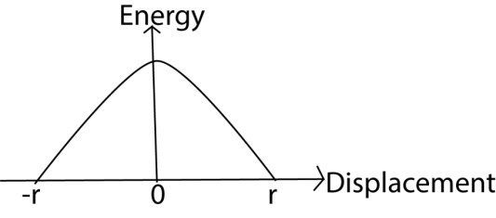
(b)(i) Considering spring S1 From Hooke’s law mg = k₁x₁ 1 x 9.81 = 100x₁ x₁ = 9.81 x 10⁻²m Similarly for spring S2
mg = k₁x₁ 1 x 9.81 = 200x₁
x₁ = 4.905 x 10⁻²m

Total extension = x₁ + x₂ = (9.81 + 4.905) x 10⁻²m = 1.4715 x 10⁻¹m
(ii) T = 2π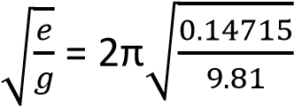 = 0.77s
f = 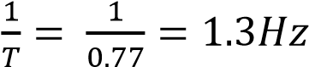
(b) If the mass is immersed in water, the amplitude decreases until the oscillations die away due to loss of energy arising from friction.

Example 9
- A mass of 0.1kg is suspended from a light spring of force constant 24.5Nm-1. Calculate the potential energy of the mass.
- (i) State four characteristics of simple harmonic motion.
    - Show that the speed of a body moving with simple harmonic motion of angular velocity, ω is given by v = ±ω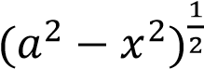 where, a, is the amplitude, and x, is the displacement from equilibrium position.
    - Sketch graphs to show the variation with displacement of kinetic and potential energies if a body moving with simple harmonic motion.
- A mass of 0.1kg suspended from a spring of force constant 24.5Nm⁻¹ is pulled vertically downwards through a distance of 5.0cm and released. Find the
    - Period of oscillation
    - Position of the mass 0.3 seconds after release.

Solution
Elastic potential energy
P.E = 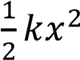 …………………….. (i)
mg = kx x = 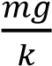
Elastic potential energy = 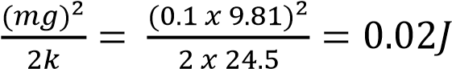

(b)(i) The acceleration is directed towards a fixed point in a motion line
The acceleration is directly proportional to the displacement from a fixed point
It is periodic
Total mechanical energy is preserved.
(ii) a = 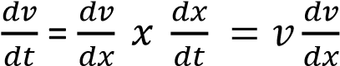

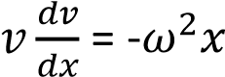

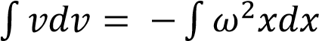

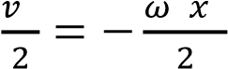+ C

At x = A (amplitude), v = 0

C = 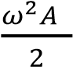

⇨ 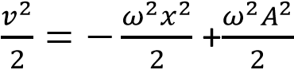

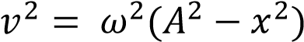

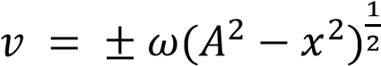

(iii)

(
c)(i) From T =

√

T = 2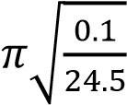 =0.401s

(ii) x = Asin(ωt + θ)
At t = 0
- 5 x 10⁻² = 5 x 10⁻² sin θ θ = sin⁻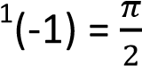 radians
At t = 0.3s
x = 5x 10⁻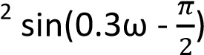
But ω = 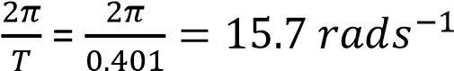
x = 5 x 10⁻²sin (0.3 x 15.7 -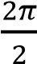) = 1.19 x 10⁻⁴m

Example 10
- Defined simple harmonic motion.
- Sketch the following graphs for a body performing simple harmonic motion
  - Velocity against displacement
  - Displacement against time
- The period of oscillation of a conical pendulum is 2.0s. if the string makes an angle 60⁰ to the vertical at the point of suspension, calculate the
  - Vertical length at the point of suspension above the circle.
  - Length of the string
  - Velocity of the mass attached to the string
- (i) Give an example of oscillating motion
(ii) What approximation is made in (b)(i)

Solution
(b)(i)
(ii)

(d)(i) simple pendulum
Liquid oscillating in a U-tube
Mass oscillating at the end of helical spring (ii) the effect of dissipative force is negligible.

TOPIC 3/6: GRAVITATION
Competency: The learner evaluates the effects of gravitation and its applications on objects both on earth and in space.

Kepler’s Law of Planetary Motion

- Planets revolve in elliptical orbits having the sun at one focus

- Each planet revolve in such a way that the imaginary line joining it to the sun sweeps out equal areas in equal times
- The squares of the periods of revolution of the planets are proportional to the cubes of their mean distances from the sun

Newton’s law of gravitation
The force of attraction between two bodies is directly proportional to the product of their masses and inversely proportional to the squares of their distance apart.

Consider two bodies of mass M and m with a distance r apart
Force, F 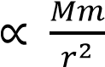

- = 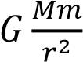
Where, G, is the universal gravitational constant.
- = 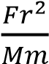 Nm²kg⁻¹ or M³kg⁻¹s⁻²

Numerical value of G = 6.67 x 10⁻¹¹Nm²kg⁻²

Proof of Kepler’s 3rd law
Consider a planet of mass m moves with speed v in a circle of radius r round the sun of
mass M.
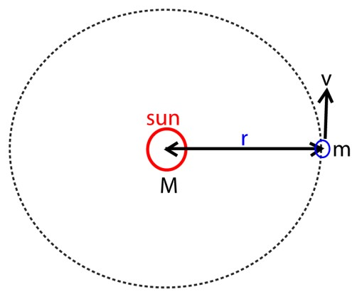

Gravitational attraction of the sun for the planet, F 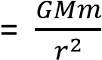 ……. (i)

The centripetal force keeping the planet in orbit, F = 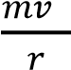 …….. (ii)
Equation (i) and (ii)

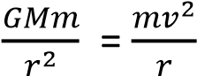
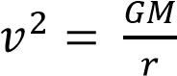 ………………………………………………….. (iii)

But period of revolution, T = 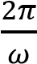
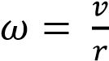
T = 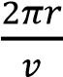
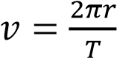 ………………………… (iv)
Equation (iii) and (iv)
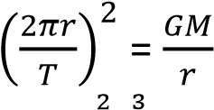
T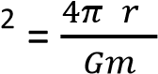
Since G, m, π are constant, then, T² r³ which verifies Kepler’s 3rd law

Mass and density of the earth
For a body of mass, m, on the earth’s surface, the force of gravity acting on it is given by F = mg

The earth of mass M and radius r is assumed to be spherical and uniform and thus its mass concentrated at its center. The force of attraction on the earth on the body is given by
F = 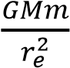
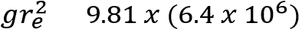
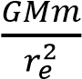= mg
M = 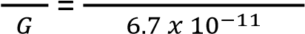 since r_{e} = 6400km or 6.4 x 10⁶m
= 6 x 10²⁴kg
Density
Since the earth is spherical
Density = 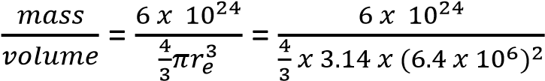 = 5500kgm³

Mass of the sun
Consider the earth of mass m revolving round the sun of Mass, M at a distance r from the sun Centripetal force on the earth
F = 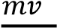
v = ωr F = mω²r but ω =
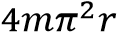
F = …………………………. (i)

Force of attraction between the earth and the sun is
F = 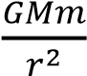 …………………………. (ii)
Equation (i) and (ii)
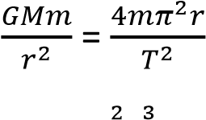
M = 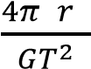
T = 1year = 365 x 60 x 60 = 31, 536, 000s, G = 6.67 x 10⁻¹¹Nm²kg, r = 150 x 10⁶km= 1.5 x 10¹¹m
M = 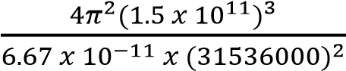 = 2 x 10³⁰kg
Assumptions
- The sun is stationary
- The earth is spherical

Example 1
State the effect of frictional forces on the motion of an earth satellite against distance from the earth’s center.
Solution
The mechanical energy of a satellite decreases, potential energy decrease, kinetic energy increases. The velocity of the satellite increase while the the radius of the orbit decrease and satellite may burn if no precaution are taken.
A graph showing the variation of energy of a satellite against distance from the earth’s center.
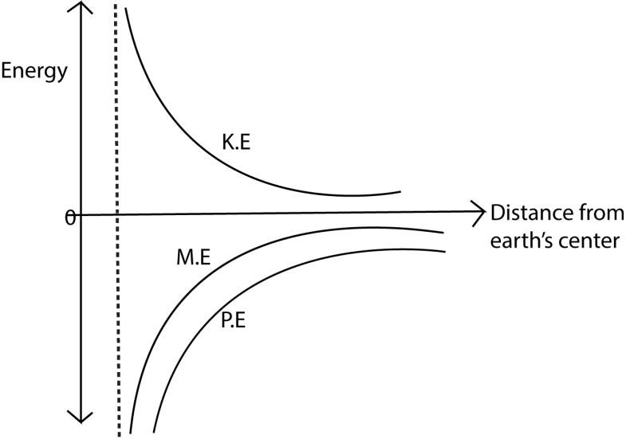

Escape velocity
This is the vertical velocity that should be given to a body at the surface of a planet so that it just escapes from gravitational attraction of the planet.
Derivation
Consider a body or a rocket of mass, m, fired from the earth’s surface such that it escapes from the gravitational influence of the earth. However, it requires a certain velocity to escape.
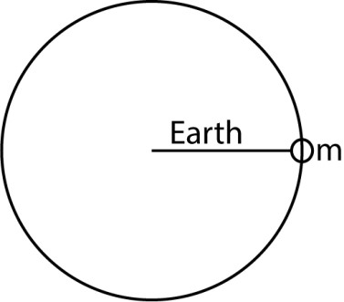
At the surface
K.E = 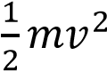
P.E = -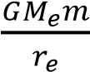
When the rocket escapes is at infinity, Me = 0
By conservational of momentum
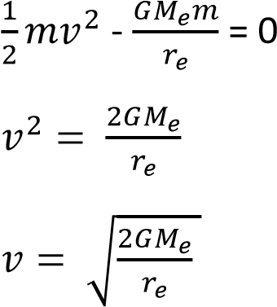
This shows that the escape velocity is independent of the mass of the body.

Example 2
Explain why the moon has no atmospheres yet the sun has
Solution
This is because the gravitational attraction at the moon is too weak to hold the gases due to its small mass and as a results, the gases escape leaving the moon without atmospheres.
Variation of acceleration due to gravity, g, with latitude
The acceleration due to gravity, g, varies over the earth because the earth is elliptical, with the polar radius, b = 6.357 x 10⁶m and the equatorial radius, a = 6.378 x 10⁷m, hence as one moves from the equator to the poles the distance of the point on the surface of the earth from the centre of the earth decreases. Hence the acceleration due to gravity or attraction of the body towards the center increases. (note that force of attraction due to gravity at a place inversely proportional to the distance of the point from the center of the earth squared)
The latitude of a point is the angle θ between the equatorial plane and the line joining that point to the center of the earth. Latitude of the equator is 0⁰ and that of the pole is 90⁰.
Consider a body of mass, m, at point P with latitude θ as shown on the surface of the earth and g_{θ} be the acceleration due to gravity at P.
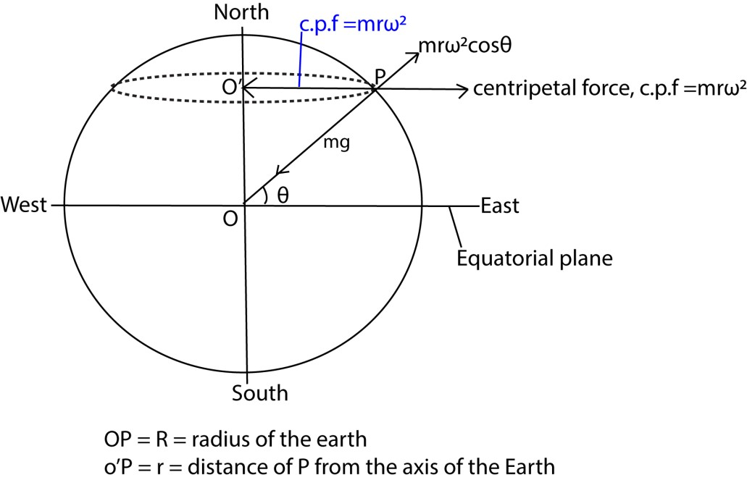
Due to rotation motions of the earth about its axis P experiences a centripetal force given by mrω²
Resolving the centripetal force into two rectangular component, its component along the radius of the earth = mrω²cosθ
Also, the body is acted on by two forces; its weight acting towards the center of the earth and the component, mrω²cosθ acting radially outwards.
The difference in between the the two forces is the weight of the body at that point at that point
mg_{θ} = mg - mrω²cosθ ………………….. (i)
But cosθ 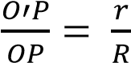
 ………………………….. (ii)
Substituting equation (ii) in (i)
mg_{θ} = mg – m(Rcosθ)ω²cosθ g_{θ} = g – Rω2cos²θ
This is the expression for acceleration due to gravity at point P on the earth’s surface having latitude θ.
At equator θ = 0⁰, hence g_{θ} is minimum. At the pole θ = 90⁰, hence, g_{θ} is maximum.
Example 3
What is the weight of a body of mass 1000kg on the earth at
- Equator
- Pole
- Latitude of 300 (Radius of the earth, R = 6400km, acceleration due to gravity, g =
9.81ms⁻²)
Solution
Period of the earth, T = 24 x 60 x 60s
Angular velocity of earth, ω =
The weight of a body W_{θ} = latitude θis given by
W_{θ} = m(g – Rω2cos²θ)
- At the equator θ =0⁰
W₀ = 1000[9.81 – 6.4 x 10⁶(7. 273 x10⁻⁵)²cos²0]
=9776.15N
- At the pole θ = 90₀
W₀ = 1000[9.81 – 6.4 x 10⁶(7. 273 x10⁻⁵)²cos²90] =9810N
- At the latitude where θ = 30₀
W₀ = 1000[9.81 – 6.4 x 10⁶(7. 273 x10⁻⁵)²cos²30]
=9784.61N

Variation of acceleration to gravity due to depth
From mg =

g = …………. (i) where M is the mass of the earth.
But M = volume x density, ρ, of the earth’s material
M = 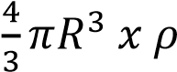 ……… (ii)
Substituting (ii) in (i)
g = 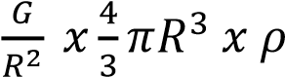
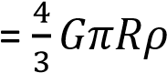 ……….. (iii)
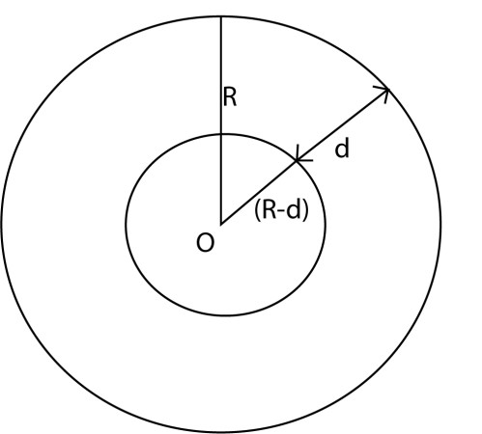
When the body is a distance, d, below the earth’s surface, the acceleration due to gravity, g_{d} is given by
g_{d} 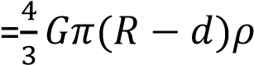 ……………..(iv)
Dividing equation (iv) by (iii)
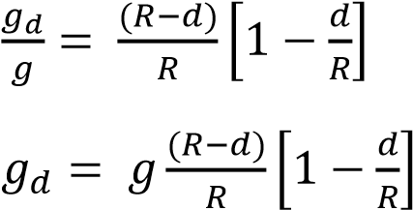
The expression shows that acceleration due to gravity reduces as depth, d, increases toward the earth’s center. At the center d = R, hence acceleration due to gravity = 0. Variation of acceleration due to gravity with altitude
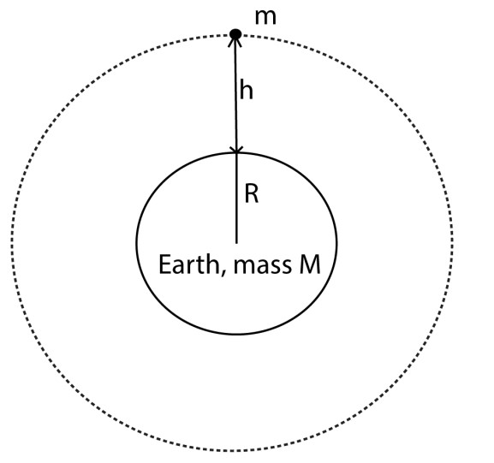
We have
GM = R²g………………. (i)
Gm = (R +h)²g_{h} ……………(ii)
From (i) and (ii)
R²g =(R +h)²g_{h}
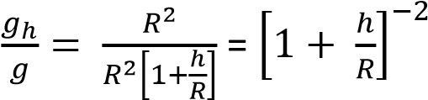
Expanding binomially and neglecting terms of higher powers of we get
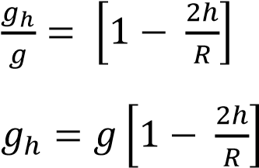
The expression shows that acceleration due to gravity decreases as h increases.
A graph of variation of acceleration due to gravity against the distance from earth’s center
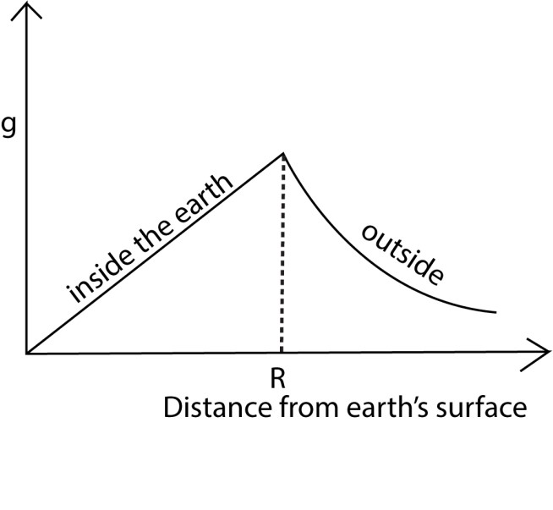

Example 3
At what height will a man’s weight become half his weight on the surface of the earth? Take the radius of the earth as R.
Solution
From 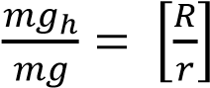
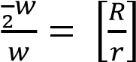
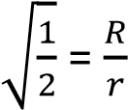
r = R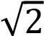 but r = (R + h)

R + h = R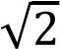 = 1.414R
H = 0.414R
Determining gravitational constant
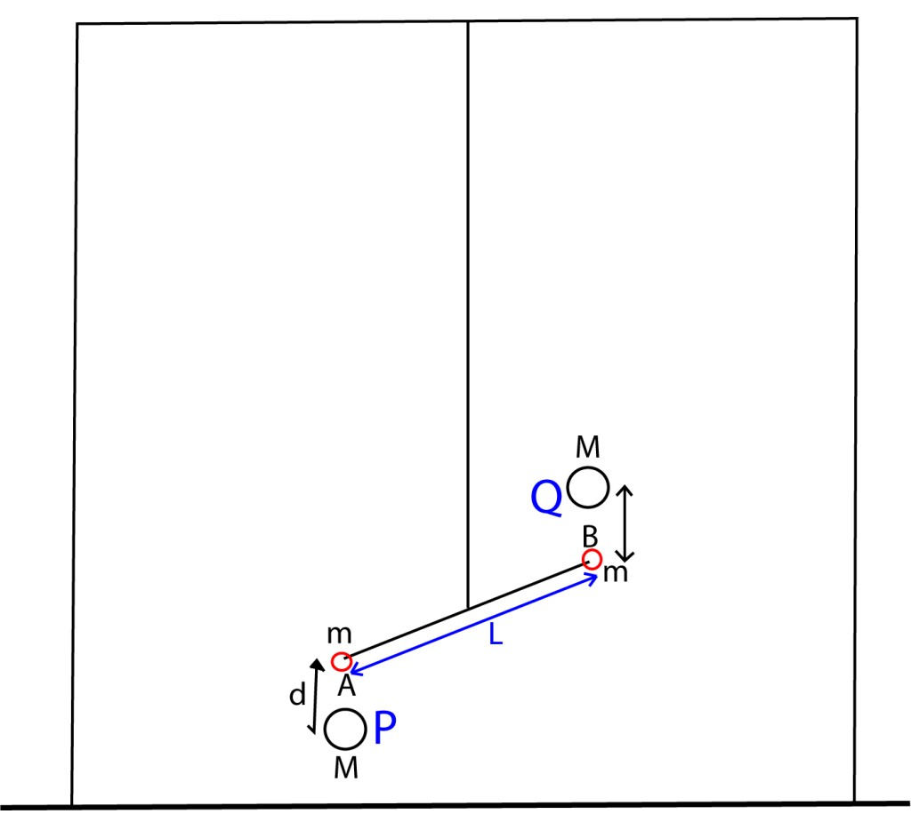
- Two equal lead spheres A and B each of mass, m, are attached to end of a bar AB of length, L.
- The bar AB is suspended from a ceiling.
- Large spheres P and Q are brought towards A and B respectively from the opposite side
- Large spheres P and Q altered small spheres A and B respectively by equal and opposite gravitational forces give rise to gravitational torque, F, which in turn twist the suspended through angle θ.
- A resting torque of the wire opposes the twisting of the wire from equilibrium position
Then
- = Cθ =

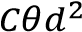
- =
Where
d = distance between the center of A and P or B and Q. C = The twisting couple per unit twist (θ = 1)

Artificial satellite
It is a huge body that moves around a planet is an orbit due to the force of gravitation attraction. Satellite can be launched from the earth’s surface to circle the earth. The are kept in their orbit the gravitational attraction of the earth.
Consider a satellite of mass, m, moving around the earth of mass M in an orbit of radius, r.
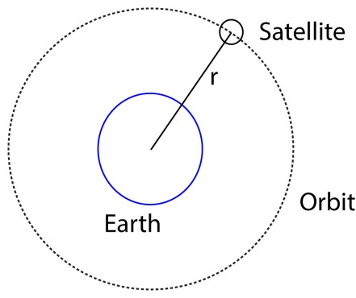
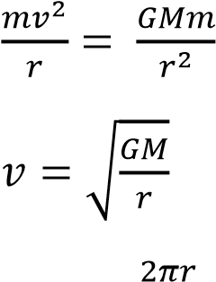
But T =
T = 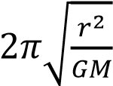

Parking orbital
A parking orbit is a path in space of a satellite which makes it appear to be in the same position relative to the observer at a point on the earth.

An object in a parking orbit has a period equal to the period of the earth’s rotation about its axis. The direction of motion of the object in a parking orbit is in the same sense as the rotation of the earth about its axis.

The angular velocity of an object in its orbit is equal to that of the earth as it rotates about its axis. An object in a parking orbit is directly above the equator

Uses of parking orbits
Used in telecommunication

Disadvantage of parking orbits
Many geostationary satellites are required for efficient broad casting which makes very expensive.

Communication can only occur provided there is no obstruction between the transmitter and the receiver.

Gravitational Potential energy
This is the work done in moving a body of mass m from infinity to a point in the earth’s gravitational field.

F = 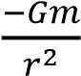
∆w = F∆r
Total work done in moving a mass m from infinity to a point from earth of mass, M is given by
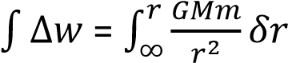
= GMm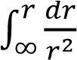
= GMm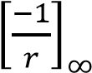 w = 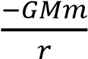
Gravitational potential energy on the earth’s surface, w = 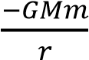

Kinetic energy
Consider a body of mass, m, moving around the earth of mass, M, with velocity v.
K.E of the body = 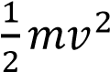
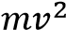
Centripetal force =
But gravitational force of attraction = 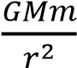
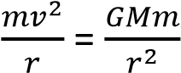
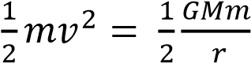

K.E = 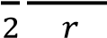

Total mechanical energy = K.E + P.E
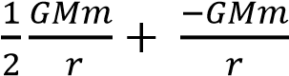

M.E = 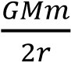

NB. For this reason, the moon is very cold. The sum has atmosphere because of the stronger gravitational attraction caused by its mass and a much higher escape velocity

Weightlessness
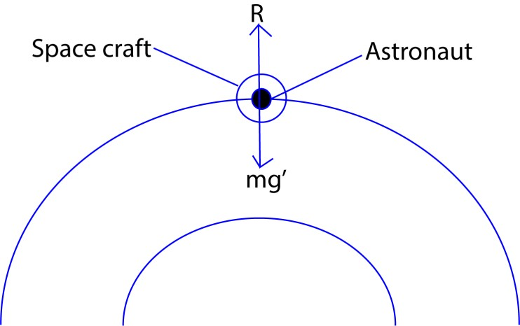

Let g’ = acceleration due to gravity at a certain height
R = reaction of the space craft in contact with astronaut.
Consider a body moving in a space craft at a particular height of the orbit.
R = mg’ ma = mg’-R
If g’ = a

mg’ = ma
R = 0

Therefore the body becomes weightless

Example 4
A body of mass 15kg is moved from the earth’s surface to a point 1.8 x 10⁶m above the earth. if the radius of the earth is 6.4 x 10⁶ and the mass of 6.0 x 10²⁴kg, calculate the work done in taking the body to that point.

Solution
Work done = 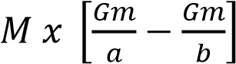
- = 6.4 x 106m
- = 6.4 x 10⁶ + 1.8 x 10⁶ = 9.2 x 10⁶m

Work done = 15 x 6.67 x 10⁻¹¹x 6.0 x 10 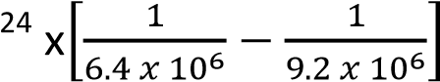= 2.85 x 10⁸J

Example 5
- With the aid of a diagram, describe an experiment to determine universal constant, G.
- If the moon moves around the earth in a circular orbit of radius = 4.0 x 108m and takes exactly 27.3days to go round once. Calculate the value of acceleration due to gravity g at the earth’s surface.

Solution
- From 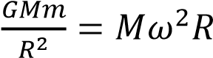

But Gm = gr_{e}² and ω =
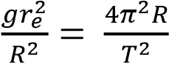

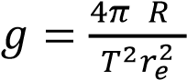
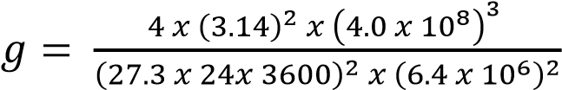
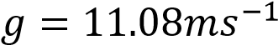

Example 6
- Show how to estimate the mass of the sun if the period and orbital radius of one of its planet are known. The gravitational potential u1 at the surface of a planet of mass M and radius R is given by 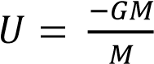 where G is the gravitational constant.

Derive an expression for the lowest velocity, v1, which an object of mass, M, must have of the planet if it is to escape from the planet.

- Communication satellites orbit, the earth in synchronous orbits. Calculate the height of communication satellite above the earth.

Solution

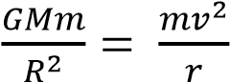

Since v = ωr = 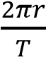
⇨ GM = 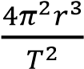
r = But GM = g
√

r =
√

=

√

= 4.24 x 10⁷m h = r – re = 4.24 x 10⁷ – 6.4 x 10⁶ m
= 3.6 x 10⁷m

TOPIC 4/6: PROGRESSIVE WAVES
Competency: The learner investigates the propagation of progressive waves in matter and its application in different situations.

WAVES

Definition
A wave is any disturbance from an equilibrium condition that travels with time from one region to another in form of oscillation. Or
A wave is a means of transfer of energy by a vibrating medium.
Classes of Waves
Waves can also be classified as mechanical waves and electromagnetic waves.

Mechanical waves
These are wave which require a material medium for transmission. Mechanical waves include: Sound waves, water waves, waves on strings etc.

Electromagnetic waves
These are wave which do not require a material medium for transmission. Electromagnetic waves include: light waves, radio waves, X-ray, ultraviolet etc.

Differences between mechanical and electromagnetic waves
Mechanical Waves

Electromagnetic waves

Need a medium for transmission.

Do not need a medium for transmission.

Cannot travel through vacuum.

Can
travel through a vacuum.

Relatively slow

Very fast

Types of waves
There are two kinds of waves namely:
- Longitudinal waves.
- Transverse waves.

Longitudinal waves
A longitudinal wave is one in which the direction of the wave motion in the same direction as the vibration. OR
A longitudinal wave is one in which particles vibrate in direction parallel to wave motion.

Examples of longitudinal waves are sound waves, waves produced by pipes and string instruments. A longitudinal wave has two regions namely: compression and rare faction regions.
Diagram showing motion of particles for longitudinal wave.



C is compression region, R is rare faction region.

Compression region
Compression region is a region in the longitudinal wave where the vibrating particles are very close together. A particle at the centre of compression region moves from the rest position in same direction as the wave.

Rare-faction region
Rare-faction region is a region in the longitudinal wave where the vibrating particles are further apart. A particle at the centre of rare-faction moves from rest position in the opposite direction to that of the wave.

Differences between compression and rare faction regions of longitudinal wave.

Compression Rare-faction
Vibrating particles are very close together. Vibrating particles are further apart.
A particle at the centre moves from rest A particle al the centre moves from rest
position in a direction the same as that of the position in opposite direction to that of the wave motion. wave motion.

Transverse waves
Transverse wave is one in which particles vibrate perpendicular to the direction of wave motion.
Example: Water waves, light waves, all electromagnet waves.

A transverse wave has two main regions namely: Crest and Trough.
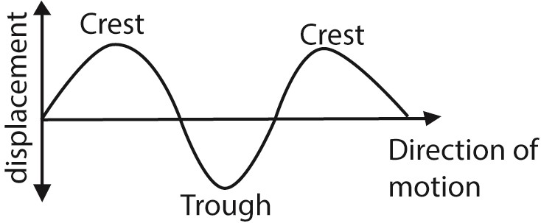

Crest is a region of maximum upward displacement of particles in a transverse wave.
Trough is a region of maximum downward displacement of particles in a transverse wave.

Differences between a transverse wave and longitudinal wave
Transverse | Longitudinal wave
Particles vibrate perpendicular to the direction of the wave motion | Particles vibrate in a direction parallel to wave motion
Has 2 regions crest and trough | It has 2 regions, compression region and rare faction
No variation in particle density occurs along the profile | Particle density varies along the wave profile
The distance between successive crests or troughs is the wavelength | Distance between successive rarefactions or compression is the wave length.
Can undergo polarization | Cannot be polarized.

General presentation of a wave
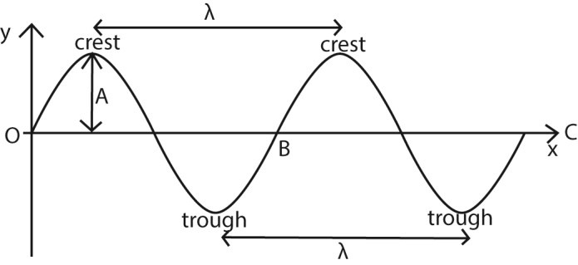
A wave can be represented graphically by a sine wave. The curve is drawn by plotting displacement of particles, y against distance of the particle from the source of the wave, x.

Definition of terms
- OC is the equilibrium/resting/mean position.
- Displacement is a distance of any particle at any point of the wave from equilibrium position.
- Amplitude (A) is a maximum displacement of a particle from its rest position on a wave.
- Crest is the point on the wave profile with maximum positive displacement.
- Trough is the point on the wave profile with maximum negative displacement.
- Cycle or oscillation: This is a complete to and fro motion of a wave. It is equivalent to moving from O to B along the wave profile.
- Wavelength, λ. This is the distance between two successive particles in a wave profile which are in phase. Particles are said to be in phase if they are at the same stage of their motion; i.e. have the same displacement from the equilibrium position and are travelling in the same direction.

As applied to a transverse waves, wavelength is the distance between two successive troughs or crests.

Applied to longitudinal waves, wavelength is the distance between two successive compressions or between two successive rarefactions.

The SI unit of wavelength is meters.

- Period, T. This is the time taken by a wave to perform one complete cycle or oscillation. It can also be defined as the time taken by a wave to cover a distance of 1 wavelength. S.I. unit of period is Hertz (Hz) or per second.

- Ray is a line perpendicular to wave front which shows the direction of travel of a wave. (j) Phase is a fraction of a cycle which has elapsed after a particle passing a fixed point
(k) Wave front, any line of section taken through an advancing wave in which all particles are in phase or it is an imaginary line which joins the set of particles that are in phase.

Particles are in phase if they are in the same point in path at the same time and are moving in the same direction.

Relationship between T and f
Consider a wave motion in which n cycle is made in time t seconds. One oscillation will be made in seconds.
- T =
Also in 1 second, oscillations are made.
- f =
But 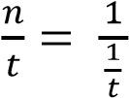
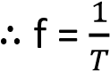

Velocity of a wave
The velocity of a wave is the speed with which the wave propagates. It can also be defined as the rate of wave travel in meters per second (ms⁻¹)

Relationship between v, f and λ
Consider a source of wave that produces waves of frequency, f and wavelength, λ. whenever the source makes one oscillation, the wave travels forward by one wavelength.

If f oscillations are made per second, the wave travels forward by a distance given by Distance = fλ
But the distance moved per second = v v = fλ

Wave motion and oscillation motion
Wave motion is a form of oscillation motion.
Oscillation motion is motion where a body or particle move to and fro in the same path.
If the oscillatory motion repeats itself at regular time intervals, then it is periodic motion. If the periodic motion can be represented by sine curve, if is said to be harmonic motion.

An oscillation is defined as a complete to and fro displacement of a particle from equilibrium position. Oscillation may be mechanical or electrical oscillation.

Mechanical oscillation are those in which energy is passed and stored by vibrating particle.

Electrical oscillation are those in which energy is possessed and stored in electrical and magnetic field.

Types of oscillation

(a) Free oscillation
These are indefinite oscillations that occurs with constant energy and amplitude due to absence of dissipative forces (e.g. friction, air resistance and viscosity).
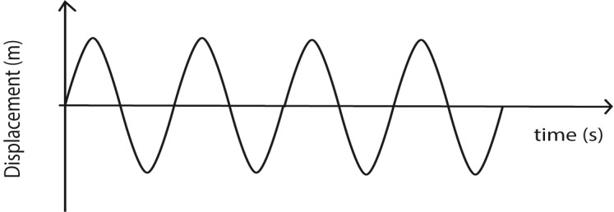

(b) Damped oscillation
These are oscillations that progress with decreasing amplitude and energy due to dissipative forces such that the system loses energy to the surrounding and amplitude of oscillation decreases until the system finally comes to rest. The amplitude of oscillation reduces because the dissipative forces cause the system to progressively lose energy.
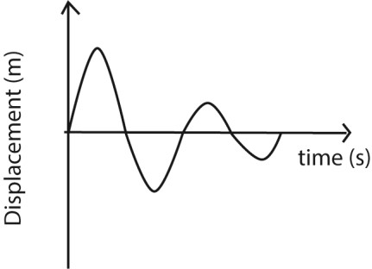

There are three types of damped oscillations

(i) Under damped oscillation
These are oscillations in which the system experiences low resistance/dissipative forces such that it loses energy gradually and amplitude of oscillations decrease gradually until the system finally comes to rest.
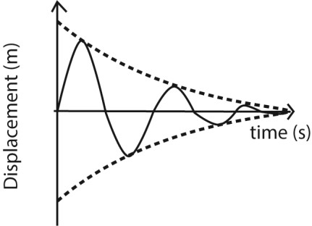

(ii) Critically damped
These are oscillation which occur when a system is displaced but does not oscillate and return to equilibrium position in the minimum possible time. The magnitude of resistive forces is such that they do not allow the system to vibrate past this equilibrium position.
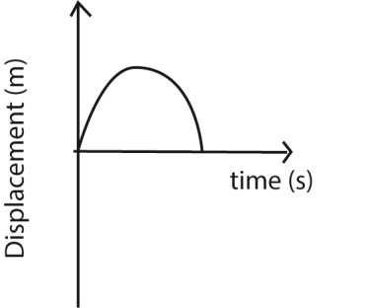
Critical damping is applied in
- Moving coil instruments such as ammeters, voltmeters to bring the pointer to rest instantly so that a reading can be taken.
- Shock absorbers
- Office doors

(iii) Over damped oscillations
These are oscillations which occur when a system is displaced and does not oscillate but returns slowly to the equilibrium position

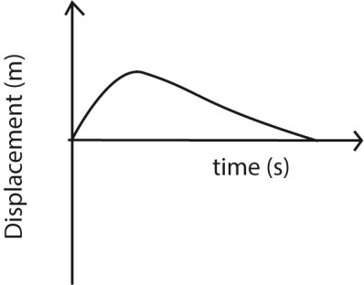

Differences between free and damped oscillations
Free oscillation | Damped oscillations
Amplitude of oscillation remain constant | Amplitude of oscillation decrease with time
Wave energy remain constant | Wave energy decrease with time
Oscillations occur in absence of dissipative force | Oscillations occur in presence of dissipative forces
System oscillates indefinitely | System finally comes to rest

Forced oscillations
These are oscillations in which the system subjected to some degree of damping is made continuously oscillate by subjecting it to external periodic force

The external periodic force restores the energy lost from the system as a result of dissipative forces.

The frequency of external periodic force is known as forcing frequency.

Progressive waves
A progressive wave is one that consists of disturbance moving from source outwards to the surrounding regions of which energy is transferred from one region to another.

In progressive wave, the wave profile moves from a source to the surrounding region at the same speed as the wave motion. The vibrations of the particles are of the same amplitude and frequency, but the phase of vibration changes from one point to another along the wave.

Phase angle
The phase angle is angular displacement between two wave oscillations. It can also be angular displacement between particles at different points in another profile. Phase angle is represented by φ and it is measured in radians.

Phase difference
The phase difference is the difference in the phase angles at any two points along the wave motion. It is also measured in radians

Consider the wave motion below
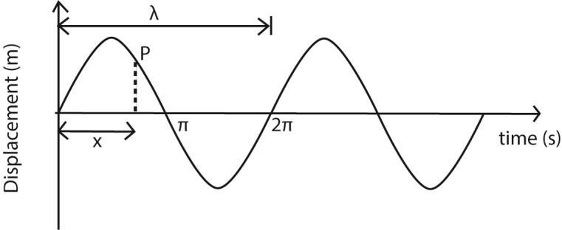

The particle at P is said to lag behind the particle at O by phase difference ∆φ or Xφ determined by the horizontal distance, x of the particle P from particle O and the wavelength of the wave motion.
The phase difference is given by the expression; 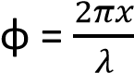
Where x = the difference between the two points on the wave motion λ = the wavelength φ = the phase difference.

Example 1
Find the phase difference between two waves each of wavelength 40cm when one leads the other by a distance of
- 20cm
From 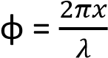
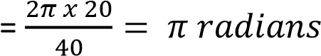
- 30cm
From
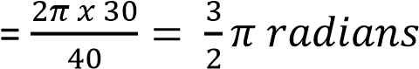

- 40cm

From 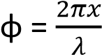
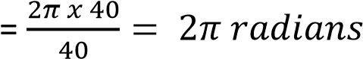

The progressive wave equation
The progressive wave equation is the same as the equation for sine curve, i.e. y = Asinωt where y = displacement
A = amplitude
ω = angular velocity

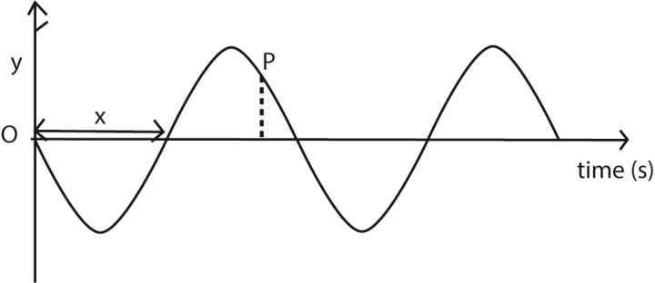

A particle P lags behind the particle O by a phase difference, φ. The displacement of such a particle is given by equation y = Asin(ωt - φ).

This is the equation for a progressive wave moving in the positive x-direction.

For progressive wave moving in opposite direction, the equation is y = Asin(ωt + φ).

But from circular motion, ω = 2πf

Also, φ = 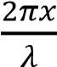

Thus the progressive wave equation for a particle moving in the progressive x-direction can also be written as

y = Asin(2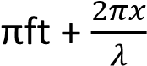)
y = Asin 2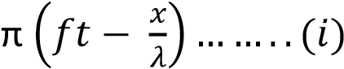
Also from v = f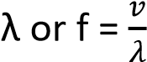

y = asin 2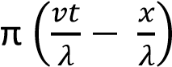 y = asin 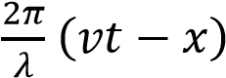

Also f =
Substituting f in equation (i)

y = asin 2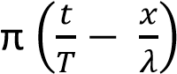

Example 2
The displacement, y, of a wave travelling in the direction at any time, t, is given by the equation y = asin 2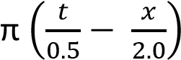
- Deduce the direction in which the wave is travelling. Positive x- direction.
- Determine the speed of the wave
Comparing y = asin 2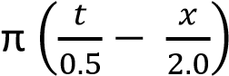 with y = asin 2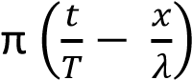
T = 0.5s; λ = 2.0m
From v = fλ but f =
v = 2 x 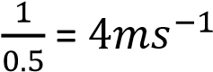

Example 3
A sound wave propagated in the x-direction given by equation y = 2 x 10⁻⁷sin(8000t – 25x)m
Find
(i) amplitude of the wave comparing with y = asin(2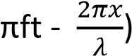
amplitude = 2 x 10⁻⁷m (ii) speed of the wave
2πft = 8000t also 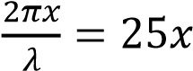
f = 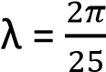
v = fλ
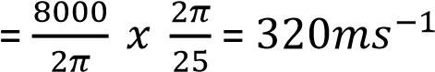

Example 4
A progressive wave and stationary waves each have a frequency of 240Hz and a speed of 8ms^{-1.}
Calculate the
- Phase difference between two vibrating points in the progressive wave which are 6cm apart.
From 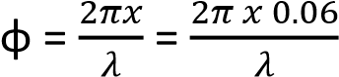
But 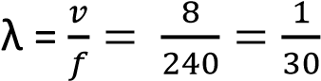
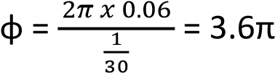 radian
- Distance between successive nodes = 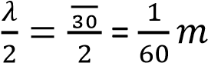

Example 5
A sound wave in x-direction is given by the equation; y = 1 x 10⁻⁷sin (6600t -20x) Determine the amplitude and velocity of a wave.
Compare with y = Asin(2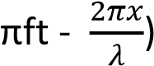

Amplitude = 1 x 10⁻⁷m

2πft = 6600t
f =
Also 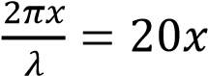
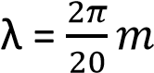
v = f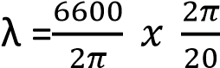 = 330ms⁻¹

Example 6
- Describe how the amplitude of a forced oscillation builds up to constant value. In forced oscillation, an oscillating system is subjected to an external periodic force which supplies energy to system. This energy builds the amplitude to the required level and then restores the energy lost by friction, viscosity and/or air resistance.

- The displacement in meters of a plane progressive wave is given by the equation y = 0.2sin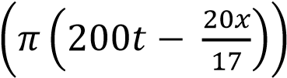. Find the
  - Amplitude
  - Wavelength
  - Speed of the wave

Compare with y = A sin2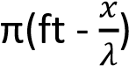
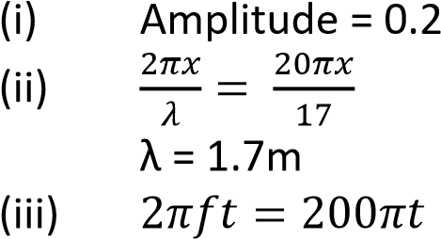
f = 100Hz v = fλ = 1.7 x 100 = 170ms⁻¹

Example 7
The frequency of a wave is 600Hz and is travelling at a speed of 340ms-1. Find the phase difference between two points which are (i) 0.17m apart
Phase difference 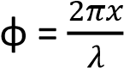
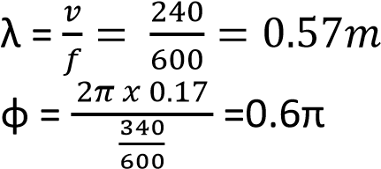
(ii) 1.7m apart
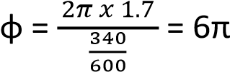
phase difference = 0

Principle of superposition
When two waves travel through a medium, their combined effect at any point can be found by the Principle of Superposition

This states that the resultant displacement at any point is the sum of the separate dis- placements due to the two waves.

The superposition principle is used to explain the formation of stationary waves

Wave front
A wave front is a section through an advancing wave along which all particles are in phase.

Along a wave front every particle transmitting the wave is at the same distance from the source of the wave and is in the same state of disturbance.

Therefore the two major forms of wave front which are circular and plane fronts.

Circular wave fronts
Consist of wave front that are concentric circles with the source wave at the center. Such wave front can be obtained when a surface of still water is disturbed by a round object.

Plane wave front are wave fronts in which the wave are parallel to each other. Such wave fronts can be obtained when the surface of water is disturbed by plane object such as a ruler.

Light is thought to be propagated to the earth as plane wave fronts.

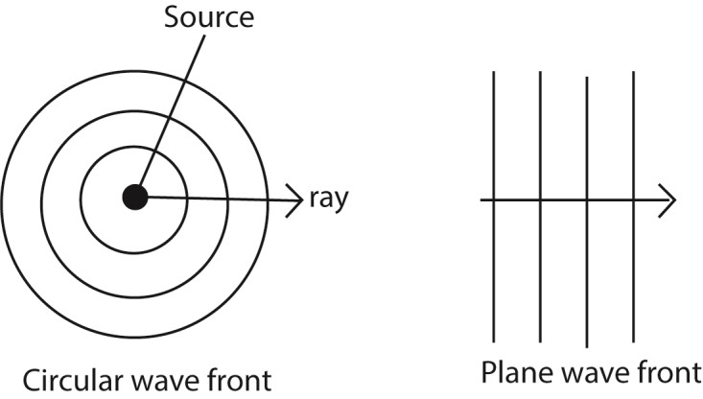

General properties of waves.
All waves can undergo
- Reflection
- Refraction
- Diffraction
- interference

Reflection of waves
This is the bouncing back of waves from an obstacle

Reflection can be shown by standing a straight metal strip as a plane reflector and curved metal strip as concave and convex reflector in water

a) Reflection of straight waves perpendicularly at plane surface
A straight metal strip attached to a vibrator using vibrations generated by electric motor, is placed in water and another straight metal strip is placed in water parallel to the vibrator. Then the electric motor is switched on and the straight waves are incident normally reflected along the same path as plane waves.

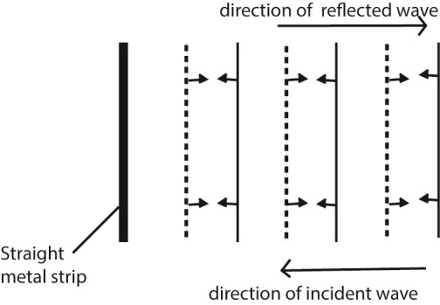

b) Reflection of straight waves at an angle on plane surface
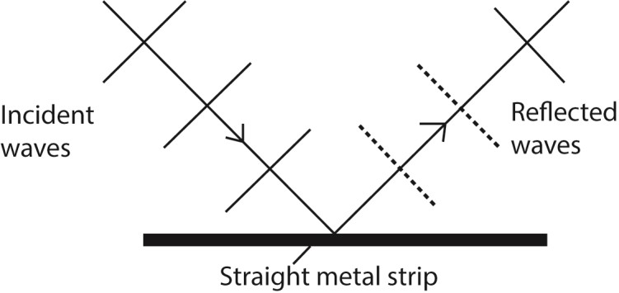

For reflection at plane surface both the incident and reflected waves are straight and have equal spacing because the incident and reflected waves have the same speed and wavelength as the wave is travelling in water of same depth.

Laws of reflection of waves
- The incident wave, reflected wave and the normal at the point of incidence all lie in the same plane.
- The angle of incidence of waves is equal to the angle of reflection of the wave.

c) Reflection of circular waves at a straight plane surface

Circular waves Incident on straight reflector the source "S" corresponds to the object and T corresponds to virtual source of the reflected waves,
The distance SM = MI. "MI" and "SM” are at right angles to the reflector.

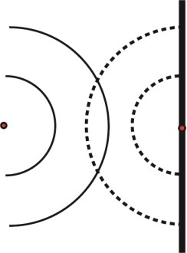

d) Reflection of waves on a convex reflector surface

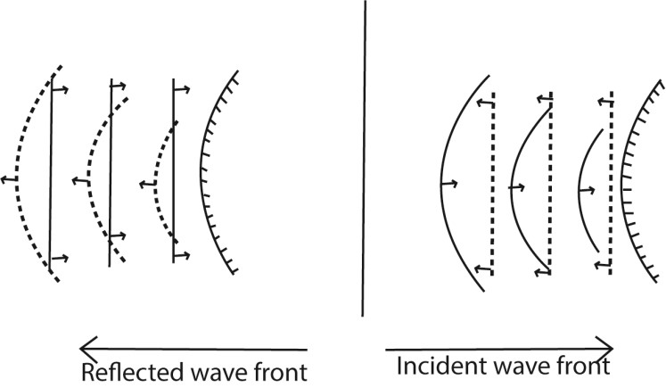

e) Reflection of waves on a concave reflector surface

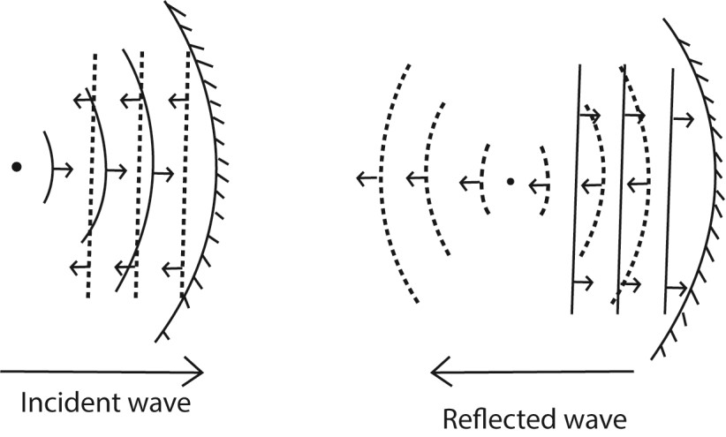
The reflected wave-fronts are circular, converging towards and passing through the principal focus F.

Points to consider when drawing
- The focal point F becomes the centre of the circular waves.
- The circular waves should be equally spaced. The distance of spacing should be the wavelength.
- The spacing for the circular waves should be the same as that for the straight waves.

Refraction of waves
Waves formed in ripple tanks can be refracted by placing a sheet of glass in water to make it shallow. The continuous straight waves in the shallow water are found to be closer to one another than in deep water. This implies that the wavelength of the wave is less in shallow water than in deep water. In short the wavelength of a wave in shallow water is shorter even though the frequency is the same.

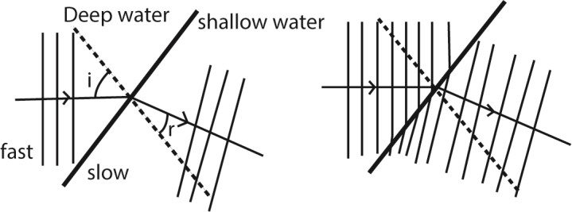

- The direction of the wave when it strikes shallow water at a right angle does not change.
- The wave speed is reduced in shallow water hence wavelength decreases. So when drawing the refracted waves are closely spaced
- The frequency of the wave motion does not change.

Since speed “V” = fλ. In shallow water the wavelength decreases yet the frequency remains constant, so the speed of the wave decreases in shallow water. The wave travels faster in deep water because the wave length increase yet the frequency remains constant.

Refraction results in a wave slowing down the speed and changing direction as the wave enters shallow water.

A glass plate placed in ripple tank at normal to the wave

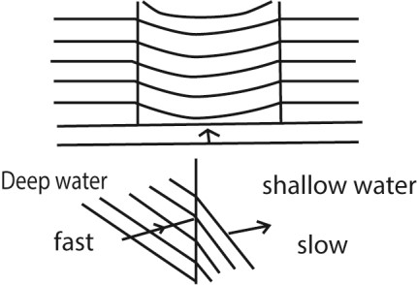

Refraction of straight waves at curved surfaces a) Converging refractor
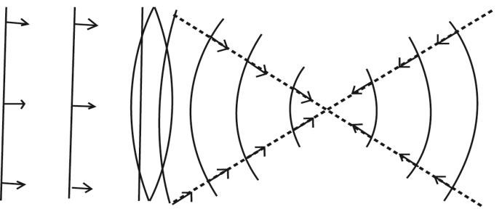

b) Diverging refractor
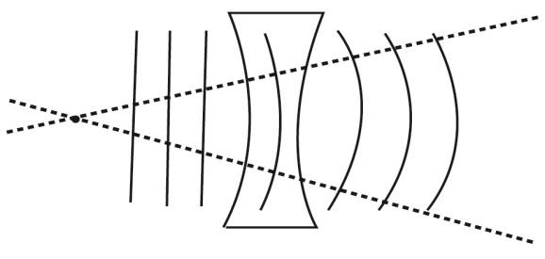

Interference
Interference is when two identical waves moving in the same direction are superposed on one another. Waves are superposed when one wave is placed on top of the other. For this to occur the amplitudes and frequencies of the two waves should be the same.

Coherent sources are sources which produce waves of the same frequency and amplitude which are always in phase or have a constant phase difference.

In the ripple tank, the two waves are produced by two ball ended dippers attached to the vibrator receiving vibration from the electric motor.
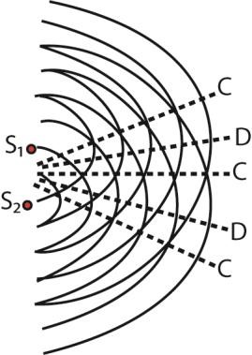Where:
"C" is constructive interference
"D" is Destructive interference
"S₁" and S₂ are sources of vibration

From principle of superposition;-
Where the two waves are superposed in the same phase e.g. crests of one wave fall on the crests of another constructive interference occurs.

Where the two waves are superposed such that they are exactly out of phase e.g. crests of one wave are superposed on the troughs of the other identical wave, no disturbance is obtained. These positions are called destructive interference.

Constructive interference
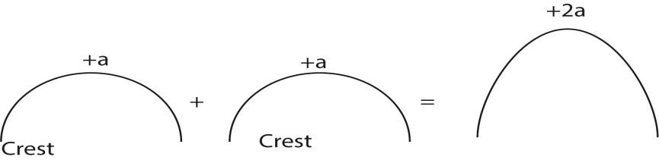
+a +a+2a
+ = displacement (+a) + (+a) = +2a occurs when the displacement due to two waves combine to produce larger displacement. This happens when the wave crests overlap. Or the waves are in phase.

Destructive interference
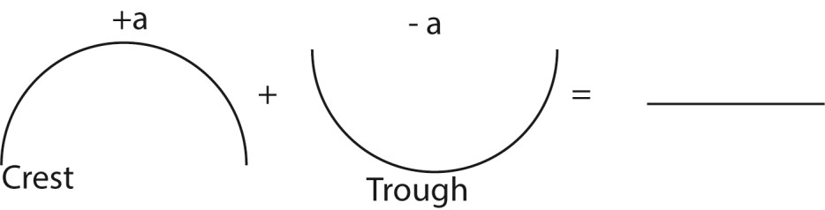

Occurs when, the crest of one wave falls in the trough of another. This produces an effect of no displacement such waves are in antiphase.

If two waves in question are sound waves, then during constructive interference, a very loud sound is heard while during destructive interference no sound or near silence is heard.

Conditions for interference to occur
- Superimpose two waves in the same direction
- The waves must have the same frequency
- The waves must have the same amplitude
- The waves must have a constant phase difference.

Path difference as applied in interference
The path difference is the difference in optical paths travelled by the two waves before they meet or superpose.
Consider two sources of waves S₁ and S₂ producing waves that travel along the Paths AB and CB
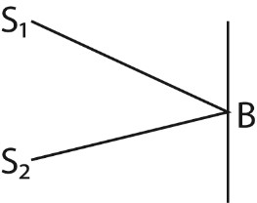Path difference = CB – CA
The path difference can be used to predict whether constructive or destructive interference will occur at the point of superposition.

- If the path difference is a whole number multiple of the wavelength of a wave, the constructive interference occurs. I.e. for constructive interference to occur the path difference should be zero or a whole number multiple of full wavelength. Or path difference = nλ where λ = wavelength of a wave, n = 0, 1, 2, 3 …

- If the path difference is an odd multiple of half wavelength, the destructive interference occur. i.e. for the destructive interference to occur, Path difference = (2n + 1); n = 0, 1, 2, 3 ….

Differences between constructive and destructive interference

Constructive interference Destructive interference
Occurs when the crest of one meets the crest Occurs when a crest one wave meets a of another or when the trough of one wave trough of another meets a trough of another.

n
(2
+1)
Reinforcement occurs Cancellation occurs
Resultant intensity is maximum or higher Resultant intensity is minimum or lower Occurs when the path difference is a whole Occurs when the path difference is an odd
number multiple of full wavelength i.e. path number multiple of a half wavelength
difference = 0 or nλ

Example 10
Two speakers producing sound of the same frequency are place 50m apart facing each other, an observer walks from one speaker to the other along the line of the speakers.
- What does the observer hear?
The observer hears alternate loud and soft or near silence. The loudness and near to silence sound come at equal interval.
- Explain the observation in (i) above.
The loud speakers act as coherent sources producing sound of the same frequency. The two waves from the loud speakers superpose and interference occurs.

Constructive interference occur where the path difference is a whole number of the wavelength of sound so that reinforcement occurs and loud sound is heard. Destructive interference occurs where the path difference is an odd multiple of half wavelength of sound and no sound is heard.

DIFFRACTION OF WAVES
Diffraction is the spreading of waves when they pass through apertures or around obstacles. The general phenomenon of diffraction may be illustrated by using water waves in a ripple tank.

For diffraction to occur the dimension/size of aperture or obstacle must be of the order of the wavelength of the wave; i.e. the width of the aperture must be of the same order as the diffracted wave.

The diffraction of Plane waves through a narrow and wide aperture is illustrated below

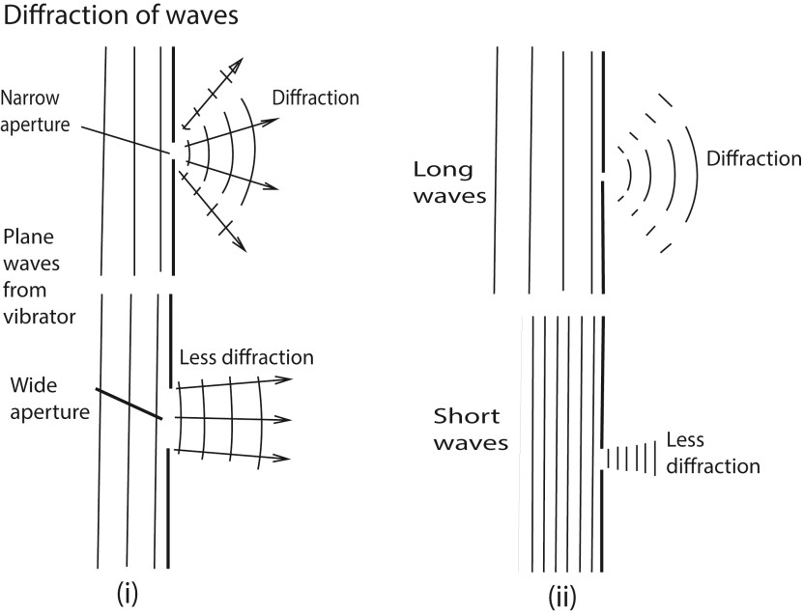
Generally, the smaller the width of the aperture in relation to the wavelength, the greater is the spreading or diffraction of the waves

Secondary, the longer the wavelength of the wave to be diffracted the greater the diffraction or spreading.

Light waves have very short wavelengths that diffraction around obstacles of normal size is negligible that we unable to see around corners while sound waves of longer wavelength are reasonably diffracted that we are able to hear around corner.

In summary diffraction of the wave depends on (i) Dimension of the aperture (ii) Wavelength of the wave.

Huygens’ Principle
Every point on a wave front may be regarded as a source of secondary spherical wavelets which spread out with the wave velocity. The new wave front is the new envelope of these secondary wavelets.

Diffraction at a single slit
Diffraction at a single slit is explained by Huygens’ Principle.
Suppose parallel light is incident on a narrow rectangular slit A and B
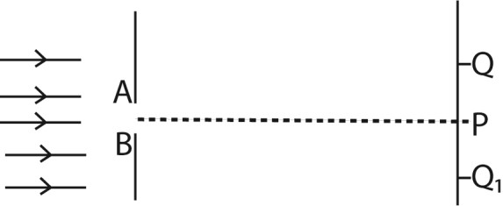

- Each point on the same wave front between A, B acts as a secondary centre of disturbance, and sends out wavelets beyond the slit.
- All the secondary centres are coherent, and their combined effect at any point such as P or Q can be found by summing the individual waves there, from the Principle of Superposition.

- At P, most of the wavelets arrive in phase causing constrictive interference leading to formation of the central bright band.

- On outwards from P, an increasing number of wavelets arrive out of phase and hence the bright bands reduces in intensity until a dark band is formed where all wavelets arrive out of phase.

- Farther away from P parallel to AB, the intensity rises again to a much smaller maximum producing less bright band than at P.

- More and more alternative bright and dark bands of reducing intensities are formed further from P parallel to AB where wave wavelets meet in phase and out of phase respectively.
The graph of intensity against distance and corresponding diffraction band are shown below.

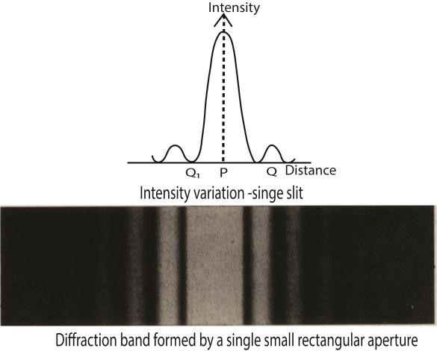

Diffraction of light at more than one slit using diffraction grating
A diffraction grating is a large number of close parallel equidistant slits, ruled on glass or metal using diamond pencil
Like single narrow rectangular slit, when parallel monochromatic light is incident normally to two or more slits of a diffraction grating each slit produces an image with a bright central or principal maximum diffraction band, together with subsidiary maxima diffraction bands which are much less bright. This time, however, the pattern is crossed by a number of interference bands, which are due to interference of waves from different slits.
Deriving an expression for angular position of n^{th} order principal maximum produced by transmission diffraction grating.
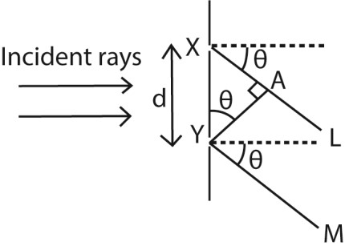
Suppose X and Y are corresponding points in consecutive slits where XY = d, and the grating is illuminated normally by monochromatic light of wavelength, λ, the direction, θ, the diffracted ray XL, and YM have path difference, XA
From sin 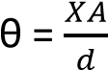; XA = dsin θ

The path difference for all corresponding points in the two slits have the same path difference, dsinθ. So other pairs of slits throughout the grating are treated the same way.

Also for bright or principle maxima to be obtained, the path difference = nλ.

dsin θ = nλ; where d= slit separation, λ = wavelength, θ = angular momentum

Example 8
Light of wavelength 5.0 x 10⁻⁷m falls on a grating with 600 lines per mm, determine the highest order of diffraction that can be observed. λ = 0.5 x 10⁻⁶m
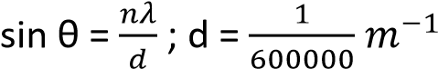
n =

Measurement of the wavelength of monochromatic light using a diffraction grating and a spectrometer.
(a) Make the following adjustment
- The collimator C is adjusted such that parallel rays emerge from it.
- The telescope is adjusted so that parallel rays entering it are brought to a focus at the cross wire near its eyepiece.
- The table is levelled so that the plane of P is parallel to the axis of rotation of the telescope.
(b)
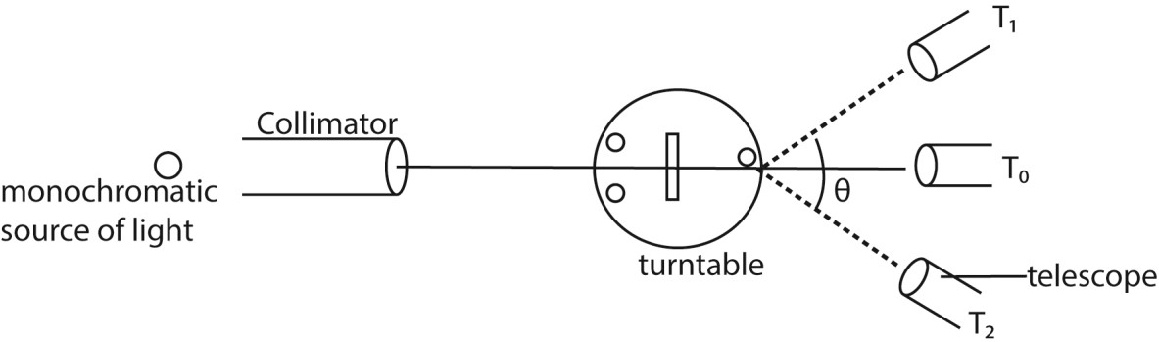
- The grating is placed on the table so that its plane is normal to incident light
- The readings of the first diffraction image are observed on both sides of the normal at T₁ and T₂.
- The angular difference is 2θ, and the wavelength is calculated from λ = d sin θ, where d is the spacing of the slits, obtained from the number of lines per centimeter of the grating.
- If a second order image is obtained for a diffraction angle θ, then λ = d sin 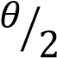.

Difference s between the spectra produced by a prism and that produced by diffraction grating
Prism | Diffraction grating
- Produce single spectrum at a time  - Shorter wavelengths are deviated most  - Produce less pure spectrum | - Many spectra at a time  - Longer wavelength are deviated most. - Produce more pure spectrum

Example 9
A diffraction grating of spacing d, is illuminated normally with light of wavelength, λ.
(a) (i) Derive the condition for concurrence of diffraction maxima. (03marks)

Consider a parallel beam of monochromatic light incident on a grating of spacing d.
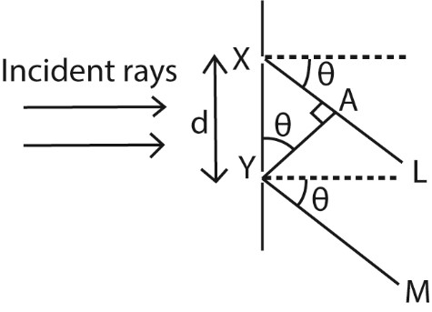
The path difference XA = dsinθ
For constructive interference, diffraction maxima occurs when the path difference is an integral multiple of wavelength, λ. i.e. path difference = nλ thus dsinθ = nλ where n = 0, 1, 2, 3, ……….

- Describe briefly the intensity distribution on screen placed beyond the grating (02marks)

The central principle maxima is the most intense; the intensity decreases on the either side.

- What is the effect on diffraction pattern when grating with larger number of lines is used (02marks)

The diffraction maxima (image) becomes narrower and shaper

(b) Light of wavelength 5.8 x 10⁻⁷m is incident on diffraction grating of 500 lines per mm. Find the
- Diffraction angle for second order image (03marks) d = 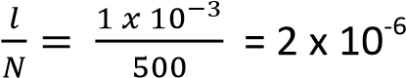m
from dsinθ =nλ
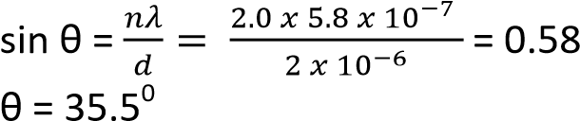

- Maximum number of images formed. (02marks)
d = n_{max}λ
n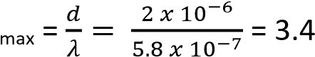 n_{max} = 3

Refractive index of a medium using Huygens' Principle at Plane Surface
Consider a beam of parallel rays between LO and MD incident on the plane surface of the medium from air in the direction shown, and suppose that a plane wave front has reached the position OA at a certain instant; every point on OA acts as a seconadry source of wavelets.
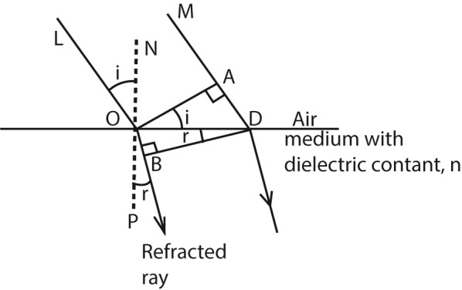
In time t, secondary wavelets from O travels a distance OB = vt (where v = velocity of light in the medium.
In the same time, t, the secondary wavelength in air travels a distance AD = ct
The targent BD to the secondary wavelet is the new wavefront.
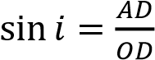 and 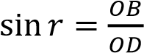
From snell’s law, 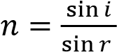
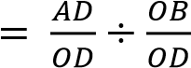
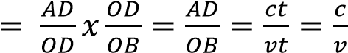

Example 10
Monochromatic light propagating in air is incident obliquely onto a plane boundary with a dielectric of refractive index, n.
- Use Huygens’ principle to show that speed, V, of light in the dielectric is given by V = where c is the speed of light. (06marks)

- (i) If the wavelength of the light is 600nm in air, what will it be in a dielectric of refractive index 1.50? (04marks)

Let f₀ and f be frequencies of light in vacuum and in the medium, then f₀ = f
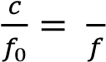
But 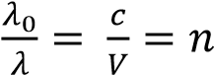
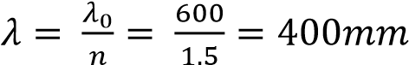

(ii) Sodium light of wavelength 5.890 x 10⁻⁷m and 5.896 x 10⁻⁷m fall normally on a diffraction grating. If the first order beam, the two sodium lines are separated by 2minutes, find the spacing of grating (03marks)
For first order diffraction, dsinθ =λ
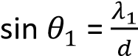 …………………………………. (i) 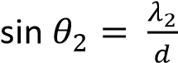 ……………………………….. (ii)
but sin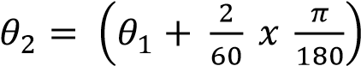
Eqn.(ii) – Eqn. (i)
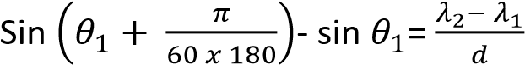
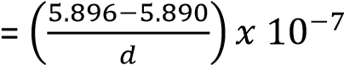m

Interference of light waves
The conditions necessary for permanent interference fringes between two sources of light
- The wave trains must have nearly the same or equal amplitudes.
- There must be a constant phase relationship between the two wave trains.
- The source must be very close to each other.
- The screen must be very as far as possible from the sources compared to separation of light sources.
NB: Since emission of light is always spontaneous; the above conditions are only possible if the source of waves is the same.

Formation of interference patterns
When two waves of equal frequency and equal wavelength (coherent sources) travel in the medium, they superpose where they meet in phase, reinforcement takes place resulting in a region of maximum intensity. Where they meet completely out of phase, cancellation takes place and a region minimum intensity form. Permanent alternate region of maximum and minimum intensity are therefore observed which is referred to as interference pattern.

Division of wave front
This is a process of getting two coherent waves from a single wave front. This may be achieved by using Young’s double slits or biprism or diffraction grating
Formation light interference pattern by division of wave front using double slits.
One of the first demonstrations of the interference of light waves by division of wave front was carried out YOUNG in 1801
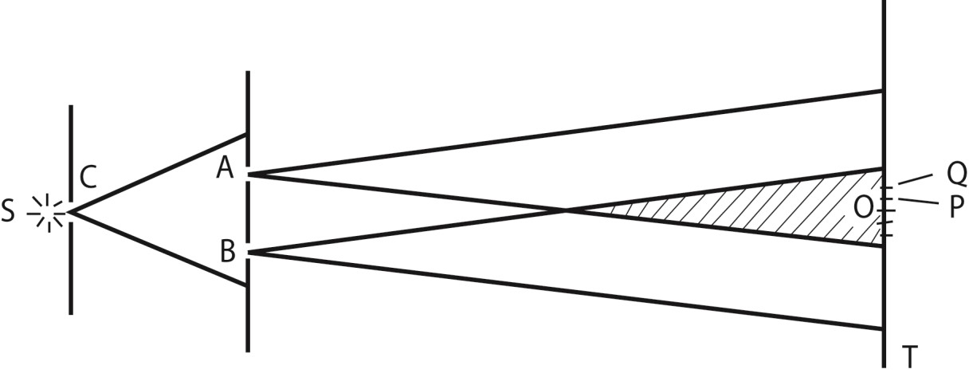
A source, S, of monochromatic light in front of a narrow slit C, and two very narrow slits A, B, close to each other, in front of C.
S is narrow, the light which emerges from A and B is coherent since it comes from the same wave front
Interference thus takes place in the shaded region, where the light beams overlap forming bright and dark bands on either side of O on a screen T, where O is on the perpendicular bisector of AB where light from A overlaps that from B.
As AO= OB, a bright band is obtained at O.
At a point P close to O, such that BP - AP = λ/2, where λ is the wavelength of the light from S, a dark band is obtained.
At a point Q such that BQ - AQ = λ, a bright band is obtained; and so on .for either side of O.
The band are due to interference since covering A or B, the bands disappear.
- Constructive interference (maximum intensity) occurs when the two waves meet at a point when they are in phase. This occurs when the path difference between the waves is an integral multiple of wavelength.

- Destructive interference (minimum intensity) occurs when the two waves meet when they are completely out of phase. This occurs when the path difference between waves is an odd multiple of half the wavelength Note that
- If the source slit S is moved nearer the double slits the separation of the bands is unaffected but their intensity increases.
- If the distance apart d of the slits is diminished, keeping S fixed, the separation of the bands increases.
- If the source slit C is widened, the bands gradually disappear. The slit C is then equivalent to a large number of narrow slits, each producing its own band system at different places. The bright and dark bands of different systems therefore overlap, giving rise to uniform illumination.
It can be shown that, to produce interference bands which are recognizable, the slit width of C must be less than >λD'/d, where D' is the distance of C from the two slits A, B.
- If one of the slits, A or B, is covered up, the bands disappear.
- If white light is used the central band is white, and the bands either side are coloured. Blue is the colour nearer to the central band and red is farther away.
The path difference to a point O on the perpendicular bisector of the two slits A and B is zero for all colours, and consequently each colour produces a bright band here. As they overlap, a white band is formed. Farther away from 0, in a direction parallel to the slits, the shortest visible wavelengths, blue, produce a bright band first.

Production of two coherent sources using a biprism
- A prism of a very large angle is placed with its refractive edge facing a monochromatic source of light, S.
- Light incident on face L is refracted to appear to come from a point S₁ and that incident on Q appears to come from S₂ due to refraction.
- The two sources are coherent since they originate from the same source S leading to interference where they superpose.
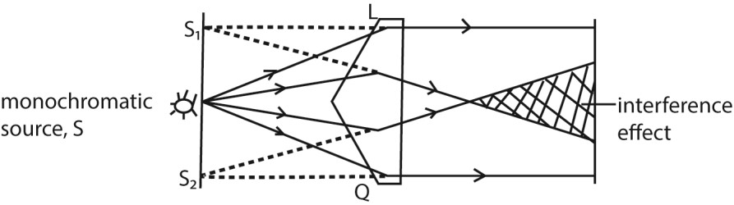

Separation of Bands in Young’s double slit experiment
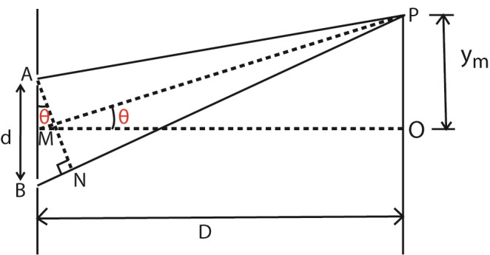
A and B are coherent sources.
Suppose waves from A and B superpose at P to form bright fringe
Suppose P is the position of the nth bright band, so that BP – AP = mλ
Let OP = y_{m} = distance P to O; the center of the band system, where MO is the perpendicular bisector of AB
If a length PN = PA is described on PB, then
The path difference BN = BP – AP = mλ
In practice AB is very small compared to PM thus, AN meets PB practically at right angle and thus θ is very small that dsinθ = dtanθ
⇨ BN = dtan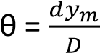
For the m^{th} bright fringe, BN = mλ, where λ is the wavelength
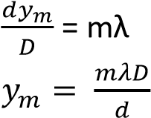
⇨

For (m + 1)^{th} bright fringe, 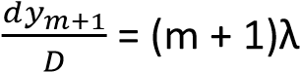
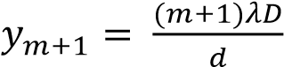
Fringe separation, y = y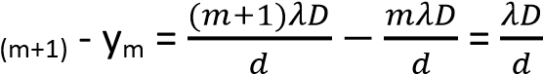

Example 11
With reference to Young’s double slit experiment,
(i) Explain how interference pattern is formed.

Solution
When two coherent waves travel in a medium, they meet and superimpose.
Where they meet in phase, constructive interference takes place and intensity is increased (or maximum)
Where they meet out of phase, cancellation takes place and intensity reduces (minimum)
Patterns of alternative regions of maximum and minimum intensities are formed that form interference pattern.
- State what happens to the fringes when the source of light is moved nearer to the slits.
The intensity of fringes increase but their separation remain unaffected.
- state what happens to fringes when the separation of slits is changes Increase in separation of slits reduces fringe separation.
- describe the appearance of fringes when white light is used
When white light is used, colored fringes are observed. The central fringe is white, followed by blue and red fringes farther off.
Outwards the colors overlap leading to white illumination

(a) Calculate the separation of the slits if the distance from slits to the screen is 800mm and the 8th bright fringe is formed 5mm from the center of the fringe system given that the wavelength of light is 6.2 x 10⁻⁷m

y = 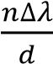
d = 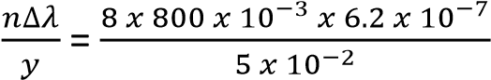 = 7.94 x 10⁻⁴m

Measurement of the wavelength of monochromatic light using Young’s double slit method
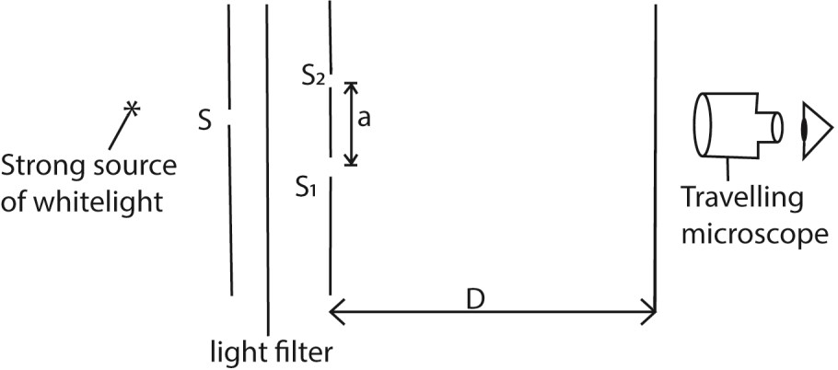
The set up is as shown above, where S, S₁, and S₂ are narrow slits through which light difracts forming interference fringes on a transparent screen. The position of the creen is adjusted until fringes are seen clearly. The number of fringes occupying a measured length along the screen is counted and the width y of a single fringe determined. The distance D, of the double slit from the screen is measured using a meter rule and the separation, a, of the double slit determined using a travelling microscope. The wavelength λ =ay/D

Example 12
- In an experiment to determine wavelength of light using Young’s method, two slits, a separation of 1.2mm were used. When the screen was placed 18.0cm from slits, 30 bright fringes occupying a distance 2.5mm was obtained. Find wavelength of light used (04marks)
Slit separation, d= 1.2 x 10⁻³m
Number of bright fringes, n =30
Distance from center of nth fringe, x_{n} = 2.5 x 10⁻³m
Distance from the slits to screen, D = 18.0cm = 0.18m
Using x_{n} 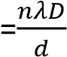
2.5 x 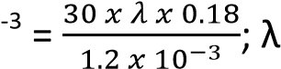10 = 5.56 x 10⁻⁷m
- A diffraction grating has 500 lines per mm and illuminated normally with monochromatic light of wavelength 589nm. Find the maximum number of diffraction image obtained. (04 marks) d=
n =

the maximum order of diffraction = 3

Appearance of Young’s interference fringes pattern using source of white light
- A central white fringe with colored edges is observed due to overlapping colored fringes. Here the path difference is zero
- Since the violet color has the lowest wavelength, then a violet fringe will be the first fringe on the either side of the central white fringe. The farthest fringe is red
- After a few fringes, the fringe pattern become invisible due to much overlapping

Interference in thin air wedge films
Thin air wedge is formed by inclining two thin glass slides at a small angle θ.
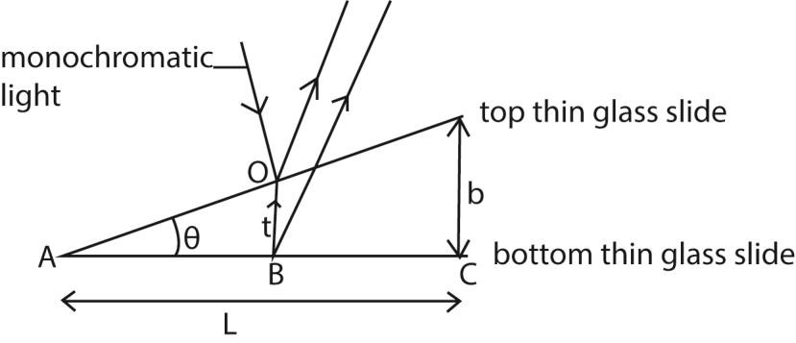
- When monochromatic light is incident normally inclined glass slides at O;
- Part of light is reflected on the bottom part of the top glass slide while part of the transmitted light is reflected at B on the top part of the bottom glass slide.
- The two reflected waves are coherent since both have originated from the same centre of disturbance at 0, and they produce an interference phenomenon if brought together by the eye or in an eyepiece.
- Their path difference is 2t, where t is the small thickness of the air-film at 0.
- The wave reflected at bottom part of top glass slide suffers no phase change while that reflected from top part of lower glass slide at B at boundary with a denser medium suffers a phase change of π due to reflection which is equivalent to an additional path of
- Therefore a dark band is formed at the point of contact A of the slide instead of bright fringe.
- Hence for constructive interference (bright fringes), 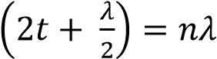, for n = 1, 2, 3…
- Destructive interference (dark fringes) 2t =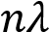, for n = 1, 2, 3 …
NB. If the wedge surf aces make perfect optical contact at one edge, the bands are straight lines parallel to the line of intersection of the surf aces. If the glass surfaces are uneven, and the contact at one edge is not regular, the bands are not perfectly straight.

Thickness of Thin Foil in air wedge
- If there is a bright band at C at the edge of the foil, the thickness b of the foil is given by 2b = (m + 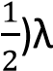, where m is the number of bright bands between A and C.
- If there is a dark band at C, then 2b = m λ.
- Thus by counting m, the thickness b can be found.

Example 13
When the slides are illuminated with light of wavelength 500nm, 10 dark fringes are observed to occupy a distance of 2.5mm. Determine the diameter of the wire.
Thickness, t
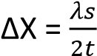
t = 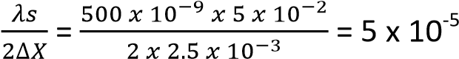m

Example 14
Two glass slides in contact at one end are separated by a sheet of paper 15cm from the line of contact to form an air-wedge. When the air wedge is illuminated normally by light of wavelength 6.0 x 10⁻⁷m, interference fringes of separation 1.8mm are found in reflection. Find the thickness of the paper. (04marks).
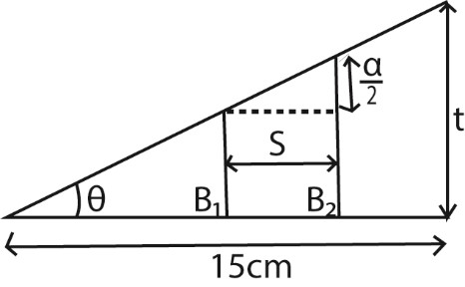
S = 1.8 x 18⁻³m
tan 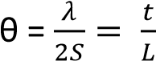
t = 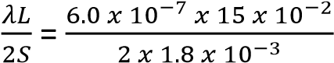 = 2.5 x 10⁻⁵m

Example 15

An air wedge is formed by placing two glass slides of length 5.0cm in contact at one end and separated by a wire on the other end as shown below
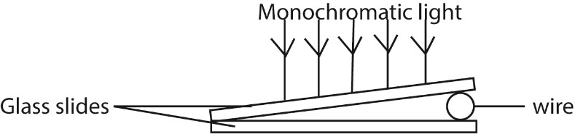
When the slides are illuminated with light of wavelength 500nm, 10 dark fringes are observed to occupy a distance of 2.5mm. Determine the diameter of the wire
Let the diameter be, t
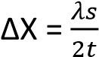
t = 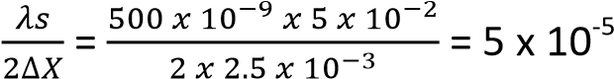m

Example 16
Two glass slide in contact at one end are separated by a wire of diameter 0.04mm at the other end to form a wedge. Fringes are observed when light of wavelength 5.0 x 10⁻⁷m is incident normal to the slides. Find the number of fringes which can be observed. (03marks)
Solution
2t = nλ
n 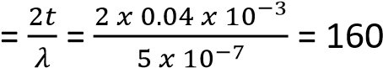

Angle θ of the air wedge
The small angle θ of the wedge is given by , where L is the distance AC, and by measuring L with a travelling microscope focused on the air-film, θ can be found.
When the separation of fringe is y, and wavelength length of light is λ
Then, tan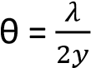

Example 17
Two glass slides are separated by a thin wire to form an air wedge. When the wedge is illuminated normally by light of wavelength 5.6 x 10⁻⁷m, a total of 20 fringes occupying a distance of 15mm are obtained. Calculate the angle of the wedge.
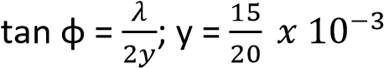= 0.75 x10⁻³m
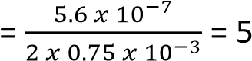
φ = 0.021⁰

Example 18
An air wedge is formed by placing two glass slides of length 5.0cm in contact at one end and a wire at the other end as shown in the figure below
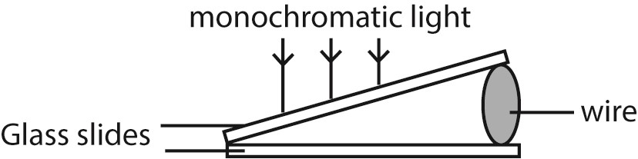
Viewing from vertically above, 10 dark fringes are observe to occupy a distance of 2.5mm when the slides are illuminated with light of wavelength 500mm.
Determine the diameter of the wire. (04marks)

Solution
Fringe separation = 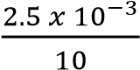 = 2.5 x 10⁻⁴m
λ = 500nm = 5 x 10⁻⁷m
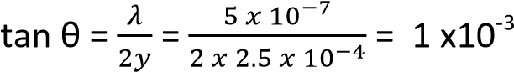 - 0
θ = 1 x10 3 or 0.06
Replacing the air with a liquid in air wedge.
If a liquid wedge is formed between the plates, the optical path difference becomes 2nt, where the air thickness is t, n being the refractive index of the liquid.
An optical path difference of λ now occurs for a change in t which is n times less than in the case of the air-wedge.
The spacing of the bright and dark bands is thus n times closer (reduces) than for air, and measurement of the relative spacing enables n to be found.

Example 19
Explain what will be observed if a liquid is introduced between the slides (02mark)
From refractive index, n_{l} 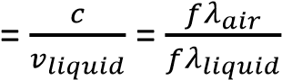
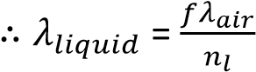
where c and v_{liquid} are velocities of light in air and liquid and λ_{air} and λ_{liquid} are wavelength of light in air and liquid respectively.
Fringe separation, y= 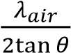 where θ is the wedge angle.
The new fringe separation, y’ =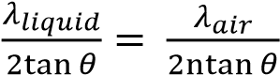
Hence fringe separation is reduced by a factor of n in relation to that of air wedge
Experiment how flatness of surface can be determined by interferences from air wedge.
- The surface under test is made to form an air-wedge with a plane glass surface of standard smoothness as shown below.
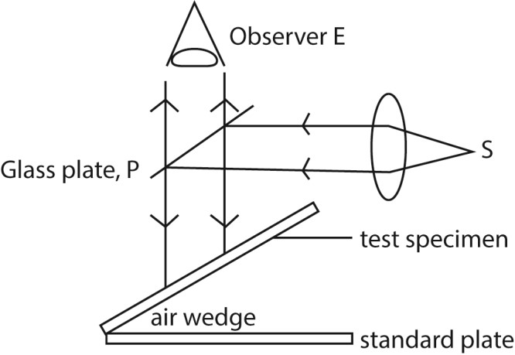
- A parallel beam of monochromatic light from source, S, is reflected from a glass plate, P to fall normally to the air wedge.
- Light reflected by the air wedge is observed.
- Irregularity in the surface of test specimen will show up as irregularity in the fringe pattern.
Reasons for appearance colored oil drop on a rainy day.
- Then white light incident on the oil film, is partly reflected and partly refracted.
- Dispersion occurs due to refraction.
- The dispersed rays are reflected at oil-water interface.
- The light reflected from both surface meet and superpose in air.
- Constructive superposition of colored rays give colored fringes. Hence colored oily surface.
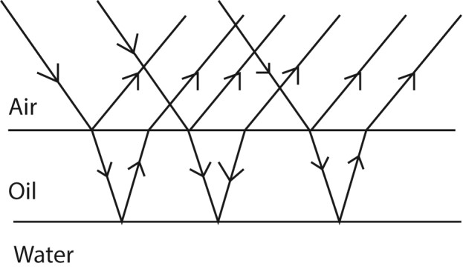

Newton’s ring
It is an example of interference in which a pattern of dark and bright concentric circles are observed when monochromatic light is reflected from a converging lens of large radius of curvature placed on a plane sheet of glass.
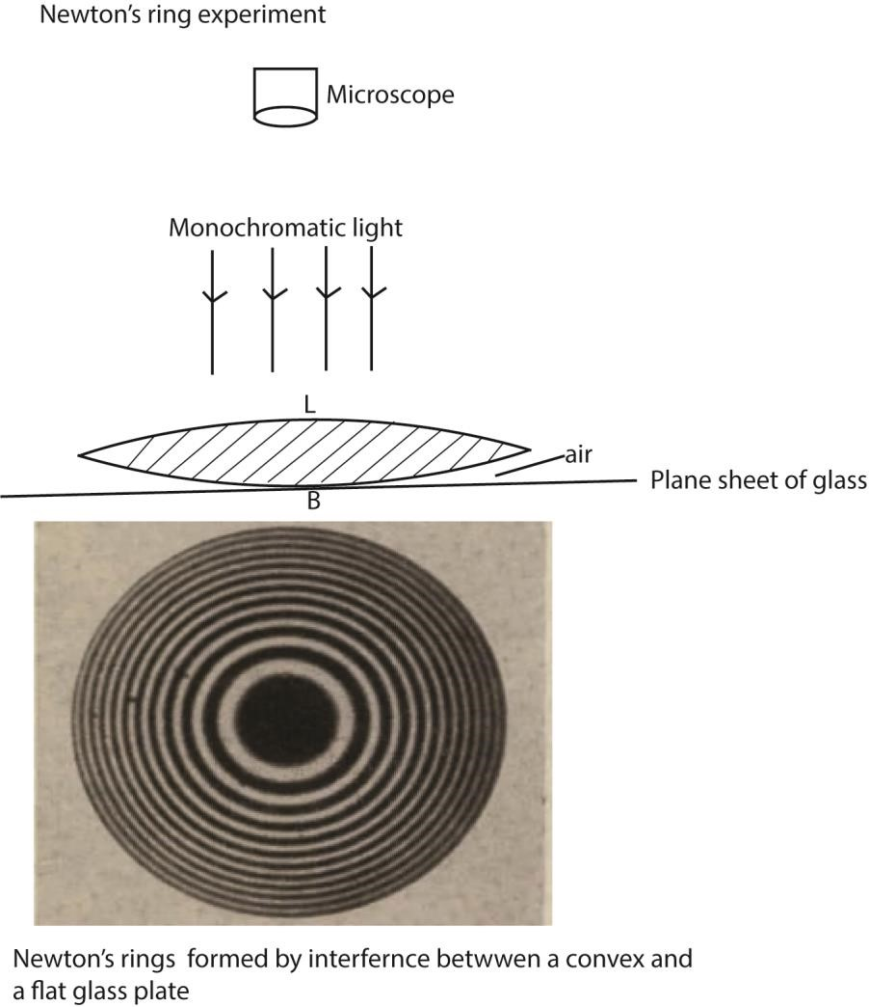
- Air is formed between the lens and the glass plate
- Some light is reflected from the lower surface of the lens while some of that transmitted is reflected from the top side of the glass plate.
- The light reflected from the top side of glass plate undergo a phase difference of 1800 equivalent to a phase difference of 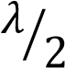. Thus a dark band is formed at B where the phase difference is 0.
- If the thickness of the air is t; bright ring is formed when 2t = (n + 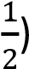λ and a dark ring is formed when 2t = nλ; λ is the wavelength of light, n = 0; 1; 2; 3; …..

Polarization of light
Transverse waves can undergo polarization while longitudinal waves like sound waves do not.

Definition
Plane polarized light is one whose electrical vectors varies in only one plane perpendicular to the direction of travel of the wave.
Unpolarized light is whose magnetic and electrical vibrations occur in more than one plane
Polarization is the phenomenon where light is absorbed by a medium in such a way that transverse vibrations in a perpendicular direction is allowed to pass through. The emergent light is thus polarized.
Polarization of light can prove that light is transverse and also electromagnetic wave.
Electromagnetic waves are transmitted by varying electric and magnetic fields and the vibrations therefore occur in electric and magnetic vectors. These vectors are always perpendicular to each other and also perpendicular to the direction of propagation of light.
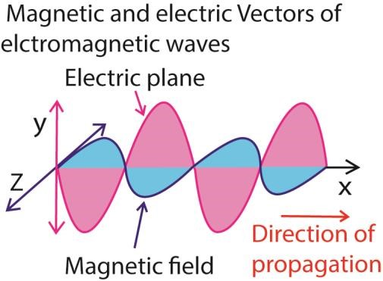
Experiments show that when light interacts with matter, the vibrations in a magnetic vector are absorbed leaving only vibrations in electric vectors occurring in one plane. This is when light is said to be plane polarized.
Detection of plane polarized light.
A sheet of Polaroid is held in the path of the plane polarized light and rotated slowly about an axis perpendicular to it. When all light is absorbed in a particular direction, then it is polarized.
A Polaroid is a material which transmits only those vibrations of light occurring in a certain perpendicular direction.
Method of producing plane polarized light

(a) Selective absorption
Unpolarized light is made incident on a plane sheet Polaroid. The transmitted light will be completely polarized.

(b) Reflection

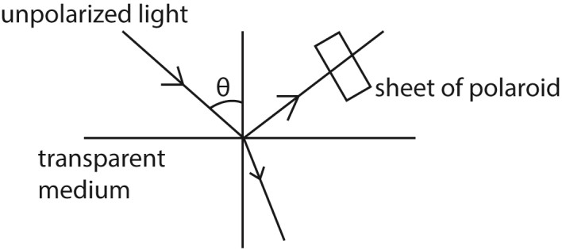
- A narrow beam of light is made incident on transparent medium.
- The reflected light is observed through a Polaroid.
- The angle of incidence is varied
- At each angle of incidence, the polaroid is rotated about the axis along the light incident on it
- At one angle of incidence, the light gats cut off the observer as the Polaroid is rotated.
- The reflected ray is now completely polarized.
- The angle of incidence i_{p} at which all light is polarized is given by i_{p} = tan⁻¹ n; where is the refractive index of the material. (Brewster’s law)

Example 20
A parallel beam of Unpolarized light is incident on a transparent medium of refractive index 1.62. It is reflected as plane polarized light. Calculate the angle of incidence in air and angle of refraction in the medium
Using Brewster’s law; n = tan i_{p} i_{p} = tan⁻¹ 1.62 = 58.3⁰
r = 90 – i_{p}
= 90 – 58.3 = 31.7⁰

(c) Double refraction
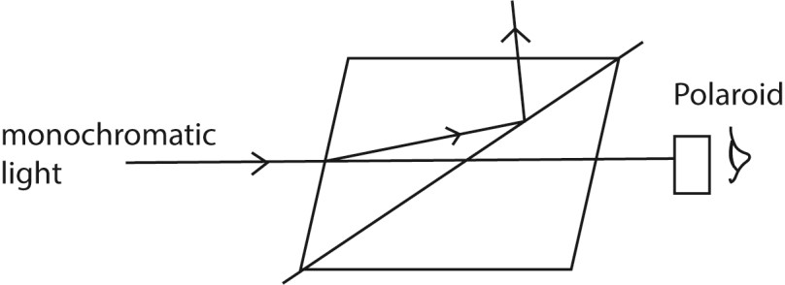
- A narrow beam of monochromatic light is made incident on nicol prism and viewed from the opposite side as shown above
- The angle of incidence is gradually increased or changed and at each angle, the Polaroid is rotated about an axis through its plane.
- At one point, the emergent light is plane polarized.
Note that;
Some crystals such as calcite and Iceland spar exhibit a property known as double refraction where they split unpolarized light into two polarized light rays; ordinary and extraordinary rays.
Uses of polarized light.

(i) Polarized light is used in measurement of the concentration of sugar in a solution
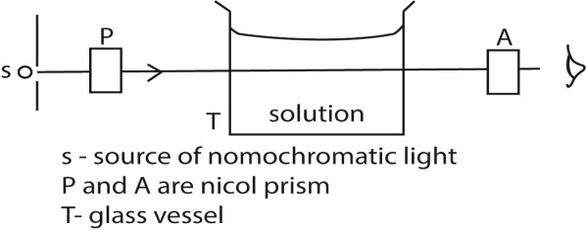
The apparatus are arranged as above
First without the solution, the prism A called analyzer is rotated until the emergence light from T is completely extinguished. This orientation is noted.
T is filled with sugar solution, on looking through A, light can now be seen.
A is then again rotated until light is extinguished. This point is noted.
The angle θ between the two positions is noted.
The angle of rotation θ is proportional to the concentration.

(ii) It is used in stress analysis
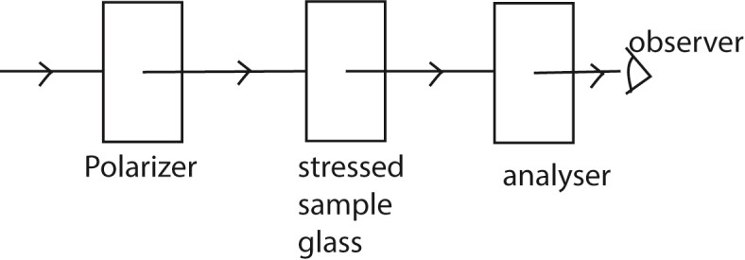
The apparatus is arranged as above
The polarizer and analyzer are Polaroid which are crosses with respect to each other so that light does not pass through.
When a piece of stressed glass is placed between the Polaroids, a pattern of interference fringes can be seen.
The intensity of light depends on the degree if stress and hence the region and degree of stress is determined.
- In film to give illusion of three dimension (orography)
- In liquid crystal display

TOPIC 5/6: STATIONARY WAVES
Competency: The learner investigates the behaviour of stationary waves and their applications in different situations.

Stationary/standing waves
A stationary wave, or standing wave, is a wave pattern that appears to stay in one place, formed by the interference of two waves with the same frequency and amplitude traveling in opposite directions, like a wave reflecting back on itself.
Formation of stationary wave.
Stationary wave is formed when two progressive waves having the same speed and frequency and approximately equal amplitude but travelling in opposite direction are superposed.

Conditions for formation of stationary waves
- Superposition of two waves travelling in opposite direction
- The waves should have the same frequency and speed
- The waves should have nearly equal amplitude

Progressive waves which agree with above condition can be obtained when a wave travels along a given path and strikes an obstacle such that it reflected perpendicularly and returns along the same path. The incident and reflected waves superpose to form a stationary wave in which the wave profile does not move along the medium.

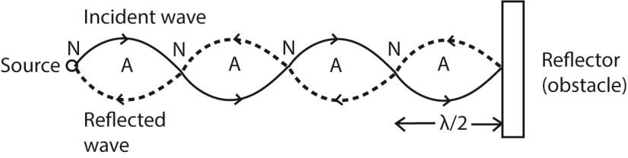

The superposition of the two waves results into points where the particles are permanently at rest. These points are known as nodes. These points midway between successive nodes will have their particles vibrating with maximum amplitude. The points are known as antinodes.

The distance between any two successive nodes or any two successive antinodes is equal to half the wavelength of the stationary waves. i.e. distance between successive node = the distance between successive antinodes = the distance between a node and neighboring antinode = .
A stationary wave unlike progressive waves does not transfer energy since the wave profile does not move along the medium.
Also, at points between successive nodes, all vibrations are in phase.

Characteristics of a stationary wave
- The amplitude of the wave varies from place to place along the wave profile.
- Wave energy is not transmitted along the wave profile.
- It has nodes and antinodes
- At points between successive nodes, the vibrations are in phase
- At nodes, particles are permanently at rest while at the antinodes the particles have maximum displacement.
- The medium is split up into segments. The particles in the segments are out of phase with particles in the neighboring segments by 180⁰.
- In a given segment, the particles attain maximum velocity and acceleration at the same instant.
- Compression and rarefactions do not travel forward as progressive waves. They appear and disappear alternatively in the same place.
- During each vibration, all particles pass simultaneously through their mean position twice with maximum velocity which is different for different particles.

Differences between stationary and progressive waves Stationary waves Progressive waves
Each point along the wave has different The vibration of particles are of the same amplitude of vibration from the neighboring amplitude.
points
At points between successive nodes the The phase of vibration of points near each vibrations are in phase i.e. the phase of other are all different. vibration does not vary.
They do not transfer energy They transfer energy from one point to another.
The wave profile does not move along the The wave profile moves along the medium medium with the wave speed.
The medium does not move The medium moves

NB. The velocity of stationary wave is zero

The stationary wave equation
Stationary waves are formed by superposition of two progressive waves in opposite direction which have equal amplitude and frequency. The equations of such progressive waves will be y₁ = Asin(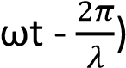

y₂ = Asin(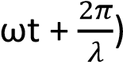
the equation of the stationary waves would then be the sum of these two equations
Y = y₁ + y₂ = Asin(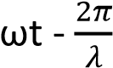) + Asin(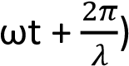
= 2Acos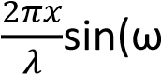t)
But 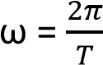
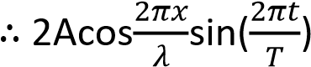
Amplitude of a wave, A = 2acos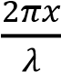

Since x varies from point to point, the amplitude also varies from point to point along the wave.
For antinodes, the amplitude should be maximum (regardless of the sign)
Amplitude is maximum when 2Acos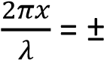 1, this occurs when 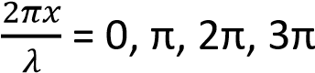 …….
Then amplitude maximum = 2A

The separation between successive antinodes can be obtained

The 1st antinode when 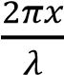 = 0, x = 0
The next antinode when 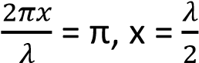
the distance between two successive antinode is

For the node the amplitude is zero since the particles are permanently at rest.
From amplitude, A = 2acos; A = 0 when cos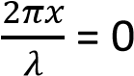
This occurs when 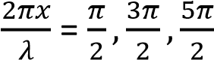 …
At the first node, occurs when 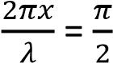 or when x =
The 2nd node occurs when 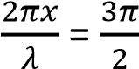 or when x =
Distance between successive nodes = 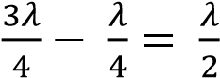

Example 1
Show that the distance a successive node and antinode is
Solution
For the 1st antinode, 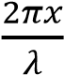 = 0; x = o
At the first node, occurs when 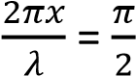 or when x =
Distance between successive node and antinode = 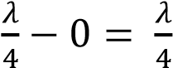

Example 2
A plane progressive wave is given by the equation
y = a sin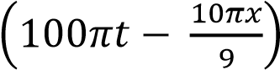 where x and y are in millimeters and t in second.
(i) Write the equation for progressive waves which would give rise to a stationary wave if superposed on the above
y₁ = a sin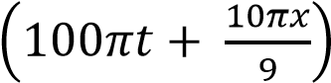
i.e. it is a wave in opposite direction with equal frequency, speed and amplitude.
(ii) Find the equation of stationary wave and hence determine its amplitude of vibration.
Y = y + y₁ = a sin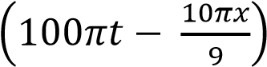 + a sin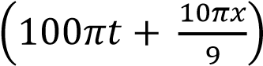
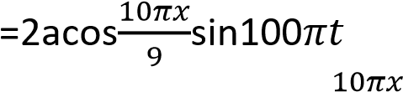
Amplitude, A = 2acos mm
(iii) Determine the frequency and velocity of stationary wave ω = 100π 2πf = 100π
f = 50Hz
Velocity v =0 because the wave is stationary.

MUSICAL NOTES
Musical notes are regular vibrations of sound waves.

Properties of musical notes
Musical notes have three properties namely:
Pitch, loudness and quality/timbre

Pitch
A pitch is the sharpness or mildness of the soft musical note. A pitch is directly proportional to the frequency in that high frequency gives high pitch (sharper note).

A high pitched note has high frequency and short wavelength and vice versa.

Loudness and intensity
This is the amount of sound energy entering the ear per second. The greater the amount of energy, the louder the sound.

The intensity or loudness of sound depends on the amplitude of the vibration in that a loud note has a large amplitude while a quiet note has a small amplitude.

A mother and child may both shout a note of the same frequency but the note from a mother is louder because the amplitude of the sound wave made by the mother is larger so a greater mass of air is set into vibration.

In general, the greater the mass of air which can be set into vibration the louder will be the sound. The prongs of a vibrating tuning fork, make a small mass of air vibrate. So the sound is soft. However if the end of the fork is placed on a table the sound is much louder because a large mass of air in contact with surface of the table is set into vibration.

A violin string directly produces soft sound because very little air is set into vibration as the violin has small surface area.

When the same violin string is attached to a sounding box a much louder sound is produced because the large surface area of the sounding box results in large mass of air to vibrate as the box vibrates,

The sound from a telephone earpiece is heard distinctly only when the ear is placed close to the earpiece because the vibrating circular metal plate inside has a small area so only a small mass of air is set into vibration.

A loud sound may be heard from a small transistor set or a television set because the loud speaker has a vibrating cone with relatively large surface area so a large mass of air in contact is set into vibration.

Intensity of sound
The intensity of sound is the rate of flow of energy per unit area perpendicular to the direction of sound. Intensity is proportional to;
i) The square of the amplitude, ii) The square of the frequency
iii) The density of the medium

Loudness of sound
Loudness depends on;-
i) The varying pressure exerted on the eardrum by the sound, ii) ii) The sensitivity of the ear to the different frequencies, iii) The sound intensity.
Loudness of sound is the sensation of a note in the mind of an individual.

Quality or tone (timbre) of a musical note
The same note on different instruments sounds different, the notes are said to differ in quality or timbre. The difference arises because no instruments except a tuning fork and single generator can emit a pure note i.e. of one frequency but they produced notes consisting of main or fundamental frequency mixed with overtones.

Overtones have frequencies that are exact multiples of the fundamental. The number and strength of overtones determines the quality of a note.

A violin has more and stronger higher overtones than a piano.

Beats
Beats are periodic rise and fall in sound intensity when two sound waves of nearly equal frequency but same amplitude are sounded together.
Rise in sound is due to constructive interference while fall in sound is due to destructive interference.
Conditions for formation of beats
Beats are formed from notes of
- nearly equal frequency
- same amplitude sounded together
Beat frequency
This Is the number of beats formed in one second.
Beat period
This Is the time taken to fish one beat after completion of the previous one

Derivation of the expression for beat frequency
Consider two notes of frequencies f₁ and f₂ sounded together. Suppose the wave of frequency f₁ makes one cycle more than that of f₂ in time T₀.
In time T, the number of waves of f₁ is f₁T
The number of waves of f₂ is f₂T Therefore f₁T – f₂T = 1 f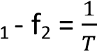
but 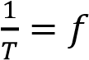
f₁ –f₂ = f, the beat frequency

Example 3
Two whistles are sounded simultaneously. The wavelengths of the sounds emitted are 5.5m and 6.0m respectively. Find the beat frequency if the speed of sound is 330ms⁻¹.
For 1st sound 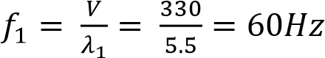
For 2nd ^{t} sound 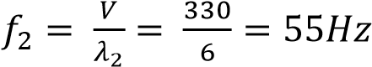
Beat frequency

Uses of beats
- Tuning a musical instrument to desired note.
- Determination of frequency of a musical note.

WAVES IN STRINGS AND PIPES

Vibrating string

Factors on which the frequency of a wave in a vibrating string depend -Length of the string.
-Tension in the string.
-Mass per unit length of the string.

A stationary wave can be set up in a string which has both ends fixed.

The figure below shows the number of waves that can be formed when a string of fixed length is struck in the middle
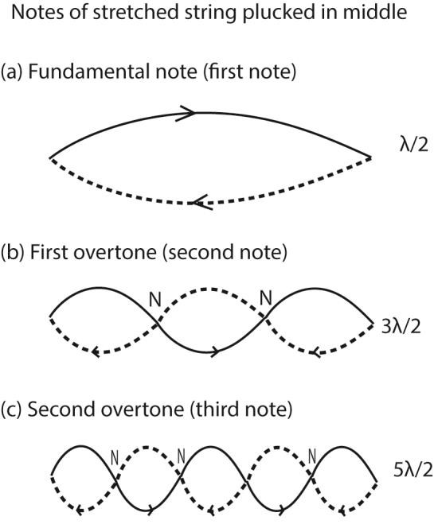

An experiment to investigate the variation of frequency with length for vibrating wires
A sonometer below is used
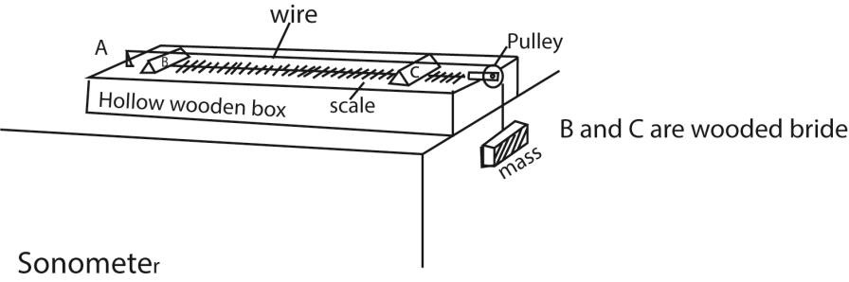
- The wooden bridges B and C vary the effective length of the wire, L.
- Constant tension in the wire is maintained by the fixed mass
- A paper rider is placed on the wire in the middle of BC and a sounding fork placed near it.
- The position of the bridge C is varied until sound is heard.
- The distance between the bridges L and the frequency, f, of the tuning fork is noted.
- The procedure is repeated for various tuning forks and values of L, f and are tabulated
- A plot of f against gives a straight line showing that the frequency of vibration of the wire is inversely proportional to length.
An experiment to show the fundamental frequency varies with the tension in a given wire.
A sonometer below is used.
- The length L between the bridges is fixed.
- A suitable mass, m, is attached to the free end of the wire.
- The wire is plucked in the middle and a tuning fork of known frequency, f, is sounded
- The mass m corresponding to the frequency, f, are recorded in the table including values of f².
- The procedure is repeated for different values of f.
- A graph of f² against m is plotted.
- A straight line graph is obtained through the origin, implying that f² m
But m = 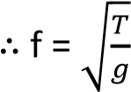 thus increase in tension, T, increases the frequency, f, of the wire.

Example 4
- What are overtones?
Overtones are notes of higher frequencies produced by an instrument after fundamental (or main) notes.
- Explain why a music tone played on one instrument sound differently from the same note played on another instrument.
  - When an instrument is played, all the allowed vibration take place producing different frequencies.
  - The quality of the musical note is determined by the number and strength (intensity) of the overtones.
  - Thus when the note played on an instrument has fewer overtones, it sounds different from the same note played on different instrument with more overtones.
- A stretched string of length L, is fixed at both ends and then set to vibrate in its allowed modes.
Derive an expression for frequency of the second overtone in terms of fundamental frequency.
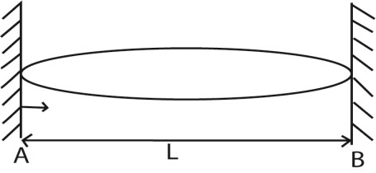
When the string is vibrating with fundamental frequency, the number of waves between A and B is
L = 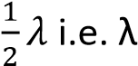 =2L
Let the velocity of the wave be v, then frequency of fundamental note, 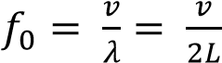
When vibrating with 2nd overtone, the number of waves made by the length of the string between A and B is 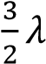.
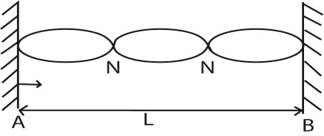
L = 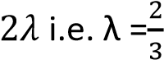L
The f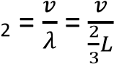
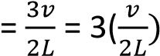
f₂ = 3f₀

- A wire of length 0.60m and mass 9 x 10⁻⁴kg is under tension of 135N. The wire is plucked that it vibrates in its third harmonic. Calculate the frequency of the third harmonic.
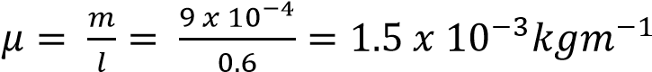
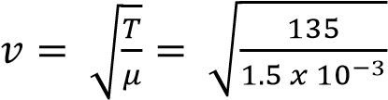= 300ms⁻¹
The frequency of the third harmonic
f 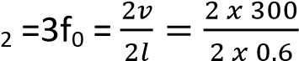= 750Hz

Example 5
A uniform wire of length 1.00m and mass 2.0 x 10⁻²kg is stretched between two fixed points. The tension in the wire is 200N. The wire is plucked in the middle and released. Calculate the
- Speed of the transverse waves. (03marks) L=1.0m, m = 2.0 x 10⁻²kg. T= 200M
V = 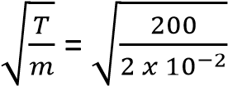 = 100ms⁻¹.
- Frequency of the fundamental note (03marks) λ = 2L and V = fλ
f = 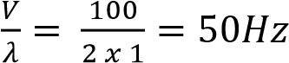

Example 6
A string of length 0.5m and mass 50g is stretched between two fixed points. If the tension in the string is
100N, find the frequency of second harmonic. (04marks)

From f = …………………………. (i)
But v = 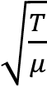; where μ is the mass per unit length.
μ = 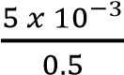 = 0.01kgm⁻¹
v = 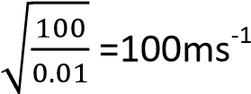
For second harmonic, first overtone, λ = L = 0.5m Substituting in eqn. (i) f = 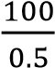 = 200Hz

Resonance
Resonance occurs when a body or system is set into vibrations with its own natural frequency by a nearby body or system vibrating with the same frequency.

The vibrations combine to produce a larger vibration with a larger amplitude.

Thus, resonance occurs when a body is set into vibration with its own natural frequency by another nearby body which vibrates with the same frequency.

Resonance tubes/ vibrating air column /Vibration of air in pipes

In vibrating air column, stationary waves are set up.

There are two types of pipe for air vibration:
- Closed pipe
- Open pipe

Resonance in a closed pipe
a) First position of resonance
This occurs when a node is at the closed end and antinodes at the open end
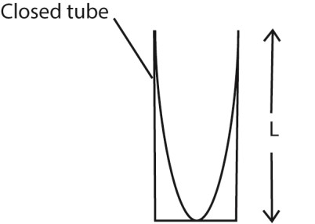

L =
λ = 4L
The fundamental note f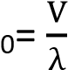 is given out, f_{o} 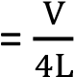
(b) Second resonance

This occurs when a second node is formed such that the length L of vibrating air equals three quarters of a wave length.
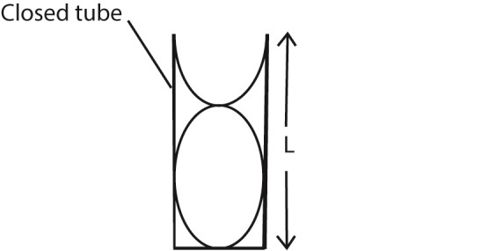

L = 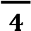 λ = 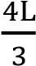

The note given out is the first overtone f₁ f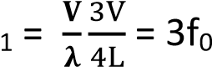
where f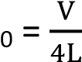
The third resonance is obtained when air column L equals

The note given out is the second overtone f₂
L = 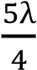 i.e. λ = 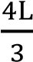
f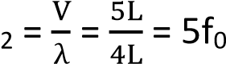

Where f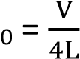
Where f₀ is the fundamental note.
For closed pipes, the possible harmonics are,f₀, 3f₀, 5f₀, 7f_{o}…..

NB: A closed pipe produces only odd notes.

Example 7
A pipe closed at one end has a length of 10cm. If the velocity of sot in air of the pipe is 340 m/s, calculate
- the frequency of fundamental note
L = L = 10cm = 0.1m
λ= 4L f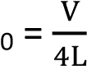
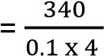 = 850Hz

- the frequency of first overtone L = 10cm = 0.1m for l^{st} overtone
L = L = 10cm = 0.1m
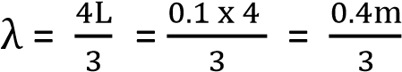
F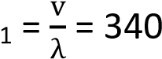
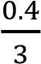
= 2550Hz

Alternative method
F₀ = 850
For 1 overtone
= 3 x 850
= 2550 Hz Note:
The frequency of fundamental may alter during the day because this temperature changes of air during the day result in change of velocity of sound.

Vibrating turning fork
When the vibrating tuning fork is held over the mouth of tube T, the air inside the tube is set into vibration. The wave sent downwards is reflected from the surface of' water and a stationary wave is set.

Experiment 1: to determine the speed of sound in air by resonance method- air obtained by raising the tube from water

- A tuning fork of known frequency, f, is set into vibration and placed above near the open tube as in the diagram.

- The tube is raised from water until the length of air column, L₁ is reached when a loud sound is heard. This is the position of first resonance.
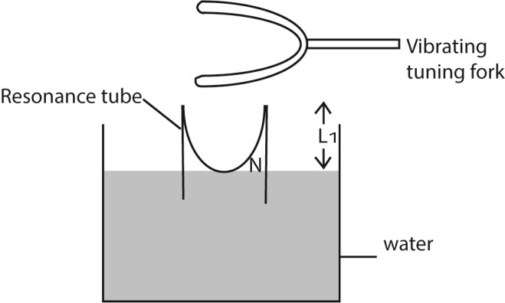

L 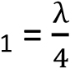+ C ……………. (i)
where C is the end correction and λ is the wave length.

- While is sounding fork is kept in place; the tube is raised further to length L₂ of the air column until a second loud sound is heard. This is the position of the second resonance.

The tube is raised to length L₂ and the air column is varied until a loud sound is heard. This is the position of the second resonance. L 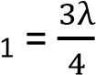+ C ……………. (ii)
where C is the end correction and λ is the wave length.

Subtracting resonance: 2nd position – 1st position
L 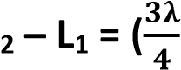+ c) – 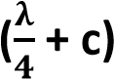

L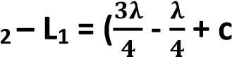-c
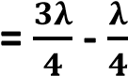
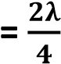
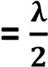
λ = 2(L₂ - L₁)
But V = λf

V = 2(L₂ - L₁)f
where v is the velocity of sound in air.

Experiment 2: to determine the speed of sound in air by resonance method- air obtained by draining the tube.

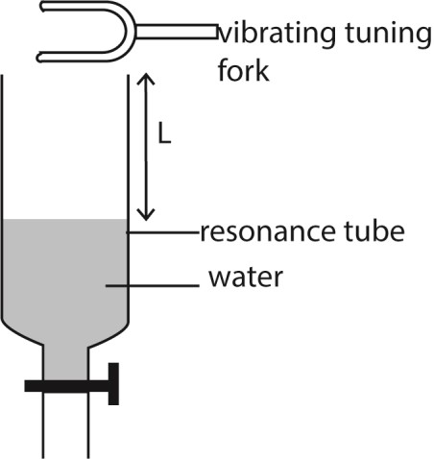

- A glass tube which can be drained from bottom is filled with water.
- A sounding tuning fork of frequency f is brought to the mouth of the tube.
- The water is slowly drained until a loud sound is heard. The tap is closed and length L₁ is measured.
- The tuning fork is again sounded at the mouth of the tube and the water drained further until a loud sound is heard and distance L₂ is noted
- Velocity, v, of sound in air = 2f(L₂-L₁)

Experiment 3: to determine the speed of sound in air using tuning forks of different frequencies and resonate tube.
A resonance tube is place to stand in a tall jar full of water.
Starting with a short length air column, a vibrating tuning fork is held over the mouth of resonance tube. The tube is raised until a point where a loud sound is heard. The length L of the air column and frequency f of tuning fork are recorded.

The experiment is repeated with other five tuning forks of different frequencies Values of L, f and are tabulated.
A graph of L against is plotted and slope S is determined
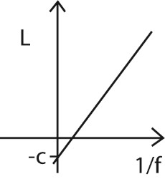
The velocity, v, of sound = 4S.

The end correction c is an intercept on L axis.

Note that; this experiment shows that frequency is inversely proportional to length of the air column.

Vibration in open pipes
An open pipe is one which is open at both ends as shown below, Here the antinodes are open at both ends. (a)
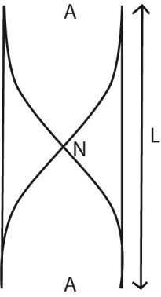
For fundamental note f₀ the air column 'L' equals half the wave length.

L = λ= 2L
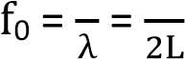

For 1st overtone f₁
For 1st overtone f₁ the air column 'L' equals the wave length.
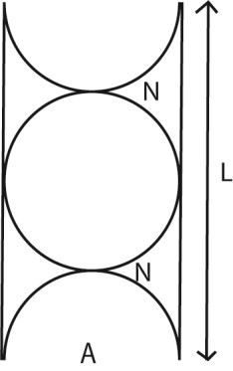

f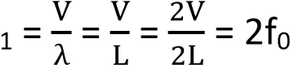

where f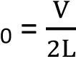

For 2nd overtone f₂.
For 2nd overtone f₂ the air column 'L' equals 3/2 the wave length.
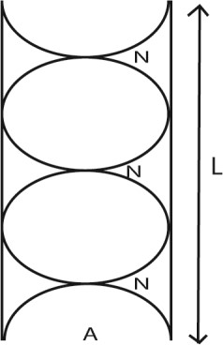

L = 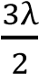
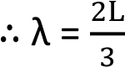
v = fλ
f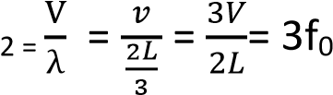

The harmonics present in the open pipe are f₀, 2f_{tf}, 3f₀, 4f₀...
NB: open pipe produces both odd and even notes.

End correction, c
The end correction of an air pipe is a small distance that must be added to actual length of the pipe to account for increase in the effective length of the pipe as a result of the vibrating air column extending beyond the open end of the pipe.

The effective length of the pipe is therefore longer than actual length of the pipe because the vibrating air column extends beyond the open end(s) of the pipe.

The end correction is proportional to the radius of the pipe and the wavelength of sound wave. Experiment show that end correction, c= 0.6r where r is the radius of the pipe.

End correction in open pipe

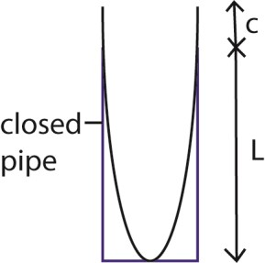

L +c =

;
λ

=4(L+
)
c

The fundamental frequency in closed pipe, 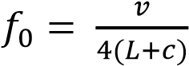

End correction in open pipe
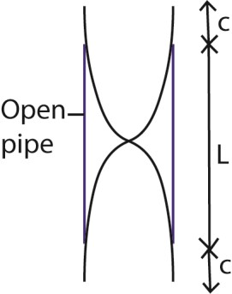
L +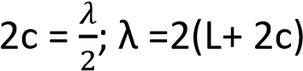
The fundamental frequency in closed pipe, 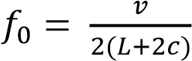

Example 8
A closed pipe of length 0.68m is blown at its open end so that it produced the first harmonic.
- Sketch the wave pattern of the pipe
- Determine the frequency of the note produced.
- What is the radius of the pipe?
(End correction of the pipe = 0.002m and velocity of sound is 340m/s)
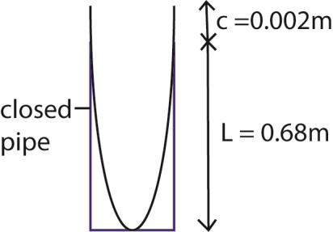
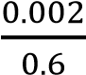
(
)
a

(
)
d

=
124.6Hz

e
)
(

From c = 0.6r

r =
3.3 x
10
=
-
3
m

Example 9
A circular pipe of length 29cm is closed at one end. The air in the pipe resonated when a turning fork of frequency 860Hz is sounded. Determine the
- Mode of vibration of the pipe
- End correction (the speed of sound in air is 340m/s)

Solution

Let f_{n} = 860Hz = nf₀
Ignoring end correction
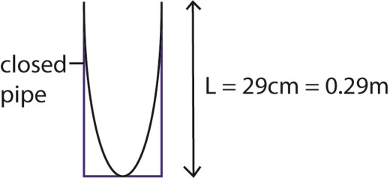

f
0

=

= 293.1

but f
n

=
nf
0

n =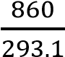 = 2.943 ≈ 3
the mode of vibration is 3rd harmonic of 2nd overtone.

(ii) L + c = 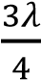
From v = fλ
340 = 860 x 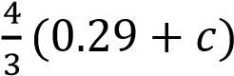
c = 0.00651m

Advantages of open pipes over closed pipes
Open pipes produce notes of better quality than closed pipes because they produce both odd and even harmonics while closed pipes produce only odd harmonics.

The Doppler Effect
It is the apparent change in frequency of a wave motion due to relative motion between the source and observer.
Calculation of Apparent Frequency based Doppler Effect
Suppose V is the velocity of sound in air, u_{s} is the velocity of the source of sound S, u₀ is the velocity of an observer 0, and f is the true frequency of the source.
- Source moving towards stationary observer.
  - If the source S were stationary, the f waves sent out in one second towards the observer O would occupy a distance V, and the wavelength would be V/f
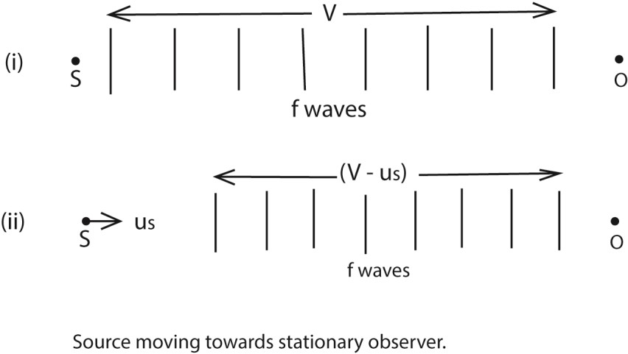
  - If S moves with a velocity u_{s} towards 0, however, the f waves sent out occupy a distance (V – u_{s}), because S has moved a distance u_{s} towards 0 in 1s, fig. (ii).
Thus the wavelength λ' of the waves reaching O is now 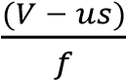
But velocity of sound = V
Apparent frequency, f’ = 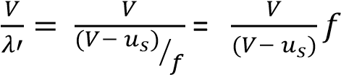
Since (V - u_{s}) is less than V, f' is greater than f; the apparent frequency thus appears to increase when a source is moving towards an observer.
- Source moving away from stationary observer.
In this case the f waves sent out towards 0 in 1s occupy a distance (V + u_{s}),
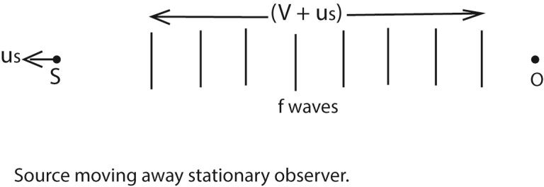
Thus the wavelength λ' of the waves reaching O is now 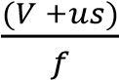
But velocity of sound = V
Apparent frequency, f’ = 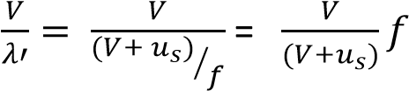
Since (V + u_{s}) is greater than V, f' is less than f; the apparent frequency thus appears to reduce when a source is moving towards an observer.

- Source stationary, and observer moving towards it.
Since the source is stationary, the f waves sent out by S towards the moving observer O occupies a distance V,

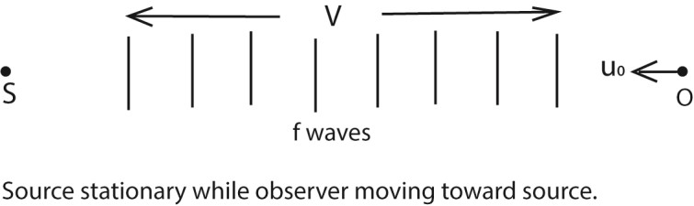

The wavelength of the waves reaching O is hence V/f, and thus unlike the cases already considered, the wavelength is unaltered.
The velocity of the sound waves relative to O is not V, however, as O is moving relative to the source.
The velocity of the sound waves relative to O is given by (V + u_{o}) in this case, and Hence the apparent frequency f' is given by
Apparent frequency, f’ = 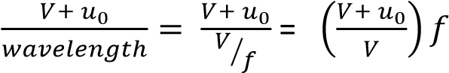
Since (V + u₀) is greater than V, f' is greater than f; the apparent frequency thus appears to increase when an observer is moving towards the source.

(d) Source stationary, and observer moving away from it.
Since the source is stationary, the f waves sent out by S towards the moving observer O occupies a distance V,

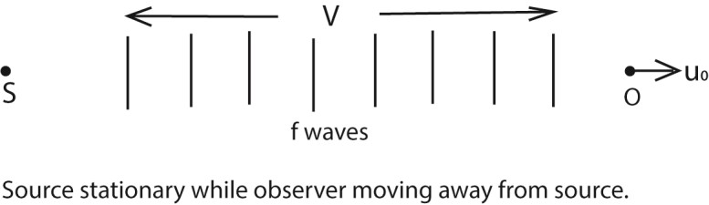

The wavelength of the waves reaching O is hence V/f, and thus unlike the cases already considered, the wavelength is unaltered.
The velocity of the sound waves relative to O is not V, however, as O is moving relative to the source.
The velocity of the sound waves relative to O is given by (V - u_{o}) in this case, and Hence the apparent frequency f' is given by
Apparent frequency, f’ = 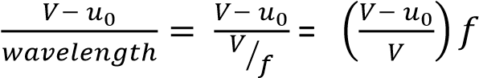
Since (V - u₀) is less than V, f' is less than f; the apparent frequency thus appears to reduce when an observer is moving away from the source.

Source and Observer Both Moving
If the source and the observer are both moving, the apparent frequency f' can be found from the formula f’ = 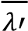
where V' is the velocity of the sound waves relative to the observer, and λ’ is the wavelength of
the waves reaching the observer. This formula can also be used to find the apparent frequency in any of the cases considered before.
- Suppose that the observer has a velocity, u_{o}, the source a velocity u_{s}, and that both are moving in the same direction. Then
V' = V- u_{o} And
λ' = (V - u_{s})/f
f’ =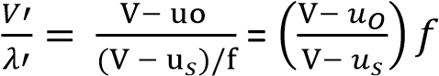

Suppose that the observer has a velocity, u_{o}, the source a velocity u_{s}, and If the observer is moving towards the source, then
V' = V+ u_{o}
And
λ' = (V - u_{s})/f
f’ = 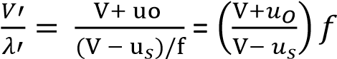
- A source of sound moving with velocity, u_{s}. approaches an observer moving with velocity u₀ in the same direction. Derive the expression for frequency of sound heard by observer. (05marks)
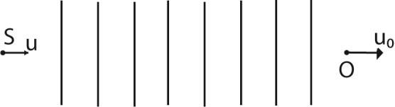

Let c be the velocity of sound from a source of frequency, f.
Apparent wave length, 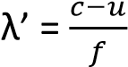
Apparent velocity c’= c-u₀
Apparent frequency = 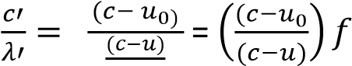

Example 10
One species of bats locates obstacles by emitting high frequency sound waves and detecting the reflected waves. A bat flying at a steady speed of 5ms⁻¹ emits sound of frequency 78.0 kHz and is reflected back to it.
- Derive the equation for the frequency of the sound waves reaching the bat after reflection
(05marks)
Suppose the velocity of sound wave is c and that of the bat is v₀ and the frequency is f. The velocity v’ of reflected sound relative to the bat is given by v’ = v₀ + c.
The apparent wave length 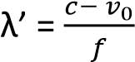
But the apparent frequency, f’ = 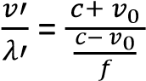
Hence f’ = 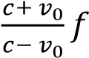
- Calculate the frequency of sound received by the bat given the speed of sound in air is 340ms⁻¹.
(02 marks)
From, f’ = 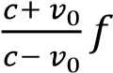
f' = 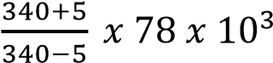 = 90.3kHz

Example 11
A motor cyclist and police car are approaching each other. The motor cyclist is moving at 10ms-1 and the police car at 20ms-1. If the police siren is sounded at 480Hz. Calculate the frequency of the note
heard by the cyclist after the police car passes by. 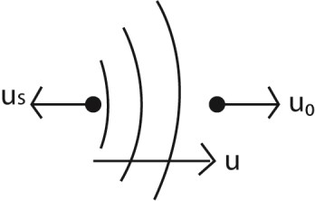 Apparent wavelength reaching the observer, 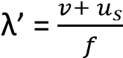
Apparent velocity of sound received, v’ = v – u₀
Apparent frequency of sound received, f’ = 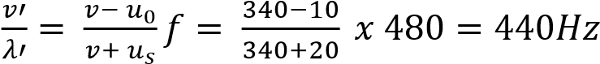

Example 12

- A source of sound moving with velocity, u. approaches an observer moving with velocity u₀ in the same direction. Derive the expression for frequency of sound heard by observer. (05marks)

Let c be the velocity of sound from a source of frequency, f.
Apparent wave length, 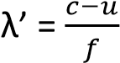
Apparent velocity c’= c-u₀
Apparent frequency = 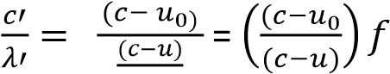

- Two whistles are sounded simultaneously. The wavelengths of the sounds emitted are 5.5m and
6.0m respectively. Find the beat frequency if the speed of sound is 330ms⁻¹.
For 1st sound 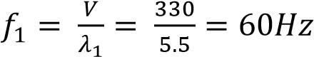
For 2nd ^{t} sound 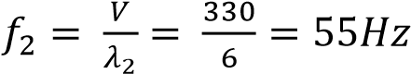
Beat frequency

TOPIC 6/6: SOUND WAVES
Competency: The learner investigates the behaviour of sound waves and their applications in different situations.

Sound waves
Sound is a form of energy produced by vibrating objects. It travels as a longitudinal wave through a material medium.

Production
Sound is produced by vibrating objects. Vibrating objects cause nearby surrounding air molecules to vibrate. When these vibrating air molecules reach our ear, sensation of sound is produced. A sound wave is a longitudinal wave

Propagation of sound
Sound waves need a material medium for transmission so that the vibrating objects cause the nearby molecules of the medium to vibrate

Experiment to show that sound needs a material medium for the transmission
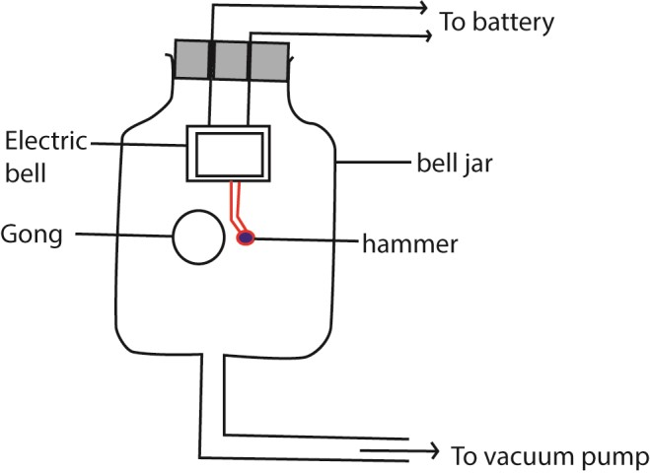

Switch on the electric bell
Switching on the electric bell, a loud sound is heard

Removal of air gradually
On gradually removing the air by a vacuum pump, the loudness of sound gradually dies away.

No sound is heard when all the air has been completely removed though the hammer is seen hitting the gong.

This shows sound waves need material medium like air, liquid or solid for transmission.

The speed of sound waves depends on:-
- Temperature.
- Density and elasticity of the medium.
- Wind in the case of air.

How each factor affects the speed of sound waves?
Density: The speed of sound waves is higher in denser medium than in less denser medium. This is the reason why the speed of sound is higher in solids than in liquids and gases because solids are generally denser.

In a steel rod for example, the speed of sound is about 5000ms⁻¹ yet in water the speed of sound is 1500ms⁻¹ because steel is denser than water.

In daily life, an approaching train can easily be detected by human ears positioned close to the rails than in air. This is explained from the fact that sound waves travel faster through solids than through air as solids are generally denser than air.

Temperature: Increasing the temperature, increases the speed of sound in air greatly because the speed of vibrating air molecules increases with temperature.

However in solids and liquids, increasing the temperature, decreases the speed of sound waves because solids and liquids become less dense as temperature increases.

Wind in the case of air: The speed of sound waves increases if the direction of sound wave travel is the same as that of the wind. If the direction of sound waves travel is opposite that of wind, the speed decreases.

Note: Pressure change in air (gases) does not affect the speed of sound wave because density of air is negligibly affected by change in pressure.

Properties of sound waves
- Reflection
- Refraction
- Diffraction
- interference

Reflection
Sound is bounced back from obstacles in similar manner to light. The reflected sound is called an echo.

Laws of reflection of sound waves state:-
i) Incident sound wave, reflected sound wave and the normal at the point of incidence all
He in the same plane, ii) The angle of incidence of sound waves is equal to angle of reflection of sound waves.

Experiment to show reflection of sound waves
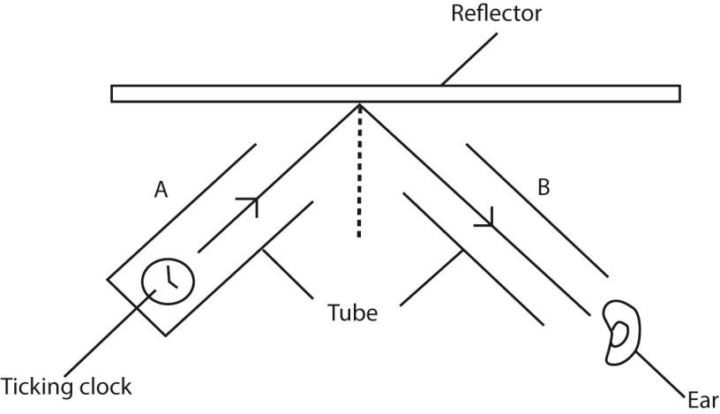

(a) Producing sound waves
Sound waves produced by the clock at the end of tube A are reflected at the hard surface reflector.

b) Moving tube B
The ear is put at the end of the tube B and the tube B is moved until the ticks of the clock are loudest. This is the direction of reflected sound wave.

Note: Hard surfaces reflect sound waves while soft surfaces absorb sound waves.

Echoes
An echo is reflected sound waves

Echoes are produced by the reflection of sound from a hard surface. Echoes are often heard in the neighborhoods of large houses, high walls, cliffs etc.

I echoes are often heard in the big churches, halls etc. They are not heard in a small room or class-room because the reflected sound waves return very quickly and mix up with the original sound wave.

Echoes are troublesome in lecture halls, cinema etc. To reduce echoes in such places, the walls are covered with soft thick porous materials.

Furniture and people in halls also reduce echoes. So many echoes are produced in empty halls compared to one filled with people because bodies of people are soft so they absorb some of the sound.

Reverberation
It is a prolongation of sound due to reflection from nearby obstacle. If the reflecting surface is nearer, the echo joins the original sound which then seems to become prolonged.

Implications of reverberations

- To some degree, reverberation is desirable in concert halls to stop the hall sounding dead so that hearing in such places is improved.
- However, too much reverberation causes confusion.

The time taken by a particular intensity of sound to die away is the reverberation time.

For echo
Velocity =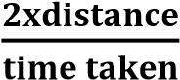

How to minimize reverberation
To minimize reverberation, add soft, sound-absorbing materials like carpets, heavy curtains, upholstered furniture, and acoustic panels to walls and ceilings, as these materials trap sound waves and reduce reflections, making a space sound drier and clearer, while diffusers can scatter waves for better sound balance. Strategically placing these elements, especially in large, hard-surfaced rooms, breaks up direct sound paths and controls echoes effectively.

Experiment to measure the speed of sound (echo method)
Two people one claps and the other records the time, while standing at a known distance from a high wall. The time taken for the sound wave to travel to and from the wall is recorded.

The exercise is repeated many times so that the average time is obtained.
Speed of sound = 2 x distance
Average time

Example 1
A man stands at a distance of 990m away from a tall building and makes a loud sound. He hears the echo after 6 seconds. Calculate the speed of sound.

For echo: Speed = 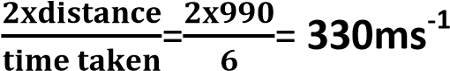

Example 25
A man stands between two walls, but nearer one of them and makes a: loud sound. If he hears the third echo after 6 seconds, calculate the distance between the two walls, (speed of sound in air is 330ms⁻¹.
V =330 ms⁻¹ d =? T = 6 seconds Velocity =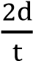
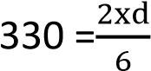
d =330x3 =990m

Example 2
A sound of frequency 150Hz is produced 45m away from a cliff. Calculate the (i). wavelength
From V =λ f
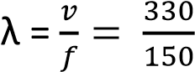= 2.3m
(ii). Time it takes the sound wave to travel to and from the cliff (Speed of sound in air=300ms⁻¹).

Time = 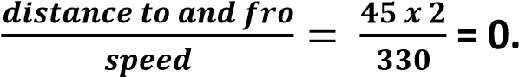 27s

Refraction of sound waves
Refraction of sound waves occurs when the speed of the wave changes as it moves from one medium to another of different density. The speed of sound waves in air is affected by the air temperature. When sound waves pass through layers of air at different temperature they are refracted i.e. turned into another direction. On a hot day sound waved are bent upwards away from the earth where they otherwise travel faster.

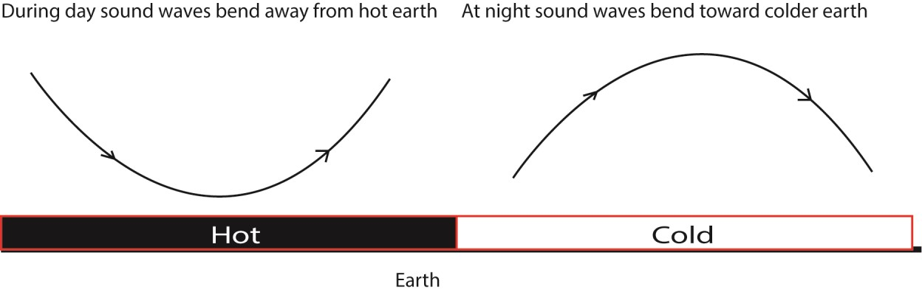

In the evening when the air near the ground becomes cool, refraction of sound is towards the earth, making it easier to hear distant sound as the range of sound is more.

Radios are clearer at night than during day because at night the sound waves are bent down towards the cool earth making the range of sound more.

Interference of sound waves

- - Constructive interference
- - Destructive interference
Overlapping sound waves produce regions of louder sound by constructive interference and regions of quiet sound by destructive interference.

If two loud speakers are connected to the same audio frequency generator, they produce sound waves of identical frequency and similar amplitude.
A louder sound is produced when the waves from the two speakers arrive in phase and interfere constructively.
A quiet sound is produced when destructive interference occurs.
If the speakers are moved closer together, the distance between the places where loud sound is heard is increased.

Experiment to show interference of longitudinal waves.
- Using two loud speaker
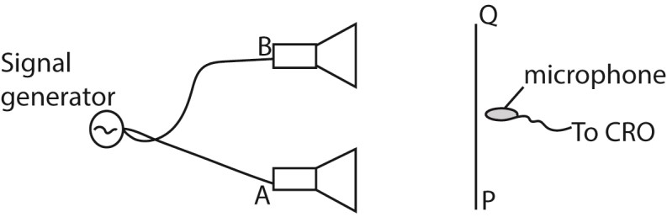
Two loud speaker A and B were connected to a signal generator. A microphone connected to the y-plates of s C.R.O with the time base switched off.
As the microphone is moved along the line PQ which is parallel to the line joining the loud speaker, the vertical trace on the screen of CRO is seen to increase to maximum and reduce to minimum at equal distances. The alternative maximum and minimum intensity are interference pattern.

- Using two tubes
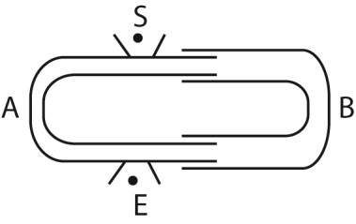
Tube A is fixed while B is free to move. A note is sounded at S and detected at E. Tube B s then pulled out slowly. It is noted that the sound detected E increases to a maximum and reduces to minimum intensity at equal intervals of the length of the tube. The alternate maximum and minimum intensity formed are interference pattern.

An experiment 1 to determine the velocity of sound in air by an interference method.
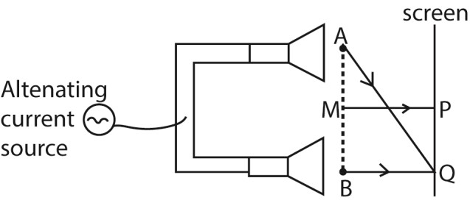
Two small loud speakers A and B about 1m apart are connected to the same oscillator so that both emit sound waves of frequency, f, in phase.

A sensitive detector is moved parallel to the line AB along PQ and it detects a maximum wave at P on perpendicular bisector MP of AB and another maximum wave when it first reaches a point Q directly opposite to B.

Constructive interference of sound wave occurs at P and Q, so the wavelength of sound wave is given by λ = AQ –BQ

The speed of sound in air is then calculated from V =fλ.

An experiment 2 to determine the velocity of sound in air by an interference method.

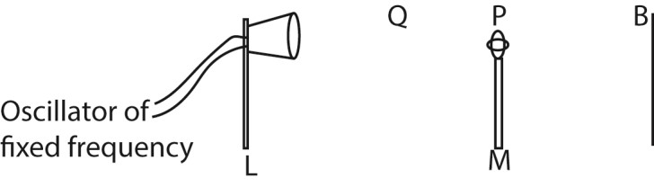
  - The loud speaker, L is connected to an oscillator of constant frequency, f.
  - A microphone, M is connected to the Y-plates of a cathode ray tube.
  - The microphone is moved away from B towards L until the amplitude of the wave on C.R.O is maximum.
  - The position P of the microphone is noted and distance BP is measured.
  - The microphone is move farther away from B to Q where another maximum amplitude of wave front is obtained. Distance BQ is measured and recorded.
  - The distance between two successive maxima d= BQ – BP = where λ is the wavelength Velocity of sound = fλ = 2df.

Ultrasonic
Sound waves with frequencies above 20 kHz are called ultrasonic waves. They are emitted by bats. Sound of high frequency that human ear cannot detect is described as ultrasonic.

Applications of ultrasonics
- Ultrasonic enable bats to judge the distance of an object from the time taken by the reflected wave to return.
- Ultrasonic are used in spectacles for blind to judge distances of an object from the time taken by reflected waves to return. Such spectacles contain ultrasonic sender and receiver.
- In sonar (echo-sounding system) of ships use ultrasonic wave to measure the depth of sea and to detect shoals of fish.
- In industry, ultrasonic waves are used to reveal flaws in welded joints and also holes are cut in glass and steel by ultrasonic drills.
Note:
In an echo sounder (sonar, ultrasonic waves are used because they:-
i) Cannot be confused with engine sound and other sound made ship,
(ii) Can penetrate sea water to a large distance without undue loss of energy. ii) They are not much detracted.

Frequency and audio frequency range.
The human ear has a range of sound frequencies which it can hear. The lowest limit of audibility is about 30Hz and the upper limit audibility for most people is between 20 kHz and 30 kHz.

In daily life, a dog is more able than a human being to detect the presence of a thief tiptoeing at night. A thief tiptoeing at night produces sound of low frequency that can only be detected by dog ears not human being ears because the dog has wider ears than human being ears.

The Doppler Effect
It is the apparent change in frequency of a wave motion due to relative motion between the source and observer.
Calculation of Apparent Frequency based Doppler Effect
Suppose V is the velocity of sound in air, u_{s} is the velocity of the source of sound S, u₀ is the velocity of an observer 0, and f is the true frequency of the source.
- Source moving towards stationary observer.
  - If the source S were stationary, the f waves sent out in one second towards the observer
O would occupy a distance V, and the wavelength would be V/f

  - If S moves with a velocity u_{s} towards 0, however, the f waves sent out occupy a distance (V – u_{s}), because S has moved a distance u_{s} towards 0 in 1s, fig. (ii).
Thus the wavelength λ' of the waves reaching O is now 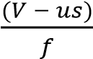
But velocity of sound = V
Apparent frequency, f’ = 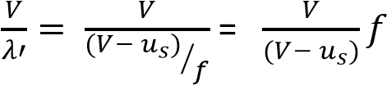
Since (V - u_{s}) is less than V, f' is greater than f; the apparent frequency thus appears to increase when a source is moving towards an observer.
- Source moving away from stationary observer.
In this case the f waves sent out towards 0 in 1s occupy a distance (V + u_{s}),

Thus the wavelength λ' of the waves reaching O is now
But velocity of sound = V
Apparent frequency, f’ =
Since (V + u_{s}) is greater than V, f' is less than f; the apparent frequency thus appears to reduce when a source is moving towards an observer.

- Source stationary, and observer moving towards it.
Since the source is stationary, the f waves sent out by S towards the moving observer O occupies a distance V,

The wavelength of the waves reaching O is hence V/f, and thus unlike the cases already considered, the wavelength is unaltered.
The velocity of the sound waves relative to O is not V, however, as O is moving relative to the source.
The velocity of the sound waves relative to O is given by (V + u_{o}) in this case, and Hence the apparent frequency f' is given by
Apparent frequency, f’ =
Since (V + u₀) is greater than V, f' is greater than f; the apparent frequency thus appears to increase when an observer is moving towards the source.

(d) Source stationary, and observer moving away from it.
Since the source is stationary, the f waves sent out by S towards the moving observer O occupies a distance V,

The wavelength of the waves reaching O is hence V/f, and thus unlike the cases already considered, the wavelength is unaltered.
The velocity of the sound waves relative to O is not V, however, as O is moving relative to the source.
The velocity of the sound waves relative to O is given by (V - u_{o}) in this case, and Hence the apparent frequency f' is given by
Apparent frequency, f’ = 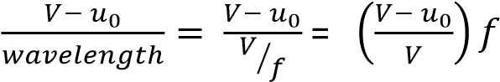
Since (V - u₀) is less than V, f' is less than f; the apparent frequency thus appears to reduce when an observer is moving away from the source.

Source and Observer Both Moving
If the source and the observer are both moving, the apparent frequency f' can be found from the formula f’ = 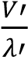
where V' is the velocity of the sound waves relative to the observer, and λ’ is the wavelength of
the waves reaching the observer. This formula can also be used to find the apparent frequency in any of the cases considered before.
- Suppose that the observer has a velocity, u_{o}, the source a velocity u_{s}, and that both are moving in the same direction. Then
V' = V- u_{o} And
λ' = (V - u_{s})/f
f’ = 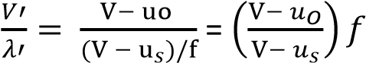

Suppose that the observer has a velocity, u_{o}, the source a velocity u_{s}, and If the observer is moving towards the source, then
V' = V+ u_{o}
And
λ' = (V - u_{s})/f
f’ = 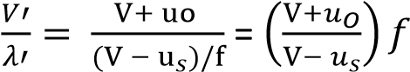
- A source of sound moving with velocity, u_{s}. approaches an observer moving with velocity u₀ in the same direction. Derive the expression for frequency of sound heard by observer. (05marks)

Let c be the velocity of sound from a source of frequency, f.
Apparent wave length, 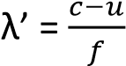
Apparent velocity c’= c-u₀
Apparent frequency = 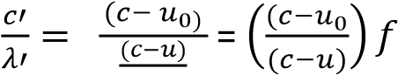

Example 3
One species of bats locates obstacles by emitting high frequency sound waves and detecting the reflected waves. A bat flying at a steady speed of 5ms⁻¹ emits sound of frequency 78.0 kHz and is reflected back to it.
- Derive the equation for the frequency of the sound waves reaching the bat after reflection
(05marks)
Suppose the velocity of sound wave is c and that of the bat is v₀ and the frequency is f. The velocity v’ of reflected sound relative to the bat is given by v’ = v₀ + c.
The apparent wave length 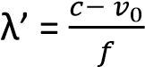
But the apparent frequency, f’ = 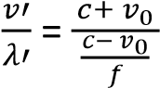
Hence f’ = 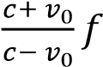
- Calculate the frequency of sound received by the bat given the speed of sound in air is 340ms⁻¹.
(02 marks)
From, f’ = 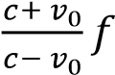
f' = 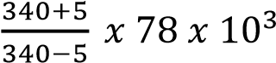 = 90.3kHz

Example 4
A motor cyclist and police car are approaching each other. The motor cyclist is moving at 10ms-1 and the police car at 20ms-1. If the police siren is sounded at 480Hz. Calculate the frequency of the note
heard by the cyclist after the police car passes by.
Apparent wavelength reaching the observer, 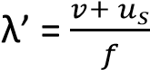
Apparent velocity of sound received, v’ = v – u₀
Apparent frequency of sound received, f’ = 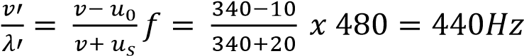

Example 5

- A source of sound moving with velocity, u. approaches an observer moving with velocity u₀ in the same direction. Derive the expression for frequency of sound heard by observer. (05marks)

Let c be the velocity of sound from a source of frequency, f.
Apparent wave length, 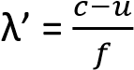
Apparent velocity c’= c-u₀
Apparent frequency = 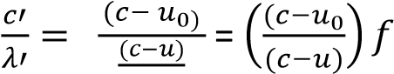

- Two whistles are sounded simultaneously. The wavelengths of the sounds emitted are 5.5m and
6.0m respectively. Find the beat frequency if the speed of sound is 330ms⁻¹.
For 1st sound 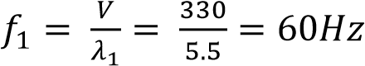
For 2nd ^{t} sound 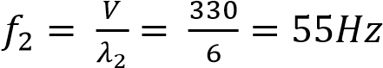
Beat frequency

